Ravenna, Emilia-Romagna, Italy
Once the capital of the Western Roman Empire, Ravenna dazzles with eight UNESCO World Heritage mosaic sites — gold-and-cobalt Byzantine masterpieces rivaling anything in Istanbul or Rome. A flat, bikeable city where Dante is buried and the food is superb.
⚓ Pier (Porto Corsini) · 🕒 Typical call: 8-10 hrs · 💶 Currency: Euro · 🗣️ Language: Italian · 🚌 Shuttle to center required
✍️ MY DAY IN PORT (FILL IN)
Ship / Date
In port | arrive ______ · all aboard ______
Booked excursion
Notes / meeting point
GETTING ASHORE
- Docking: Pier at Porto Corsini — no tendering
- Port to Center: ~12 km; shuttle bus, taxi, or public bus
- Best For: Byzantine mosaics, history, cycling, Emilian food
- Don't Miss: Basilica of San Vitale + Mausoleum of Galla Placidia combo
GETTING AROUND
- 🚕 Taxi: €40 flat rate (1–3 pax); +€10/extra person — Fixed-rate taxis connect the cruise terminal to the city center (~20 min). Ravenna has fewer than 20 taxis total — book
- 🚌 Hop-on hop-off: ✅ City Sightseeing Ravenna
TOP THINGS TO DO
- Ravenna UNESCO Mosaic Walking Tour — A guided sweep through the greatest hits: Basilica of San Vitale, Mausoleum of Galla Placidia, Neonian Baptistery, and Dante's…
- Basilica of Sant'Apollinare in Classe — About 5 km south of the city, this isolated 6th-century basilica has a stunning apse mosaic in an almost empty nave — far fewer…
- Emilian Food & Wine Experience — Emilia-Romagna is Italy's culinary heartland.
- City by Bicycle — Ravenna is pancake-flat and bike-mad — locals cycle everywhere.
- Bologna Day Trip — Italy's underrated food capital is about 75 km away (roughly 1 hr by train from Ravenna station).
BEST WALKS
- The Mosaic Circuit: 3 km · 2-3 hrs · Easy — The classic self-guided loop hitting the main mosaic sites.
- Piazza to Dante Stroll: 1.5 km · 30 min · Easy — A short walk from the central square through the medieval streets to Dante's Tomb and the flooded…
WEATHER · DAYLIGHT · MONEY
Month | High °F | Low °F | Rainy days
May | 70 | 57 | 10
Jul | 85 | 70 | 7
Sep | 77 | 63 | 8
Daylight: May 5:44AM–8:31PM · Jul 5:41AM–8:52PM · Sep 6:50AM–7:21PM
cruiseports.org/ravenna · Confirm terminal & all-aboard time with your ship

Ravenna, Emilia-Romagna, Italy — Port Map
Red = walkable sights · Amber = excursions farther out · P = cruise terminal
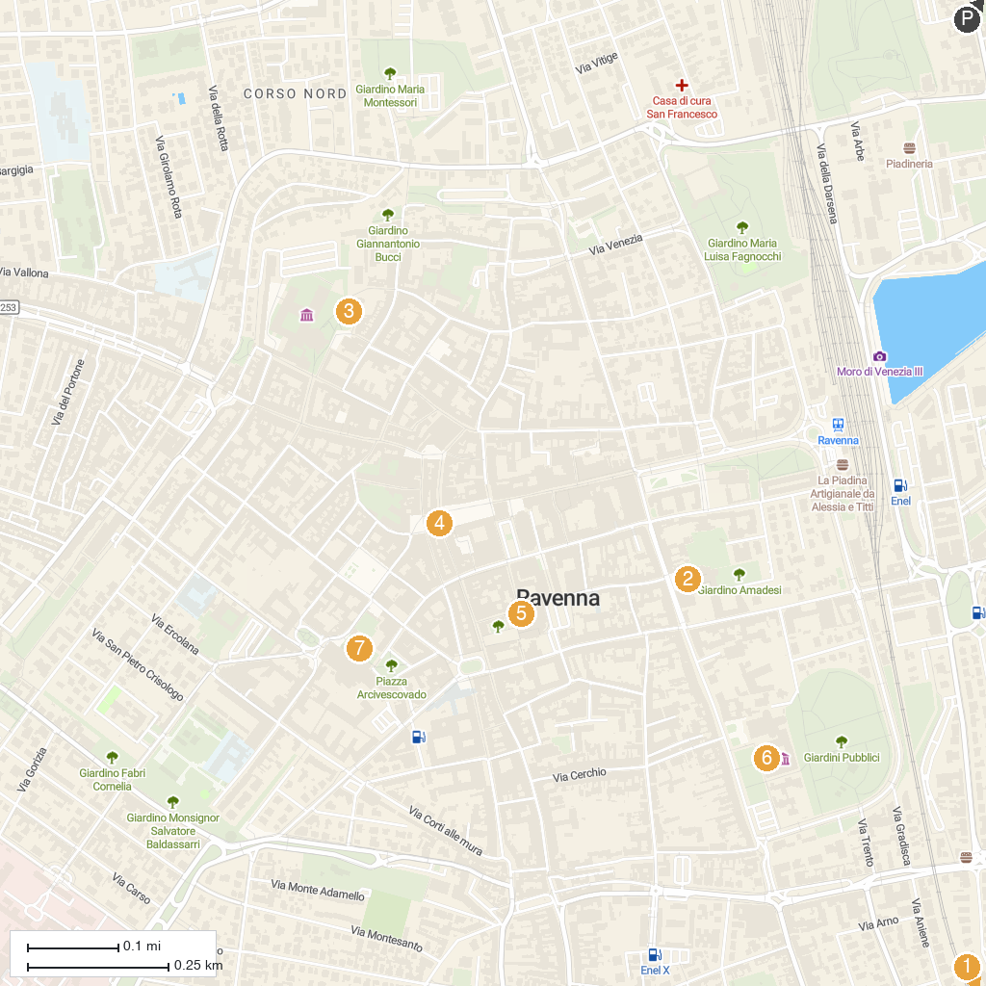
MAP KEY
1. Basilica of St. Apollinaris in Classe | 5. Dante's Tomb
2. Basilica di Sant'Apollinare Nuovo | 6. MAR - Museo d’Arte della Città di Ravenna
3. Mausoleo di Galla Placidia | 7. Battistero Neoniano (o degli Ortodossi)
4. Piazza del Popolo
P. Cruise port / terminal
Map © MapTiler © OpenStreetMap contributors · cruiseports.org

