Recife, Brazil
The 'Venice of Brazil' — a city of rivers, bridges, and colorful colonial streets, twinned with the hilltop UNESCO jewel of Olinda and a long ribbon of urban beach.
⚓ Docked (central port) · 🕒 Typical call: 8–10 hrs · 💵 Brazilian Real (BRL) · 🗣️ Portuguese · limited English
✍️ MY DAY IN PORT (FILL IN)
Ship / Date
In port | arrive ______ · all aboard ______
Booked excursion
Notes / meeting point
GETTING ASHORE
- Docking: Porto do Recife (central)
- Walk to old town: 5–10 min
- Best For: Olinda · History · Beach
- Don't Miss: Olinda hilltop
GETTING AROUND
- 🚕 Taxi: R$10–40 (~$2–8 USD) — Taxis are available at the shuttle drop-off near downtown. Short rides to Marco Zero and Recife Antigo are affordable; a
- 📱 Rideshare: ✅ Uber, 99
TOP THINGS TO DO
- Olinda Historic Center — The UNESCO-listed hill town of pastel houses, baroque churches, and artist ateliers, with sweeping views back over Recife.
- Recife Antigo Walking Tour — The restored old island core — Marco Zero square, the Kahal Zur Israel (the Americas' first synagogue), Rua do Bom Jesus, and…
- Boa Viagem Beach — Recife's long urban beach with reef-protected pools and a palm-lined promenade — a relaxed swim and a coconut (mind the marked…
- Frevo & Carnival Culture — Recife and Olinda are the home of frevo, the frenetic carnival dance — visit the Paço do Frevo museum or catch a street…
BEST WALKS
- Recife Antigo loop: ~2 km · 1.5 hrs · easy — From Marco Zero square along restored Rua do Bom Jesus past the first synagogue in the Americas and…
- Olinda hill climb: ~2 km · 1.5 hrs · moderate (hilly) — Up Olinda's cobbled lanes past the Sé cathedral and São Bento monastery to the Alto da Sé viewpoint…
- Boa Viagem promenade: ~2.5 km · 1 hr · easy — The palm-lined beachfront promenade of Recife's main beach — joggers, kiosks, and reef pools at low…
WEATHER · DAYLIGHT · MONEY
Month | High °F | Low °F | Rainy days
May | 83 | 75 | 25
Jul | 80 | 73 | 26
Sep | 81 | 73 | 20
Daylight: May 5:23AM–5:08PM · Jul 5:34AM–5:16PM · Sep 5:13AM–5:16PM
cruiseports.org/recife · Confirm terminal & all-aboard time with your ship

Recife, Brazil — Port Map
Red = walkable sights · Amber = excursions farther out · P = cruise terminal
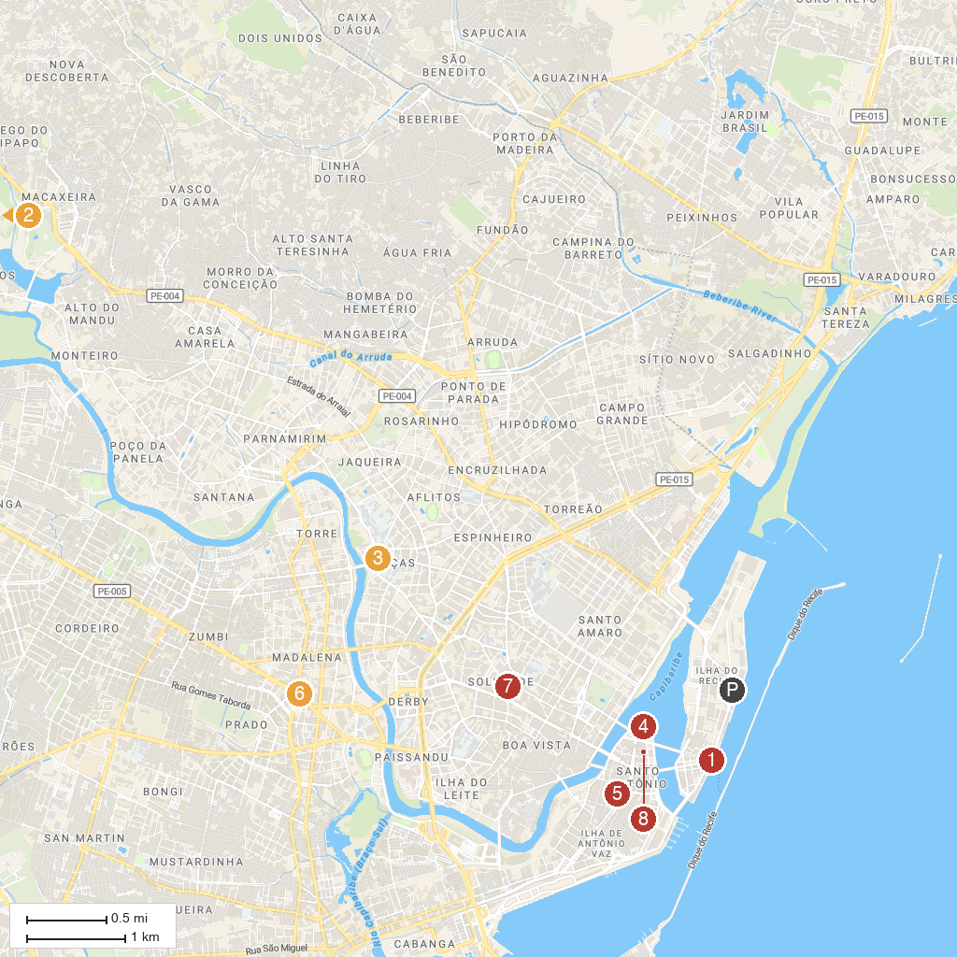
MAP KEY
1. Praça do Marco Zero | 5. Basilica of Our Lady of Mount Carmel
2. Parque Estadual Dois Irmãos | 6. Museum of Abolition
3. Pernambuco State Museum | 7. Paróquia Nossa Senhora da Soledade
4. Palácio do Campo das Princesas | 8. Capela Dourada
P. Cruise port / terminal
Map © MapTiler © OpenStreetMap contributors · cruiseports.org

