Red Wing, Minnesota, USA
Perched beneath dramatic limestone bluffs on the upper Mississippi, Red Wing punches well above its small-town weight — home to globally iconic boots, collectible stoneware pottery, and a beautifully preserved Victorian downtown all within easy walking distance of the riverfront dock.
⚓ Docked — Levee Park pier · 🕒 Typical call: 6-8 hrs · 💵 USD · 🗣️ English · 🌿 Scenic bluff country
✍️ MY DAY IN PORT (FILL IN)
Ship / Date
In port | arrive ______ · all aboard ______
Booked excursion
Notes / meeting point
GETTING ASHORE
- Docking: Docked at Levee Park, downtown riverfront
- Walk to center: 5-10 min across the railroad crossing to Main St
- Best For: Historic small towns, hiking, shopping, American heritage
- Don't Miss: Red Wing Shoe Museum & world's largest boot; Barn Bluff hike
GETTING AROUND
- 🚕 Taxi: Metered / call ahead — Several local taxi services operate in Red Wing including Red Wing Taxi (651-385-8294) and Tammie's Transportation (651-
- 📱 Rideshare: ✅ Uber, Lyft
TOP THINGS TO DO
- Red Wing Shoe Museum & World's Largest Boot — The flagship store on Main Street houses a free top-floor museum chronicling 120+ years of boot-making history, including the…
- Pottery Museum of Red Wing — Red Wing's famous stoneware and crockery built the town's economy — this museum holds an outstanding collection of historic…
- Barn Bluff (He Mni Can) Hike — The dramatic 343-foot limestone bluff overlooking downtown offers panoramic views of the Mississippi River valley and the city…
- St. James Hotel & Historic Downtown Walk — Opened in 1875, the St.
- Cannon Valley Trail — A scenic 19.7-mile paved rail-trail following the Cannon River through bluff country, connecting Red Wing, Welch, and Cannon Falls.
BEST WALKS
- Riverfront to Main Street Heritage Loop: 1.5 miles · ~40 min · Flat — From Levee Park, cross the railroad pedestrian gate and head up Levee Road to Main Street.
- Barn Bluff Summit Hike: 1.5 miles round-trip · ~1.5 hrs · Moderate-strenuous — From the trailhead at the east end of East Fifth Street, the south-face trail winds up 343 feet to…
WEATHER · DAYLIGHT · MONEY
Month | High °F | Low °F | Rainy days
May | 68 | 50 | 12
Jul | 81 | 65 | 10
Sep | 73 | 58 | 10
Daylight: May 5:42AM–8:31PM · Jul 5:39AM–8:51PM · Sep 6:49AM–7:19PM
cruiseports.org/red-wing-mn · Confirm terminal & all-aboard time with your ship

Red Wing, Minnesota, USA — Port Map
Red = walkable sights · Amber = excursions farther out · P = cruise terminal
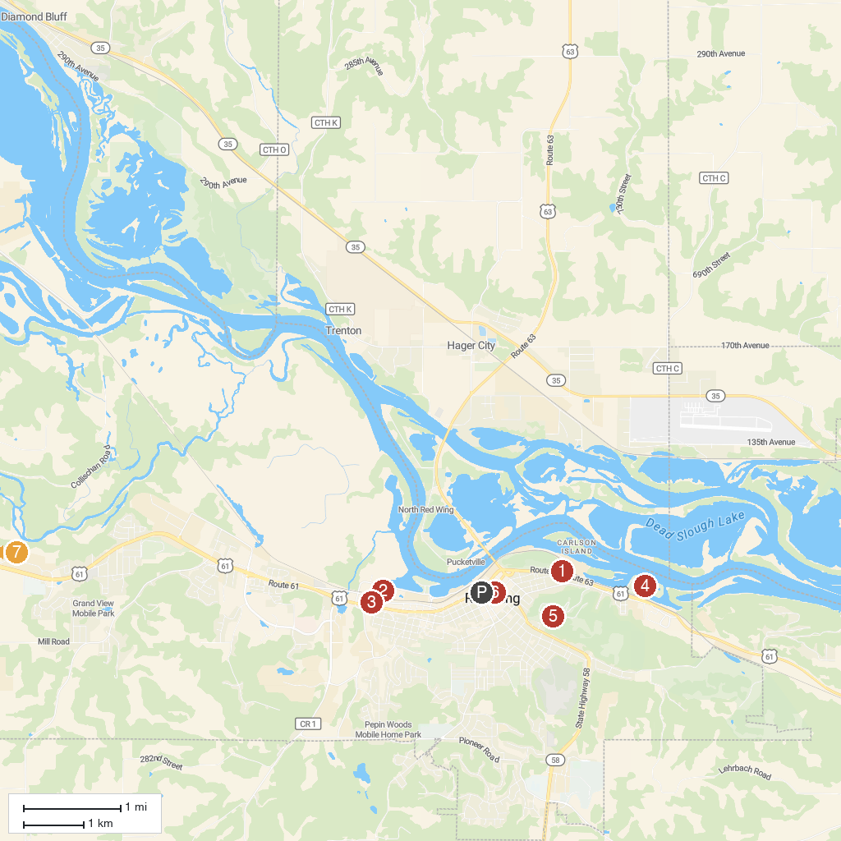
MAP KEY
1. He Mni Can/ Barn Bluff Trail Head | 5. Memorial Park
2. Pottery Pond Park | 6. Aliveo Military Museum
3. Pottery Museum of Red Wing | 7. Anderson Center Sculpture Garden at Tower View
4. Colvill Park
P. Cruise port / terminal
Map © MapTiler © OpenStreetMap contributors · cruiseports.org

