Reykjavik, Iceland
The world's northernmost capital — a colorful, walkable city on the edge of a land of geysers, waterfalls, and lava fields. Your base for Iceland's greatest hits.
⚓ Docked (Skarfabakki) or Old Harbour · 🕒 Typical call: 9–11 hrs · 💵 Icelandic Króna (ISK) · cards everywhere · 🗣️ Icelandic · English universal
✍️ MY DAY IN PORT (FILL IN)
Ship / Date
In port | arrive ______ · all aboard ______
Booked excursion
Notes / meeting point
GETTING ASHORE
- Docking: Skarfabakki / Old Harbour
- To center: Shuttle or 35-min walk
- Best For: Nature · Geology
- Don't Miss: Golden Circle
GETTING AROUND
- 🚕 Taxi: €15–20 — Taxis from Sundahöfn to the city center run about €15–20. Reykjavik taxis are metered and reliable but pricey — confirm
- 📱 Rideshare: ❌ not available
- 🚌 Hop-on hop-off: ✅ Hop-on hop-off
TOP THINGS TO DO
- Golden Circle — Iceland's classic trio: the erupting Strokkur geyser, the thundering Gullfoss waterfall, and Þingvellir National Park where the…
- Blue Lagoon Geothermal Spa — Soak in milky-blue, mineral-rich geothermal water amid a black-lava landscape near the airport.
- Whale Watching from the Old Harbour — Head into Faxaflói Bay to spot minke and humpback whales, white-beaked dolphins, and puffins (in season) — departing right from…
- South Coast Waterfalls & Black Sand — A longer run to the Seljalandsfoss and Skógafoss waterfalls and the dramatic Reynisfjara black-sand beach — Iceland's south coast…
BEST WALKS
- Old Harbour to Hallgrímskirkja: ~3 km · 1.5–2 hrs · easy — From the harbour past the mirror-clad Harpa concert hall and the Sun Voyager sculpture, up…
- Tjörnin pond & city hall loop: ~2 km · 1 hr · easy — A gentle loop around the central pond, past the City Hall, the Settlement-era streets, and…
- Laugavegur shopping street: ~1.5 km · 1 hr · easy — The main downtown street — design shops, wool, cafés, and street art running through the lively…
WEATHER · DAYLIGHT · MONEY
Month | High °F | Low °F | Rainy days
May | 48 | 39 | 18
Jul | 56 | 48 | 16
Sep | 51 | 43 | 18
Daylight: May 4:12AM–10:37PM · Sep 6:51AM–7:52PM
ESSENTIAL TRAVEL QUALIFICATIONS
Strætó adult single: 690 ISK adult single (checked 3 Oct 2026).
cruiseports.org/reykjavik · Confirm terminal & all-aboard time with your ship

Reykjavik, Iceland — Port Map
Red = walkable sights · Amber = excursions farther out · P = cruise terminal
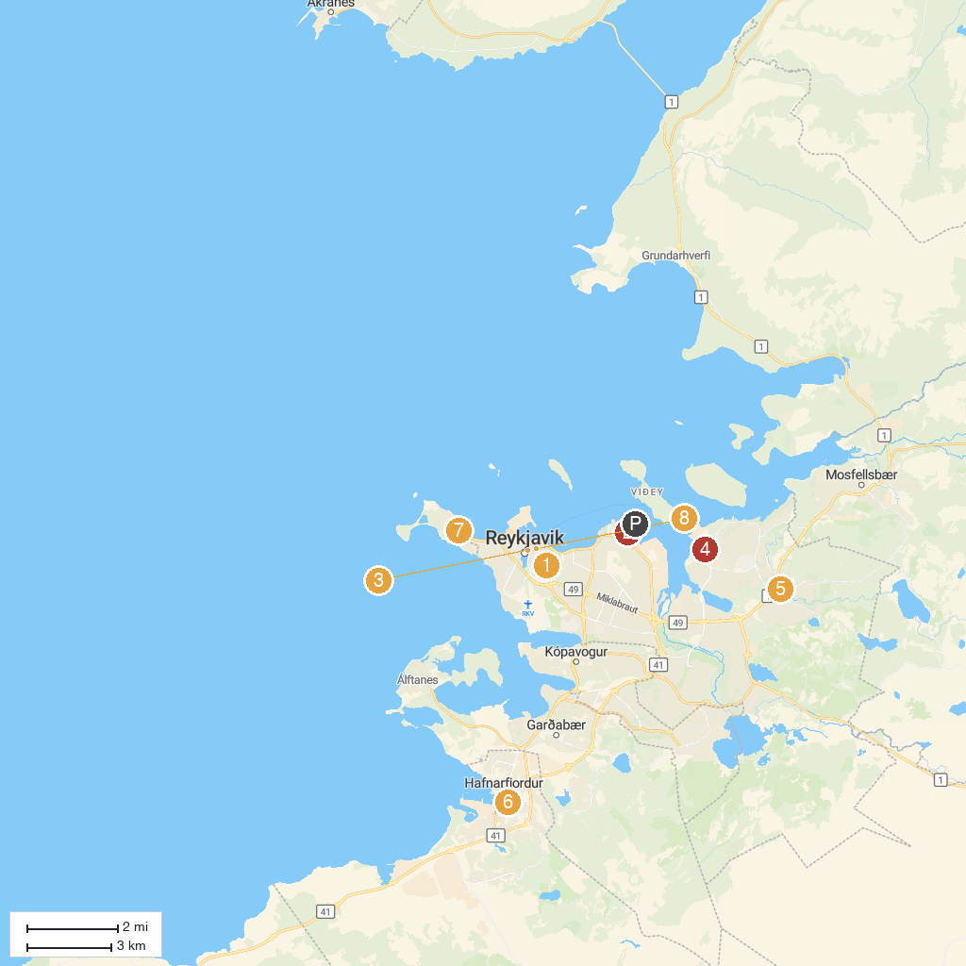
MAP KEY
1. Hallgrimskirkja | 5. Safari Quads ATV & Buggy Operator Iceland
2. Arctic Adventures | 6. Hafnarfjarðarkirkja
3. Alþingishúsið | 7. Church of Seltjarnarnes
4. Skemmtigarðurinn Grafarvogi | 8. City Center
P. Cruise port / terminal
Map © MapTiler © OpenStreetMap contributors · cruiseports.org

