Rhine Gorge, Rhineland-Palatinate, Germany
A 65-kilometre ribbon of medieval castles, terraced Riesling vineyards, and the legendary Loreley rock — the Rhine Gorge is UNESCO-protected scenery you watch unfold from your ship's sun deck, punctuated by stops in charming wine towns.
⚓ Docked (pontoon piers) · 🕒 Typical call: 6–8 hrs · 💶 Euro (€) · 🗣️ German · 🏰 UNESCO World Heritage Site
✍️ MY DAY IN PORT (FILL IN)
Ship / Date
In port | arrive ______ · all aboard ______
Booked excursion
Notes / meeting point
GETTING ASHORE
- Docking: All river cruise ships dock at riverside pontoon piers (Steiger) — no tendering anywhere along the Gorge
- Walk to centre: 2–5 min flat walk from pier to town centre in Rüdesheim, Boppard, and Koblenz
- Best For: Scenic cruising, castle spotting, wine tasting, medieval history, cable car rides
- Don't Miss: The Loreley Rock passage — crew typically plays the Lorelied song as you sail past
GETTING AROUND
- 🚕 Taxi: €20–€40 for short trips — Local taxis available in both Rüdesheim and Bingen. A typical short ride is around €34; bookable via Uber app or local c
- 📱 Rideshare: ✅ Uber
TOP THINGS TO DO
- Loreley Rock & Rhine Gorge Scenic Cruise — The star of any Rhine cruise — the 132m Loreley slate cliff at the river's narrowest point, flanked by Burg Katz and Burg Maus.
- Rüdesheim Cable Car & Niederwald Monument — Ride the Rüdesheim Seilbahn gondola over steep Riesling vineyards to the colossal Niederwald Monument, a 19th-century monument to…
- Drosselgasse Wine Lane, Rüdesheim — The most famous street in the Rheingau — 144 metres of half-timbered wine taverns, Riesling flights, live brass bands, and…
- Boppard Chairlift to Vierseenblick — The Boppard Sesselbahn chairlift rises over the vineyards to the Vierseenblick (Four-Lakes Viewpoint), where the Rhine's tight…
- Ehrenbreitstein Fortress & Koblenz Cable Car — Ride the modern gondola cable car over the Rhine from Deutsches Eck to Ehrenbreitstein Fortress — one of the largest preserved…
BEST WALKS
- Rüdesheim Town & Drosselgasse Loop: 1.5 km · 30–45 min · Flat · Free — From the pier, walk along the promenade to the Drosselgasse wine lane, then through the Marktplatz…
- Boppard Riverside Promenade: 2 km · 30–40 min · Flat · Free — Stroll south along the Boppard Rheinpromenade from the ship, past Roman fort remains (Kastell…
- Koblenz: Deutsches Eck to Old Town: 1.5 km · 25 min · Flat · Free — Walk from the cruise pier at the Deutsches Eck — where Rhine and Moselle meet under the giant…
WEATHER · DAYLIGHT · MONEY
Month | High °F | Low °F | Rainy days
May | 66 | 49 | 11
Jul | 78 | 60 | 10
Sep | 70 | 53 | 8
Daylight: May 5:42AM–9:07PM · Jul 5:36AM–9:31PM · Sep 7:04AM–7:41PM
cruiseports.org/rhine-gorge · Confirm terminal & all-aboard time with your ship

Rhine Gorge, Rhineland-Palatinate, Germany — Port Map
Red = walkable sights · Amber = excursions farther out · P = cruise terminal
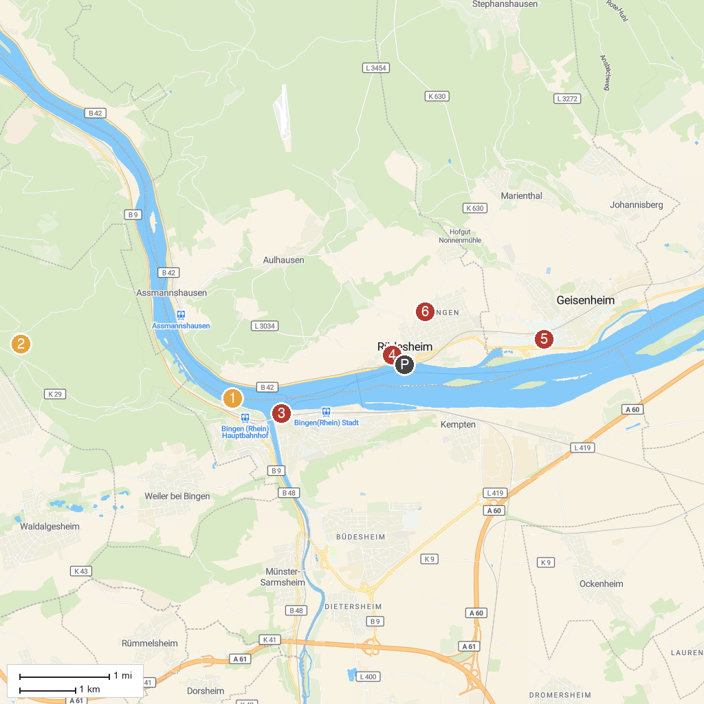
MAP KEY
1. Mouse Tower | 4. Rüdesheimer Besichtigungsfahrten GmbH (Winzerexpress)
2. Steckeschlääfer-Klamm | 5. Villa Monrepos
3. Museum am Strom | 6. Wallfahrtskirche St. Hildegard
P. Cruise port / terminal
Map © MapTiler © OpenStreetMap contributors · cruiseports.org

