Rhodes, Dodecanese, Greece
Europe's best-preserved medieval walled city is a 5-minute walk from where your ship ties up — then a hilltop acropolis village awaits 50 km down the coast.
⚓ Docked (Commercial Port) · 🕒 Typical call: 8–10 hrs · 💶 Euro (EUR) · 🗣️ Greek · English widely spoken
✍️ MY DAY IN PORT (FILL IN)
Ship / Date
In port | arrive ______ · all aboard ______
Booked excursion
Notes / meeting point
GETTING ASHORE
- Docking: Commercial Port — 5 min walk to Old Town gate
- Old Town: UNESCO World Heritage Site — free entry
- Best For: Medieval history · beaches · Lindos village
- Don't Miss: Street of the Knights & Palace of the Grand Masters
GETTING AROUND
- 🚕 Taxi: €10–15 to Old Town/center — Metered taxis are available at the port. Fares into town are short and inexpensive; a small port surcharge (~€1) may app
- 📱 Rideshare: ✅ Uber Taxi
- 🚌 Hop-on hop-off: ✅
TOP THINGS TO DO
- Medieval Old Town Self-Walk — The Old Town of Rhodes is a UNESCO World Heritage city of 200,000 sq m enclosed by 4 km of crusader walls.
- Lindos Acropolis & Village — The whitewashed clifftop village of Lindos, 50 km south, has an ancient acropolis with a Doric Temple of Athena and views over a…
- Valley of the Butterflies (Petaloudes) — From late June through August, thousands of Jersey tiger moths mass in this lush valley about 26 km southwest of Rhodes Town.
- Catamaran Cruise to Anthony Quinn Bay — Anthony Quinn Bay (Vagies Bay), named after the actor who fell in love with the island filming 'The Guns of Navarone,' is a…
- Archaeological Museum of Rhodes — Housed in the original Hospital of the Knights of St.
BEST WALKS
- Freedom Gate → Street of the Knights → Palace of Grand Masters: ~1.2 km · 30–45 min · easy — The spine of the medieval city.
- Old Town Loop — Jewish Quarter & Turkish Quarter: ~2 km · 1–1.5 hrs · easy — From Hippocrates Square (the commercial heart) head south to the Kahal Shalom Synagogue — the…
- Mandraki & the New Town waterfront: ~2 km · 45 min · easy — If you've had enough medieval cobblestones, the Mandraki waterfront has a pleasant promenade past…
WEATHER · DAYLIGHT · MONEY
Month | High °F | Low °F | Rainy days
May | 76 | 65 | 4
Jul | 90 | 77 | 0
Sep | 85 | 75 | 1
Daylight: May 6:00AM–8:06PM · Jul 6:01AM–8:24PM · Sep 6:49AM–7:14PM
cruiseports.org/rhodes · Confirm terminal & all-aboard time with your ship

Rhodes, Dodecanese, Greece — Port Map
Red = walkable sights · Amber = excursions farther out · P = cruise terminal
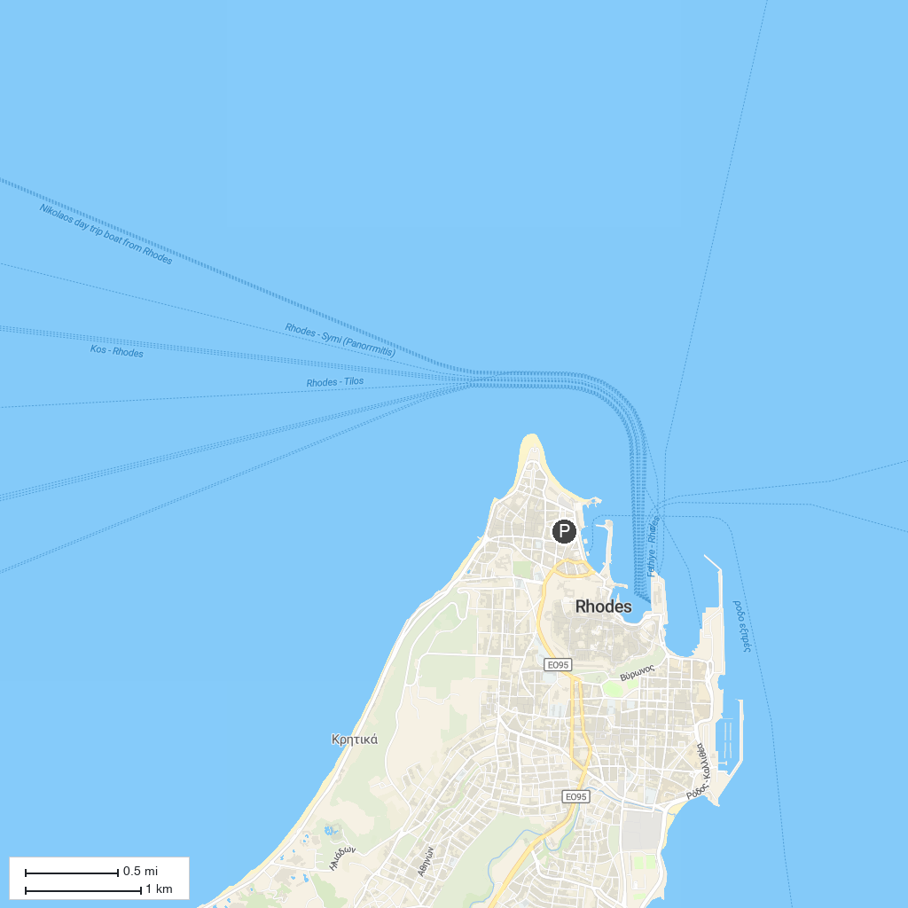
MAP KEY
1. Saint Nikolaos Fountoukli Holy Orthodox Church | 5. Temple Attaviros Zeus
2. Kritinia Castle | 6. Gadoura Dam
3. Watersport Center - Kiotari, Rhodes - watersports, watersports activities, waterski, jet bikes, sea cruise | 7. Xetrypiti Gorge
4. Thari Monastery | 8. Panorama Viewpoint
P. Cruise port / terminal
Map © MapTiler © OpenStreetMap contributors · cruiseports.org

