Rijeka, Kvarner, Croatia
Croatia's third-largest city trades glitz for authenticity — Habsburg architecture, a vibrant fish market, and a hilltop fortress with jaw-dropping Kvarner Gulf views, all a short walk from your ship.
⚓ Docked (Breakwater Terminal) · 🕒 Typical call: 6-9 hrs · 💶 Euro (€) · 🗣️ Croatian (English widely spoken) · 🎭 European Capital of Culture 2020
✍️ MY DAY IN PORT (FILL IN)
Ship / Date
In port | arrive ______ · all aboard ______
Booked excursion
Notes / meeting point
GETTING ASHORE
- Docking: Pier — Molo Longo Breakwater Terminal, central waterfront
- Walk to center: 5–10 min flat walk to Korzo promenade
- Best For: History, culture, authentic city life, day trips to Opatija
- Don't Miss: Trsat Castle views and the Central Market fish pavilions
GETTING AROUND
- 🚕 Taxi: €6–10 — Taxis are available at the port. Short city-center runs typically cost €6–10; confirm the fare before departing. Night f
- 📱 Rideshare: ✅ Uber, Bolt
- 🚌 Hop-on hop-off: ✅
TOP THINGS TO DO
- Trsat Castle & 561-Step Stairway — Climb the historic Petar Kružić stairway (or take bus #2) to Rijeka's 13th-century hilltop fortress.
- Korzo Promenade & Central Market — Stroll Rijeka's car-free main street lined with 19th-century buildings, then duck into the Art Nouveau market halls for fresh…
- Governor's Palace & Maritime Museum — A magnificent Neo-Renaissance palace built in the 1890s housing maritime history, ship models, and period rooms.
- Opatija Riviera Day Trip — Jump on bus #32 from Jelačić Square (30 min) to Opatija, a Belle Époque resort town of Habsburg-era villas, botanical gardens…
- Island of Krk Half-Day — Connected to the mainland by bridge, Krk offers medieval old towns (Krk Town and Baška), beautiful pebble beaches, and local…
BEST WALKS
- Waterfront to Old Town Loop: 1.5 km · ~30 min · Easy · Flat — From the pier, walk the Molo Longo breakwater for harbor views, then head into the city to the…
- Trsat Hill Stairway Climb: 2 km · ~45–60 min · Moderate · Uphill — From the old town, find the base of the Petar Kružić Stairway near the Rječina river canyon and…
WEATHER · DAYLIGHT · MONEY
Month | High °F | Low °F | Rainy days
May | 69 | 56 | 14
Jul | 83 | 69 | 10
Sep | 74 | 61 | 12
Daylight: May 5:32AM–8:25PM · Jul 5:29AM–8:46PM · Sep 6:41AM–7:12PM
cruiseports.org/rijeka · Confirm terminal & all-aboard time with your ship

Rijeka, Kvarner, Croatia — Port Map
Red = walkable sights · Amber = excursions farther out · P = cruise terminal
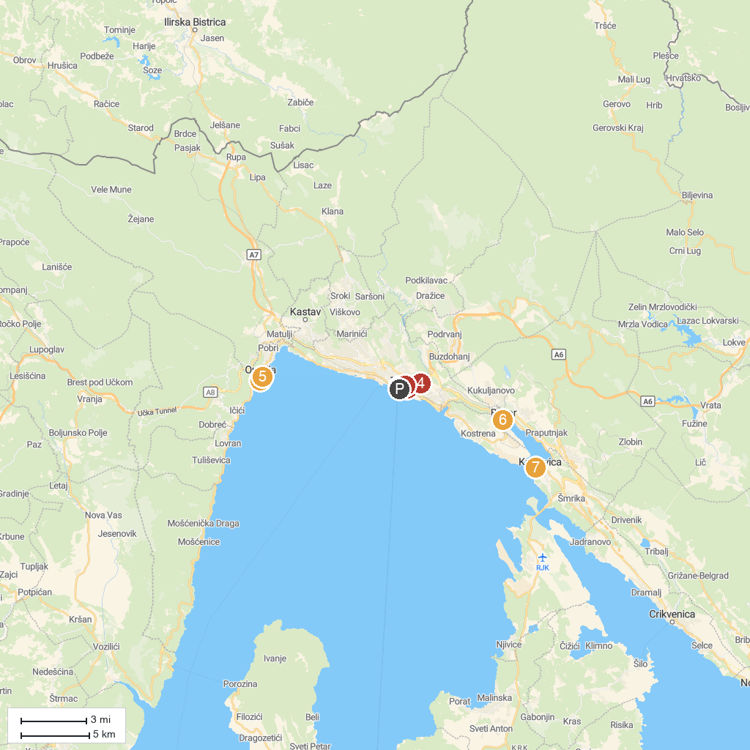
MAP KEY
1. Maiden with the Seagull | 5. Croatian Museum of Tourism
2. Saint Vitus’ Cathedral | 6. Turkish House
3. Church of Our Lady of Lourdes | 7. Castle Fran Krsto Frankopan
4. Shrine of Mary of God of Trsat | 8. Maritime and History Museum of the Croatian Coast
P. Cruise port / terminal
Map © MapTiler © OpenStreetMap contributors · cruiseports.org

