Rio de Janeiro, Brazil
Beaches, mountains and a city all at once — your ship docks at Pier Mauá in the revitalized port district, a short ride from Christ the Redeemer and Sugarloaf.
⚓ Docks at Pier Mauá · 🕒 Often homeport / overnight · 🇧🇷 Brazilian Real (BRL) · 🗣️ Portuguese · some English
✍️ MY DAY IN PORT (FILL IN)
Ship / Date
In port | arrive ______ · all aboard ______
Booked excursion
Notes / meeting point
GETTING ASHORE
- Docking: Pier Mauá (Praça Mauá)
- To Christ: ~25 min drive
- Best For: Icons · Beaches · Views
- Heads Up: Mind valuables
GETTING AROUND
- 🚕 Taxi: R$50–90 (~$10–18 USD) — Official yellow taxis queue outside Pier Mauá. Metered fare to Copacabana or Ipanema takes 20–40 min depending on traffi
- 📱 Rideshare: ✅ Uber, 99
- 🚌 Hop-on hop-off: ✅ Rio Samba Bus
TOP THINGS TO DO
- Christ the Redeemer (Corcovado) — The 125-ft Art Deco statue atop Corcovado, reached by cog train or van through Tijuca rainforest.
- Sugarloaf Mountain Cable Car — Two-stage cable car up Pão de Açúcar for the classic bay-and-beaches panorama.
- Selarón Steps & Santa Teresa — The mosaic-tiled Escadaria Selarón plus the bohemian hilltop neighborhood of Santa Teresa — colorful, artsy, and very photogenic.
- Copacabana & Ipanema Beaches — Stroll the world-famous mosaic promenades, grab an água de coco, and watch beach life.
BEST WALKS
- Orla Conde (Olympic Boulevard) & Museum of Tomorrow: ~2 km · 1–1.5 hrs · easy — From Pier Mauá, follow the waterfront promenade past the giant Kobra 'Etnias' mural to the…
- Historic Centro highlights: ~2.5 km · 2 hrs · easy — Self-guided loop through the old center — Confeitaria Colombo, Praça XV, and the Imperial Palace.
- Copacabana promenade: ~3 km one-way · 1 hr · easy — The iconic black-and-white wave mosaic along Copacabana beach.
WEATHER · DAYLIGHT · MONEY
Month | High °F | Low °F | Rainy days
May | 78 | 67 | 10
Jul | 77 | 64 | 7
Sep | 80 | 67 | 9
Daylight: May 6:18AM–5:19PM · Jul 6:33AM–5:24PM · Sep 5:49AM–5:46PM
cruiseports.org/rio · Confirm terminal & all-aboard time with your ship

Rio de Janeiro, Brazil — Port Map
Red = walkable sights · Amber = excursions farther out · P = cruise terminal
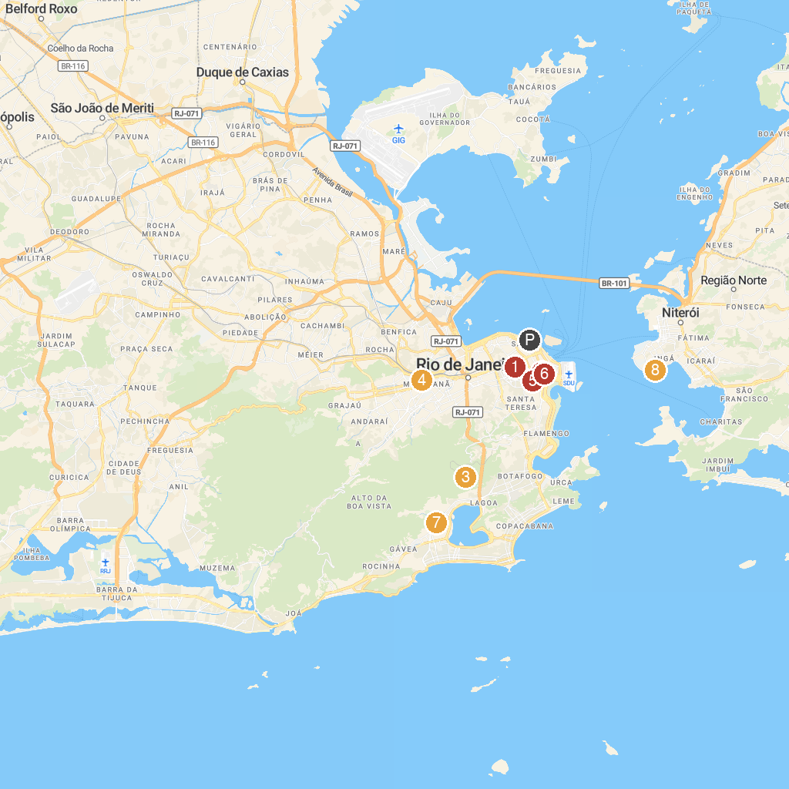
MAP KEY
1. Praça da República - Campo de Santana | 5. Fundição Progresso
2. Theatro Municipal do Rio de Janeiro | 6. Fundação Biblioteca Nacional
3. Christ the Redeemer | 7. Botanical Garden of Rio de Janeiro
4. Maracanã | 8. Museu de Arte Contemporânea de Niterói
P. Cruise port / terminal
Map © MapTiler © OpenStreetMap contributors · cruiseports.org

