Roatan, Bay Islands, Honduras
The largest of Honduras's Bay Islands, Roatan delivers Caribbean reef diving, jungle zip lines, and powdery white-sand beaches — all served by two well-equipped cruise piers minutes from the island's best spots.
⚓ Docked (two cruise piers) · 🕒 Typical call: 8-10 hrs · 💵 USD & Honduran Lempira · 🗣️ English & Spanish · 🤿 World-class reef snorkeling
✍️ MY DAY IN PORT (FILL IN)
Ship / Date
In port | arrive ______ · all aboard ______
Booked excursion
Notes / meeting point
GETTING ASHORE
- Docking: Two main piers: Isla Tropicale Cruise Center (formerly Mahogany Bay, rebranded April 2025) for Carnival/Princess/HAL; Port of Roatan at Coxen Hole for Royal Caribbean, NCL, MSC, Celebrity. Both docked — no tendering.
- Walk to Center: Isla Tropicale is a self-contained beach complex — no walking to town. Coxen Hole pier is adjacent to the capital; taxis queue just outside for West Bay (~20 min) and West End (~15 min).
- Best For: Reef snorkeling & diving, jungle zip lines, West Bay Beach, wildlife encounters, Garifuna culture
- Don't Miss: West Bay Beach, Mesoamerican Barrier Reef snorkel, Gumbalimba Park, canopy zip line, water taxi between West End and West Bay
GETTING AROUND
- 🚕 Taxi: $25–$30 per taxi — Private taxis depart from both Mahogany Bay and Coxen Hole (Port of Roatan). Fares are per taxi (not per person) to West
- 📱 Rideshare: check availability
- 🚌 Hop-on hop-off: ✅ Hop-on hop-off
TOP THINGS TO DO
- Mesoamerican Barrier Reef Snorkel — The Mesoamerican Barrier Reef — the world's second largest — runs along Roatan's north shore.
- Jungle Canopy Zip Line — Operators including South Shore Canopy and Roatan Zipline Adventures run zip-line courses high above the jungle with ocean views.
- Gumbalimba Park — A well-established wildlife and nature park in the West Bay area where you can meet trained macaws, interact with capuchin…
- West Bay Beach — Consistently rated among the Caribbean's best beaches, West Bay has a long stretch of white sand, calm turquoise water, and a…
- Garifuna Village and Culture Tour — The Garifuna people have deep roots along Central America's Caribbean coast.
BEST WALKS
- Coxen Hole Town Walk: ~1 km · Easy · 20-30 min — From Coxen Hole pier, walk into the island capital — a working Honduran port town with colorful…
- West End Village Stroll: ~1.5 km · Easy · 30-40 min — West End is Roatan's laid-back dive hub — a low-key strip of dive shops, beach bars, open-air…
WEATHER · DAYLIGHT · MONEY
Month | High °F | Low °F | Rainy days
May | 83 | 80 | 7
Jul | 83 | 80 | 15
Sep | 84 | 81 | 18
Daylight: May 5:15AM–6:09PM · Jul 5:22AM–6:22PM · Sep 5:34AM–5:47PM
ESSENTIAL TRAVEL QUALIFICATIONS
Ride-share availability and cruise-port pickup coverage unconfirmed; check the app at your location and confirm pickup, or arrange a licensed taxi/confirmed transfer.
cruiseports.org/roatan · Confirm terminal & all-aboard time with your ship

Roatan, Bay Islands, Honduras — Port Map
Red = walkable sights · Amber = excursions farther out · P = cruise terminal
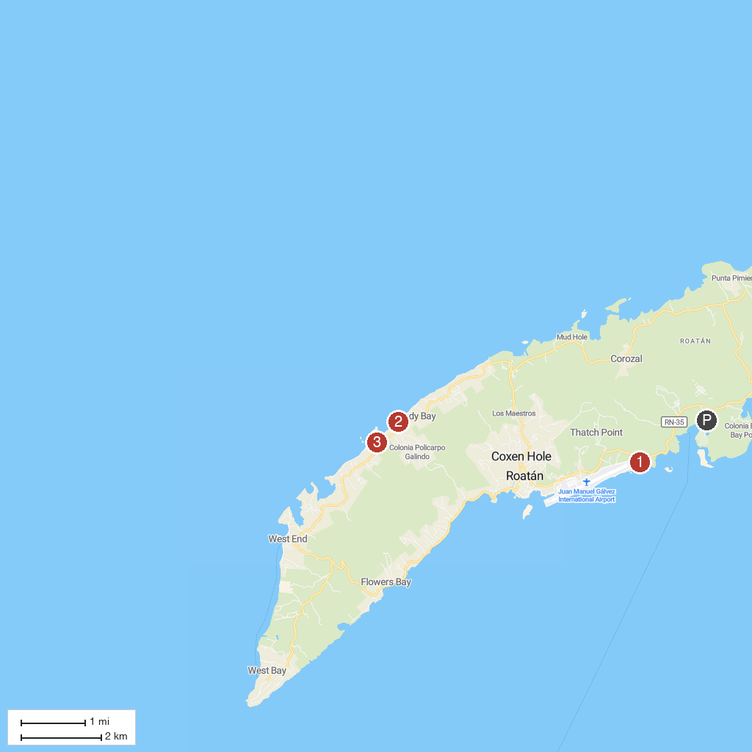
MAP KEY
1. West Bay Beach | 4. Sandy Bay Beach
2. Gumbalimba Park | 5. Roatán Institute for Marine Sciences
3. Arch's Iguana & Marine Park
P. Cruise port / terminal
Map © MapTiler © OpenStreetMap contributors · cruiseports.org

