Robinson Crusoe Island, Juan Fernández, Chile
One of the world's most remote cruise calls — the real island that stranded Alexander Selkirk and inspired Defoe's Crusoe. Tiny village, extraordinary endemic wildlife, and a national park that rewards those who make the tender ride ashore.
⚓ Tender (anchor offshore) · 🕒 Typical call: 5–7 hrs · 💵 Chilean Peso (CLP) · 🗣️ Spanish
✍️ MY DAY IN PORT (FILL IN)
Ship / Date
In port | arrive ______ · all aboard ______
Booked excursion
Notes / meeting point
GETTING ASHORE
- Docking: Tender (anchor offshore)
- Walk to center: ~10 min from tender dock to San Juan Bautista
- Best For: Wildlife · Hiking · History
- Don't Miss: Mirador de Selkirk (Selkirk's Lookout)
GETTING AROUND
TOP THINGS TO DO
- Mirador de Selkirk (Selkirk's Lookout) — The ridge above San Juan Bautista where Alexander Selkirk — the real castaway who inspired Robinson Crusoe — kept watch for…
- Juan Fernández Fur Seal Colony — Nearly hunted to extinction, the Juan Fernández fur seal has rebounded and hauls out near the village and along the coast.
- Archipiélago Juan Fernández National Park — A UNESCO Biosphere Reserve covering most of the island.
- Alexander Selkirk & Village History — San Juan Bautista holds a small museum covering Selkirk's marooning (1704–1709), the island's colonial history, and the WWI…
- Diving the SMS Dresden Wreck — The German WWI cruiser SMS Dresden was scuttled in Cumberland Bay in March 1915 after being cornered by British warships.
BEST WALKS
- San Juan Bautista village & waterfront: ~1.5 km · 45 min · easy — A short loop through the island's only settlement: the main plaza, the small local museum, the…
- Trail to Mirador de Selkirk: ~8 km round trip · 3–4 hrs · strenuous — The main trail climbs steeply from the village to the ridge where Selkirk watched for rescue ships.
WEATHER · DAYLIGHT · MONEY
Month | High °F | Low °F | Rainy days
May | 60 | 58 | 8
Jul | 55 | 53 | 8
Sep | 54 | 51 | 5
Daylight: May 8:00AM–6:22PM · Jul 8:17AM–6:25PM · Sep 8:14AM–8:07PM
cruiseports.org/robinson-crusoe · Confirm terminal & all-aboard time with your ship

Robinson Crusoe Island, Juan Fernández, Chile — Port Map
Red = walkable sights · Amber = excursions farther out · P = cruise terminal
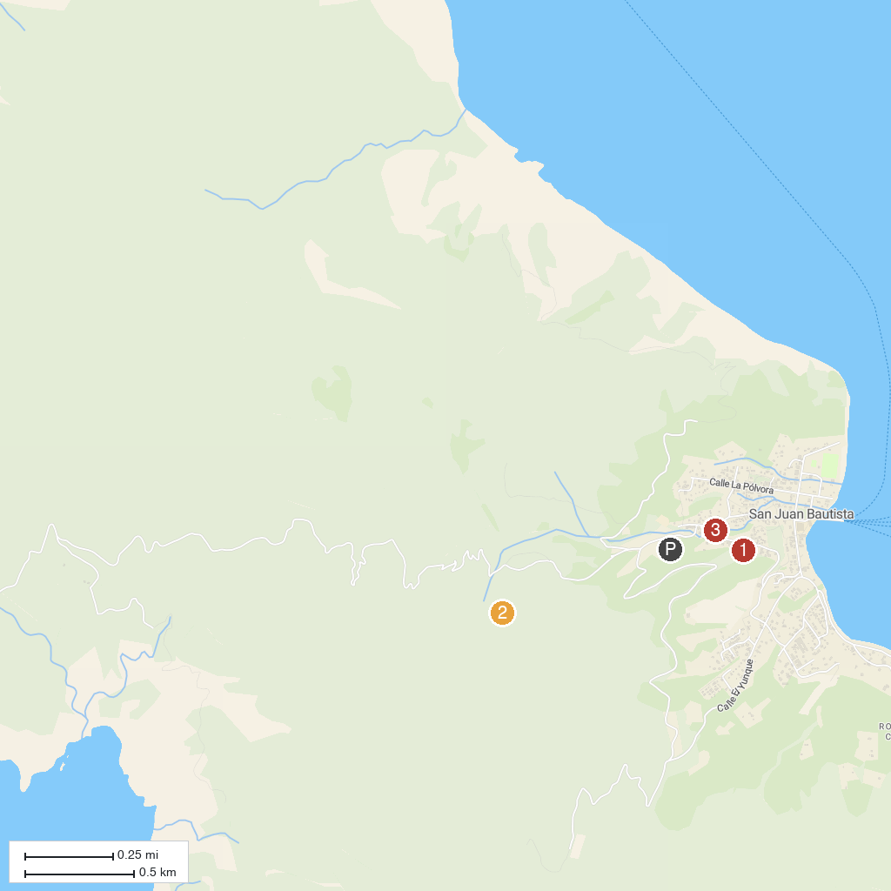
MAP KEY
1. Fuerte Santa Bárbara | 3. Museo Histórico Alfredo Dat
2. Mirador de Selkirk
P. Cruise port / terminal
Map © MapTiler © OpenStreetMap contributors · cruiseports.org

