Rockland, Maine, USA
The self-proclaimed Lobster Capital of the World pairs a gritty, working waterfront with world-class art and one of Maine's most spectacular lighthouse walks.
⚓ Tender (most ships) / Dock (small vessels) · 🕒 Typical call: 6-8 hrs · 💵 US Dollar (USD) · 🗣️ English
✍️ MY DAY IN PORT (FILL IN)
Ship / Date
In port | arrive ______ · all aboard ______
Booked excursion
Notes / meeting point
GETTING ASHORE
- Docking: Tender to Public Landing (most ships); small vessels (<215 ft) may dock directly
- Walk to center: 2 min from tender dock to Main Street
- Best For: Lobster, art museums, lighthouse walk, Maine windjammers
- Don't Miss: Farnsworth Art Museum (Wyeth collection) & the Rockland Breakwater
GETTING AROUND
- 🚕 Taxi: Meter / negotiated — Several local taxis operate in Rockland including Schooner Bay Taxi, Flagship Taxi, and Joe's Taxi. Good for trips to Ca
- 📱 Rideshare: ✅ Uber, Lyft
TOP THINGS TO DO
- Rockland Breakwater Lighthouse Walk — Stroll nearly 7/8 mile (about 0.9 miles) along a granite jetty built from roughly 700,000 tons of local stone to a classic 1902…
- Farnsworth Art Museum — World-class museum celebrating Maine's role in American art.
- Maine Lighthouse Museum — Located right at the waterfront, this museum holds the largest collection of historic Fresnel lighthouse lenses and maritime…
- Lobster & Local Food Tour — Rockland is the self-proclaimed Lobster Capital of the World.
- Windjammer Day Sail — Rockland is home port of Maine's historic windjammer fleet.
BEST WALKS
- Main Street Art & Lobster Loop: 1-1.5 hrs • 1.5 miles • Easy — From the Public Landing, head north on Main Street past historic brick storefronts, indie…
- Breakwater Lighthouse Walk: 2-3 hrs • ~1.75 miles round-trip on jetty • Moderate — Taxi to the trailhead at Marie Reed Memorial Park (the dock-to-trailhead road walk is not…
WEATHER · DAYLIGHT · MONEY
Month | High °F | Low °F | Rainy days
May | 60 | 46 | 10
Jul | 76 | 63 | 11
Sep | 69 | 57 | 9
Daylight: May 5:10AM–7:56PM · Jul 5:07AM–8:16PM · Sep 6:16AM–6:46PM
cruiseports.org/rockland-me · Confirm terminal & all-aboard time with your ship

Rockland, Maine, USA — Port Map
Red = walkable sights · Amber = excursions farther out · P = cruise terminal
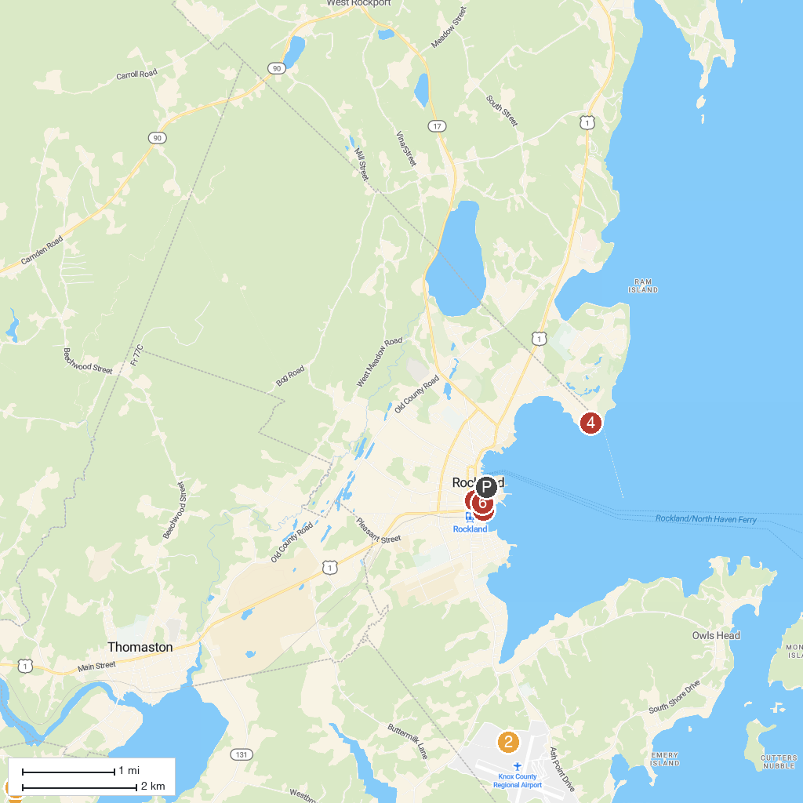
MAP KEY
1. Farnsworth Art Museum | 5. Rockland Breakwater Lighthouse Parking
2. Owls Head Transportation Museum | 6. Camden Hills State Park
3. The Camden Snow Bowl | 7. Langlais Art Preserve
4. Maine Lighthouse Museum | 8. Center for Maine Contemporary Art
P. Cruise port / terminal
Map © MapTiler © OpenStreetMap contributors · cruiseports.org

