Roermond, Limburg, Netherlands
Where two rivers meet and centuries of history share cobblestones with Europe's biggest designer outlet — Roermond punches well above its size for a river cruise stop.
⚓ River pier (no tender) · 🕒 Typical call: 6-8 hrs · 💶 Currency: Euro (€) · 🗣️ Dutch / English widely spoken · 🛍️ Designer outlet on foot
✍️ MY DAY IN PORT (FILL IN)
Ship / Date
In port | arrive ______ · all aboard ______
Booked excursion
Notes / meeting point
GETTING ASHORE
- Docking: Roermond Marina cruise quay — walk straight ashore
- Walk to center: 10-15 min to Markt; 10-15 min to Designer Outlet
- Best For: Architecture, shopping, Limburgish food, easy walking
- Don't Miss: Munsterkerk, Cuypershuis, a slice of Limburgse vlaai
GETTING AROUND
- 🚕 Taxi: €8–€12 — Local taxis serve the marina area with short rides into the city center. Starting fare is around €3.10–€3.26 plus per-km
- 📱 Rideshare: ✅ Uber
TOP THINGS TO DO
- Munsterkerk & Cathedral Walk — See two exceptional churches side-by-side: the 13th-century Romanesque Munsterkerk (its trefoil/cloverleaf east end is the only…
- Cuypershuis Museum — Pierre Cuypers designed Amsterdam's Rijksmuseum and Central Station — and he was from Roermond.
- Designer Outlet Shopping — One of Europe's largest designer outlet malls, designed to look like a historic village, with 200+ brands (Prada, Gucci, Armani)…
- Maasplassen Lakes Cruise — Roermond sits beside the Maasplassen, the largest contiguous water-sports area in the Netherlands.
- Limburgish Food & Beer Trail — Sample zoervleis (sweet-sour beef stew), white asparagus in season (Apr-Jun), and Limburgse vlaai fruit pie at cafés on the…
BEST WALKS
- Old Town Loop: 2.5 km · 45-60 min · Easy — From the quay, walk to the Roerkade café strip, past the Rattentoren (medieval tower), through the…
- Quay to Outlet Walk: 1 km · 15 min · Easy — A straight walk from the river quay through the old center and pedestrian underpass to the Designer…
WEATHER · DAYLIGHT · MONEY
Month | High °F | Low °F | Rainy days
May | 66 | 49 | 11
Jul | 75 | 59 | 12
Sep | 69 | 54 | 10
Daylight: May 5:45AM–9:20PM · Jul 5:38AM–9:44PM · Sep 7:11AM–7:49PM
cruiseports.org/roermond · Confirm terminal & all-aboard time with your ship

Roermond, Limburg, Netherlands — Port Map
Red = walkable sights · Amber = excursions farther out · P = cruise terminal
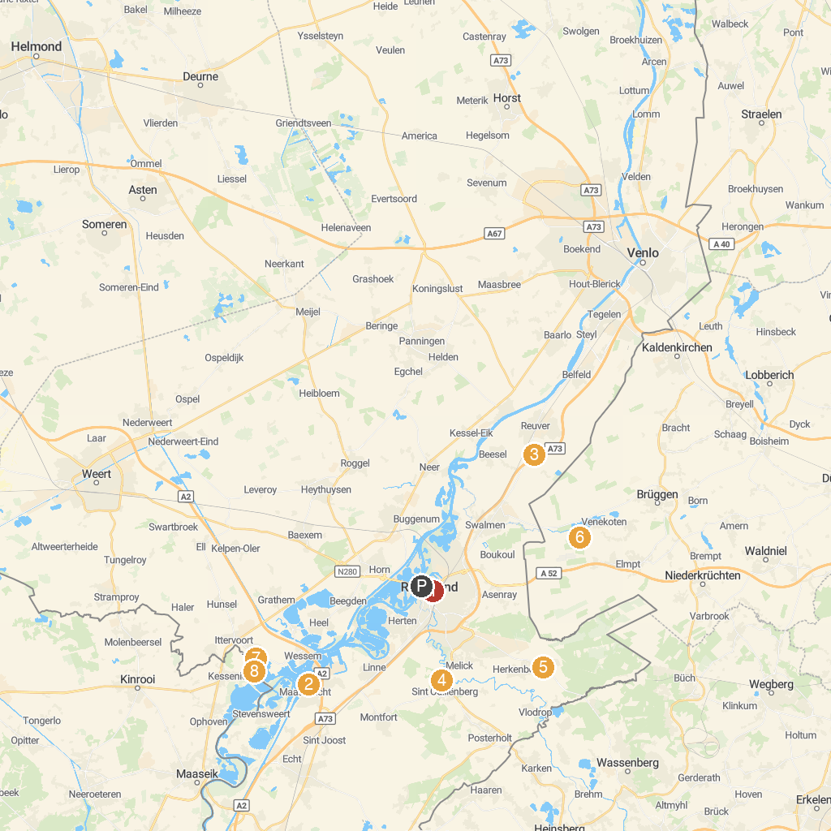
MAP KEY
1. Stadspark de Kartuis | 5. Nationaal Park de Meinweg
2. Maas Binnenvaartmuseum | 6. Aussichtsturm Elmpter Schwalmbruch
3. BillyBird Drakenrijk | Binnenspeeltuin - Buitenspeeltuin - Strandbad | 7. Abdijkerk Thorn
4. Roerstreekmuseum | 8. MRT Beach
P. Cruise port / terminal
Map © MapTiler © OpenStreetMap contributors · cruiseports.org

