Rome, Lazio, Italy
Two thousand years of empire, faith, and appetite packed into a single city. Rome rewards the ambitious shore-day visitor who moves fast and eats well.
⚓ Pier — Civitavecchia cruise terminal · 🕒 Typical call: 8–12 hrs · 💶 Currency: Euro (€) · 🗣️ Language: Italian · 🏛️ UNESCO World Heritage city
✍️ MY DAY IN PORT (FILL IN)
Ship / Date
In port | arrive ______ · all aboard ______
Booked excursion
Notes / meeting point
GETTING ASHORE
- Docking: Civitavecchia cruise pier, ~80 km (50 mi) northwest of Rome center
- Walk to center: Not walkable — train or bus required (1–1.5 hrs each way)
- Best For: Ancient history, Vatican & Sistine Chapel, food, iconic sightseeing
- Don't Miss: Colosseum, Roman Forum, Vatican Museums, Pantheon, Trastevere lunch
GETTING AROUND
- 🚕 Taxi: €125–€180 — Metered taxis from Civitavecchia port to central Rome. Confirm price before departing; the ~80 km trip takes 60–90 minut
- 📱 Rideshare: ✅ Uber (premium / itTaxi integration)
- 🚌 Hop-on hop-off: ✅ Hop-on hop-off
TOP THINGS TO DO
- Colosseum, Roman Forum & Palatine Hill — The core of ancient Rome — the Colosseum's 50,000-seat arena, the ruined heart of the Forum, and the hilltop gardens of Palatine.
- Vatican Museums & Sistine Chapel — One of the world's great museum complexes ends in Michelangelo's Sistine Chapel ceiling — stunning even with the crowds.
- Trastevere & Campo de' Fiori Walk — Rome's most atmospheric neighbourhood — cobblestone lanes, medieval churches, ivy-covered façades, and genuinely good trattorias.
- Roman Food & Market Tour — Explore Testaccio market — Rome's most authentic neighbourhood market — followed by cacio e pepe, supplì (fried rice balls), and…
- Borghese Gallery & Villa Borghese Gardens — Rome's finest baroque sculpture collection — Bernini's Apollo and Daphne, Canova's Pauline Bonaparte — in a sun-dappled villa…
BEST WALKS
- Ancient Rome: Colosseum to Capitoline Hill: 2–3 hrs · Moderate · Mostly flat with some steps — Start at the Colosseum, walk through the Roman Forum entrance, climb Palatine Hill for panoramic…
- The Centro Storico Loop: Pantheon to Campo de' Fiori: 1.5–2 hrs · Easy · Flat cobblestones — Rome's medieval heart — start at the Pantheon (still free to admire the exterior; small interior…
WEATHER · DAYLIGHT · MONEY
Month | High °F | Low °F | Rainy days
May | 74 | 55 | 12
Jul | 90 | 69 | 5
Sep | 81 | 63 | 9
Daylight: May 5:49AM–8:23PM · Jul 5:48AM–8:43PM · Sep 6:50AM–7:19PM
ESSENTIAL TRAVEL QUALIFICATIONS
Free port shuttle: docks–Largo della Pace, not the station. Direct station shuttle €6 each way on ship days; rail fare/time varies. Allow separate station transfer and return buffer (checked 3 October 2026).
cruiseports.org/rome-city · Confirm terminal & all-aboard time with your ship

Rome, Lazio, Italy — Port Map
Red = walkable sights · Amber = excursions farther out · P = cruise terminal
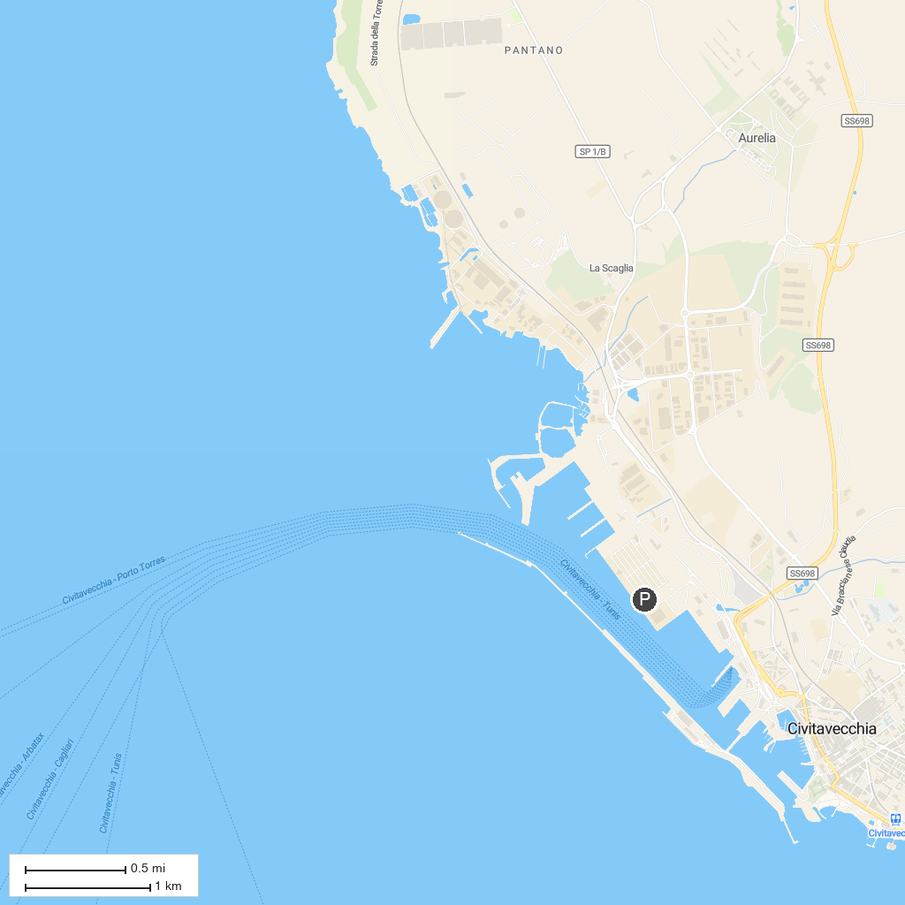
MAP KEY
1. Colosseo | 5. Pantheon
2. Fontana di Trevi | 6. Piazza Navona
3. Musei Vaticani | 7. Foro Romano
4. Basilica di San Pietro | 8. Piazza di Spagna
P. Cruise port / terminal
Map © MapTiler © OpenStreetMap contributors · cruiseports.org

