Rotterdam, Netherlands
Holland's boldest city — a skyline of daring modern architecture rebuilt from the ground up, with the windmills of Kinderdijk and the canals of Amsterdam within easy reach.
⚓ Docked (city-center terminal) · 🕒 Often embark/disembark · 💶 Euro (EUR) · 🗣️ Dutch · English universal
✍️ MY DAY IN PORT (FILL IN)
Ship / Date
In port | arrive ______ · all aboard ______
Booked excursion
Notes / meeting point
GETTING ASHORE
- Docking: Wilhelminakade terminal
- Walk to center: 15 min / metro
- Best For: Architecture · Day trips
- Don't Miss: Markthal & Cube Houses
GETTING AROUND
- 🚕 Taxi: €10–€21 — Metered taxis are readily available at the cruise terminal. Ride to city center takes 6–15 minutes depending on traffic.
- 📱 Rideshare: ✅ Uber, Bolt
- 🚌 Hop-on hop-off: ✅ City Sightseeing Rotterdam
TOP THINGS TO DO
- Kinderdijk Windmills — A UNESCO World Heritage site of 19 historic windmills along the polder canals — the postcard image of Holland, about 30 min from…
- Amsterdam Day Trip — The canals, gabled houses, and museums of the Dutch capital, an easy ~40-minute train ride away.
- Delft & The Hague — Vermeer's blue-and-white pottery town of Delft paired with The Hague's royal palaces and seat of government — classic Dutch charm…
- Rotterdam Architecture & Markthal — A self-paced or guided dive into the city's icons: the Cube Houses, the soaring Markthal food market, the Erasmus Bridge, and a…
BEST WALKS
- Erasmus Bridge to Markthal: ~3 km · 1.5 hrs · easy — Cross the swan-like Erasmus Bridge from the terminal into the center, past the Cube Houses and Old…
- Kop van Zuid & Hotel New York: ~2 km · 1 hr · easy — The waterfront district right by the terminal, anchored by the former Holland America Line…
- Oude Haven (Old Harbour): ~1.5 km · 1 hr · easy — The historic harbour basin with the leaning Cube Houses above and cafés along the water — a relaxed…
WEATHER · DAYLIGHT · MONEY
Month | High °F | Low °F | Rainy days
May | 63 | 48 | 12
Jul | 72 | 58 | 14
Sep | 67 | 54 | 10
Daylight: May 5:48AM–9:29PM · Jul 5:41AM–9:54PM · Sep 7:17AM–7:56PM
cruiseports.org/rotterdam · Confirm terminal & all-aboard time with your ship

Rotterdam, Netherlands — Port Map
Red = walkable sights · Amber = excursions farther out · P = cruise terminal
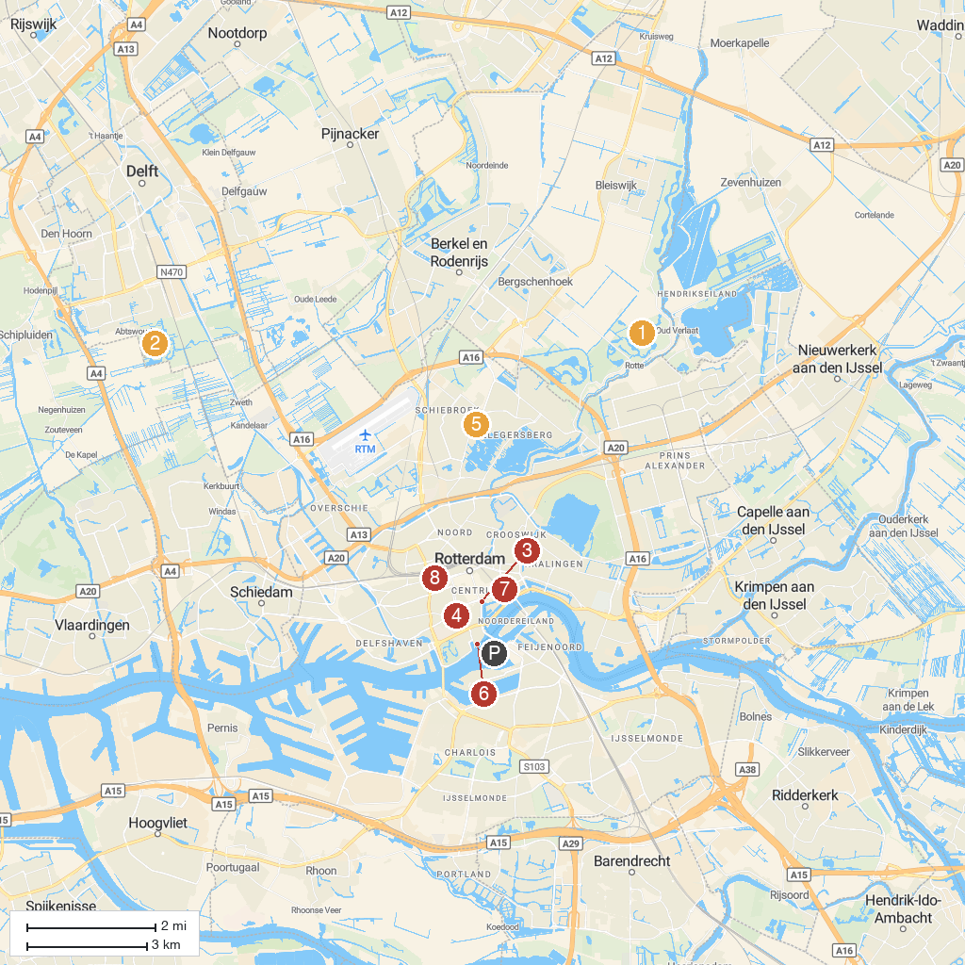
MAP KEY
1. Hoge Bergse Bos | 5. Plaswijckpark
2. Abtswoudse Bos | 6. Wereldmuseum Rotterdam
3. Maritime Museum | 7. Kijk-Kubus Museum-house
4. Museum Boijmans Van Beuningen | 8. Miniworld Rotterdam
P. Cruise port / terminal
Map © MapTiler © OpenStreetMap contributors · cruiseports.org

