Roudnice nad Labem, Central Bohemia, Czech Republic
Where Baroque grandeur meets Czech mythology — Roudnice nad Labem is a compact river town anchored by one of Bohemia's largest castles and framed by the flat-topped hill the ancient Czechs called home.
⚓ Docked (river mooring) · 🕒 Typical call: 6-8 hrs · 💵 Czech Koruna (CZK) · 🗣️ Czech
✍️ MY DAY IN PORT (FILL IN)
Ship / Date
In port | arrive ______ · all aboard ______
Booked excursion
Notes / meeting point
GETTING ASHORE
- Docking: River ships moor alongside the Elbe embankment in the town centre
- Walk to centre: 2-5 min on foot from the moorings
- Best For: Castle visits, cycling the Elbe Trail, wine tasting
- Don't Miss: Roudnice Castle and the hike up Říp Mountain
GETTING AROUND
- 🚕 Taxi: Meter-based (approx. CZK 25–30/km) — Local taxi companies serve the town; ask at the port or your ship's crew for recommended numbers. Useful for reaching th
TOP THINGS TO DO
- Roudnice Castle Tour — One of the largest Baroque castles in Bohemia, Roudnice Castle was rebuilt by the Lobkowicz family on a 12th-century Romanesque…
- Říp Mountain Hike — A solitary basalt hill rising 461 m from the Bohemian plain, Říp is sacred in Czech mythology as the place where the legendary…
- Town Square & Hláska Watchtower — The historic Náměstí Karla IV is ringed by Baroque and 19th-century facades.
- Elbe Trail Cycling — The EuroVelo 7 / Elbe Cycle Path runs through Roudnice on flat riverside terrain.
- Lobkowicz Winery & Czech Lunch — The Zámek Lobkowicz Roudnice winery operates in the castle cellars and pours wines grown on the estate's Bohemian vineyards.
BEST WALKS
- Old Town & Castle Walk: 1.5 km · 30-40 min · Easy — From the river quay, follow the embankment south to the early-20th-century steel arch bridge for a…
- Elbe Embankment Stroll: 2-4 km one way · 30-60 min · Easy — Head north or south along the riverside promenade for a gentle walk through parkland and local…
WEATHER · DAYLIGHT · MONEY
Month | High °F | Low °F | Rainy days
May | 67 | 48 | 11
Jul | 79 | 60 | 10
Sep | 70 | 52 | 8
Daylight: May 5:15AM–8:43PM · Jul 5:09AM–9:08PM · Sep 6:39AM–7:16PM
cruiseports.org/roudnice-nad-labem · Confirm terminal & all-aboard time with your ship

Roudnice nad Labem, Central Bohemia, Czech Republic — Port Map
Red = walkable sights · Amber = excursions farther out · P = cruise terminal
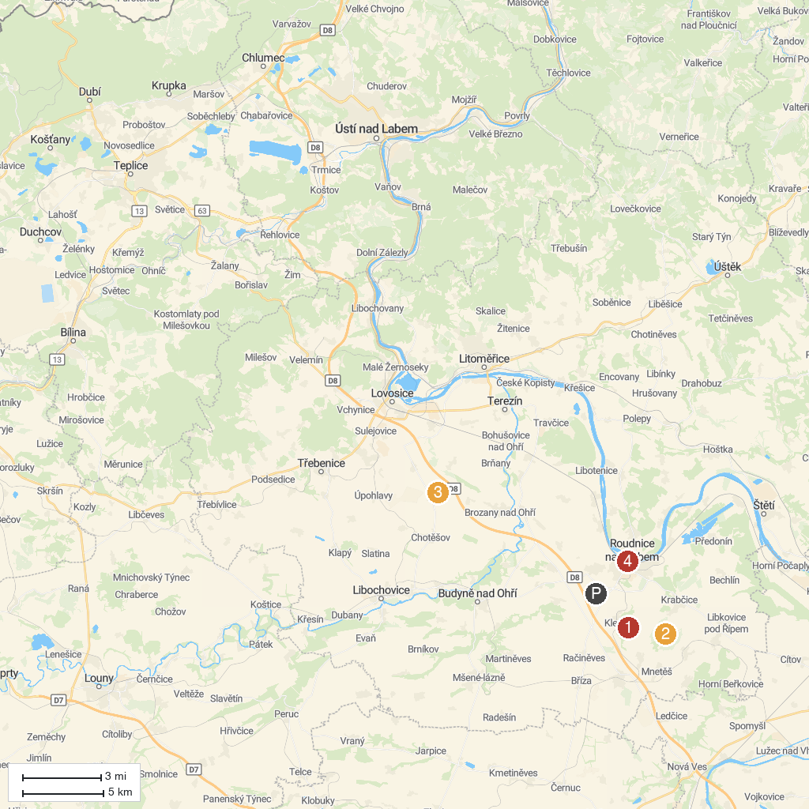
MAP KEY
1. Kleneč | 5. Zámek Vrbičany
2. The Rotunda of St. George and St. Adalbert on Mount Rip | 6. Kostel Narození Panny Marie
3. Terezin Memorial - Magdeburg Barracks | 7. Terezín Concentration Camp Memorial
4. Underground corridors
P. Cruise port / terminal
Map © MapTiler © OpenStreetMap contributors · cruiseports.org

