Rovigo, Veneto, Italy
A quietly elegant city between the Po and Adige rivers, Rovigo rewards curious cruisers with soaring medieval towers, world-class art exhibitions, and an uncrowded glimpse of authentic Veneto life.
⚓ River port (Canalbianco dock) · 🕒 Typical call: 6-8 hrs · 💶 Euro (€) · 🗣️ Italian · 🚲 Flat & walkable/bikeable
✍️ MY DAY IN PORT (FILL IN)
Ship / Date
In port | arrive ______ · all aboard ______
Booked excursion
Notes / meeting point
GETTING ASHORE
- Docking: Riverboat berth on Canalbianco canal, ~2-3 km from center
- Walk to center: 20-30 min on foot; most lines run a free shuttle
- Best For: Medieval towers, Renaissance art, Po Delta nature
- Don't Miss: Torre Donà (51 m brick tower) & La Rotonda octagonal church
GETTING AROUND
- 🚕 Taxi: €8–€15 — Local taxis are available near the docking area and train station. Short rides within the city center run €8–€15; book v
TOP THINGS TO DO
- Torre Donà & Medieval Towers — The 51-metre Torre Donà in Piazza Matteotti is one of Italy's tallest surviving medieval brick towers and Rovigo's defining…
- Palazzo Roverella Art Gallery — This stunning Renaissance palace hosts world-class temporary exhibitions — often French Impressionism or Italian Modernism…
- La Rotonda — Beata Vergine del Soccorso — Rovigo's unique octagonal 16th-century sanctuary is entirely lined with giant 17th-century canvas paintings.
- Po Delta Natural Park — A UNESCO Biosphere Reserve 45 minutes from Rovigo, the Po Delta is one of Europe's great wetlands — home to pink flamingos…
- Museo dei Grandi Fiumi — Housed in a beautifully restored Olivetan monastery, this interactive museum traces Po and Adige river civilizations from the…
BEST WALKS
- Historic Center Loop: 2-3 km · 45-60 min · Easy — From the main piazza, explore Rovigo's elegant core: two medieval towers, the Duomo, and the ornate…
- La Rotonda & Outer Monuments: 1.5 km · 30 min · Easy — A short walk southwest from the center leads to Rovigo's extraordinary octagonal sanctuary, La…
WEATHER · DAYLIGHT · MONEY
Month | High °F | Low °F | Rainy days
May | 73 | 56 | 14
Jul | 88 | 69 | 10
Sep | 78 | 61 | 9
Daylight: May 5:43AM–8:35PM · Jul 5:40AM–8:56PM · Sep 6:51AM–7:23PM
cruiseports.org/rovigo · Confirm terminal & all-aboard time with your ship

Rovigo, Veneto, Italy — Port Map
Red = walkable sights · Amber = excursions farther out · P = cruise terminal
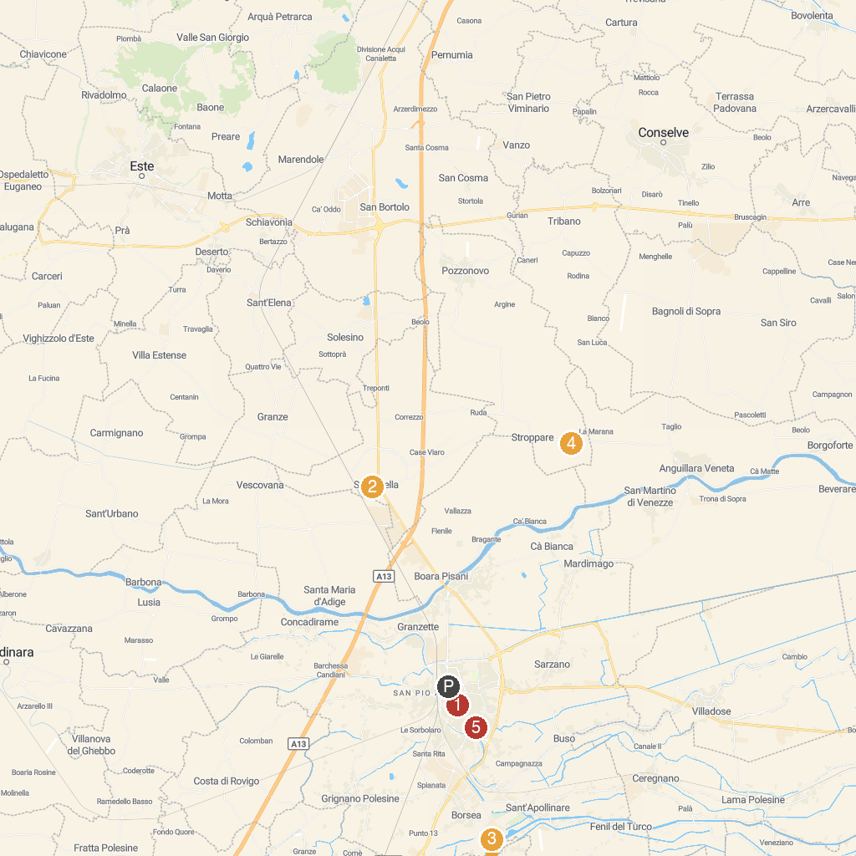
MAP KEY
1. Roncale Palace | 5. Animal Park Valcorba
2. Parco Pubblico Marco Antonio Centanini - Comune Di Stanghella | 6. Basilica Abbaziale e Santuario S. Maria del Pilastrello
3. Festa della Salama da Taglio | 7. Museum of the Great Rivers
4. Museo Archeologico Nazionale di Fratta Polesine
P. Cruise port / terminal
Map © MapTiler © OpenStreetMap contributors · cruiseports.org

