Rüdesheim am Rhein, Hesse, Germany
Step off the gangway into Germany's most festive wine town — cobblestone alleys, vine-covered hillsides, and the scent of Riesling drifting off the Rhine.
⚓ River pier (docked) · 🕒 Typical call: 6–10 hrs · 💶 Euro (€) · 🗣️ German (English widely spoken) · 🍷 UNESCO Rhine Gorge
✍️ MY DAY IN PORT (FILL IN)
Ship / Date
In port | arrive ______ · all aboard ______
Booked excursion
Notes / meeting point
GETTING ASHORE
- Docking: Floating pontoons along the Rhine promenade — directly in the heart of town, no tender
- Walk to center: 2–10 min flat walk to Drosselgasse depending on which pontoon your ship is assigned
- Best For: Wine lovers, scenic cable car rides, riverside dining, and Rhine Valley history
- Don't Miss: Rüdesheimer Kaffee — brandy, coffee & whipped cream, prepared tableside with theatrical flair
GETTING AROUND
- 🚕 Taxi: €5–€15 — Official Rheingau-Taunus district tariff: €2.90 base + €2.90/km for first 2 km, €1.80/km thereafter. Short hops within t
- 📱 Rideshare: ✅ Uber
TOP THINGS TO DO
- Cable Car to Niederwald Monument — Glide silently over the Riesling vineyards in open two-person gondolas to the 38-meter (125-ft) Niederwald Monument, crowned by…
- The Ring Tour (Ringtour) — The classic self-guided circuit: cable car up, forest walk to Jagdschloss Niederwald, chairlift down to Assmannshausen, ferry…
- Siegfried's Mechanical Music Cabinet — One of the world's largest collections of self-playing instruments — calliopes, orchestrions, music boxes — housed in the…
- Rheingau Wine & Rüdesheimer Kaffee Tasting — Sample the region's celebrated Riesling in a traditional wine tavern on the Drosselgasse, then watch a waiter flambé your…
- Brömserburg Castle & Rhine Gorge — One of the oldest castles on the Middle Rhine, right in the heart of Rüdesheim.
BEST WALKS
- Drosselgasse & Old Town Stroll: 30–45 min · Flat · Free — Walk from the pier along the Rheinstraße promenade, duck into the Drosselgasse, browse the wine…
- Vineyard Walk to Niederwald Monument: 45 min up · Moderate · Free (walking) — Follow the marked vineyard trail up through the Riesling terraces from the edge of town to the…
WEATHER · DAYLIGHT · MONEY
Month | High °F | Low °F | Rainy days
May | 66 | 49 | 11
Jul | 78 | 60 | 10
Sep | 70 | 53 | 8
Daylight: May 5:42AM–9:07PM · Jul 5:36AM–9:31PM · Sep 7:04AM–7:41PM
cruiseports.org/rudesheim-am-rhein · Confirm terminal & all-aboard time with your ship

Rüdesheim am Rhein, Hesse, Germany — Port Map
Red = walkable sights · Amber = excursions farther out · P = cruise terminal
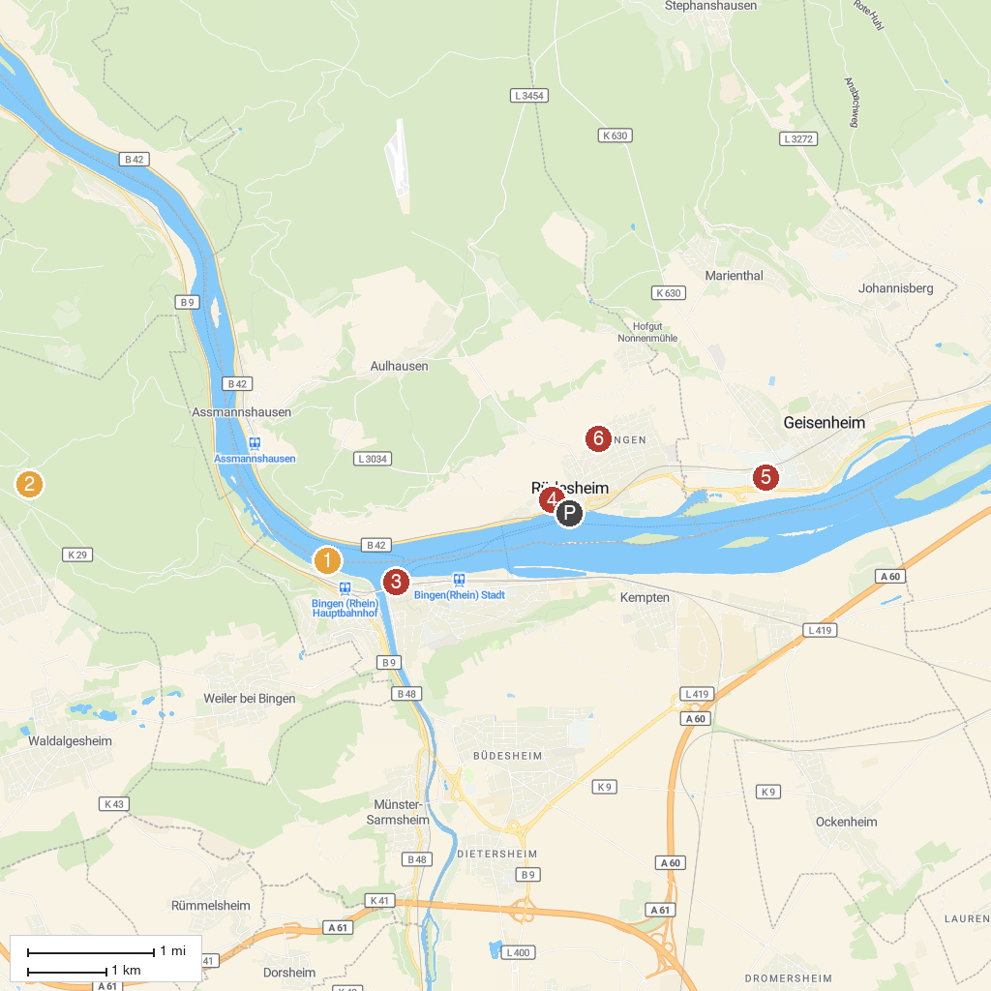
MAP KEY
1. Mouse Tower | 4. Rüdesheimer Besichtigungsfahrten GmbH (Winzerexpress)
2. Steckeschlääfer-Klamm | 5. Villa Monrepos
3. Museum am Strom | 6. Wallfahrtskirche St. Hildegard
P. Cruise port / terminal
Map © MapTiler © OpenStreetMap contributors · cruiseports.org

