Saaremaa Island, Estonia
Estonia's largest island rewards cruise passengers with a remarkably preserved medieval castle, Europe's oldest meteorite crater, a skyline of wooden windmills, and a cashless, English-friendly island culture that feels refreshingly unhurried.
⚓ Pier (deepwater berth) · 🕒 Typical call: 8-10 hrs · 💶 Currency: Euro (€) · 🗣️ Estonian / English widely spoken · 🌿 Unspoiled Baltic island
✍️ MY DAY IN PORT (FILL IN)
Ship / Date
In port | arrive ______ · all aboard ______
Booked excursion
Notes / meeting point
GETTING ASHORE
- Docking: Pier — Saaremaa Harbour handles ships up to ~200 m; no tender required for most vessels
- Into Kuressaare: Roomassaare pier is ~5 km from Kuressaare's Old Town; free shuttle or short taxi/bus ride on call days
- Best For: Medieval history, nature, quiet Baltic charm, day-tripper cycling
- Don't Miss: Kuressaare Episcopal Castle & Kaali Meteorite Crater
GETTING AROUND
- 🚕 Taxi: €35–40 one-way — The port at Roomassaare is about 38 km from Kuressaare town center, making taxi the most direct option. Metered fares ru
- 📱 Rideshare: ✅ Bolt
TOP THINGS TO DO
- Kuressaare Episcopal Castle — One of the best-preserved medieval castles in the Baltic, the 14th-century Kuressaare Castle houses the Saaremaa Museum.
- Kaali Meteorite Crater — The Kaali crater field — nine ancient impact craters, the largest forming a mirror-still lake — is the first scientifically…
- Angla Windmill Hill — A cluster of five traditional wooden windmills on an open hilltop, some dating to the early 20th century.
- Panga Cliff Coastal Walk — The highest bedrock sea cliff in western Estonia (about 21 m) on the northern coast drops dramatically into the Baltic.
- Kuressaare Spa Day — Kuressaare has a long spa tradition fed by therapeutic muds and sea water.
BEST WALKS
- Old Town to Castle Loop: ~3 km · 45-60 min · easy — From the shuttle drop-off in Kuressaare's Old Town, stroll along Tallinna tänav, visit the castle…
- Castle to Beach Promenade: ~2 km · 30 min · flat — Head south from the castle park along the shoreline promenade to Kuressaare Beach — a pleasant…
WEATHER · DAYLIGHT · MONEY
Month | High °F | Low °F | Rainy days
May | 58 | 45 | 9
Jul | 70 | 59 | 12
Sep | 61 | 53 | 9
Daylight: May 5:04AM–9:49PM · Jul 4:49AM–10:21PM · Sep 7:00AM–7:48PM
cruiseports.org/saaremaa-island · Confirm terminal & all-aboard time with your ship

Saaremaa Island, Estonia — Port Map
Red = walkable sights · Amber = excursions farther out · P = cruise terminal
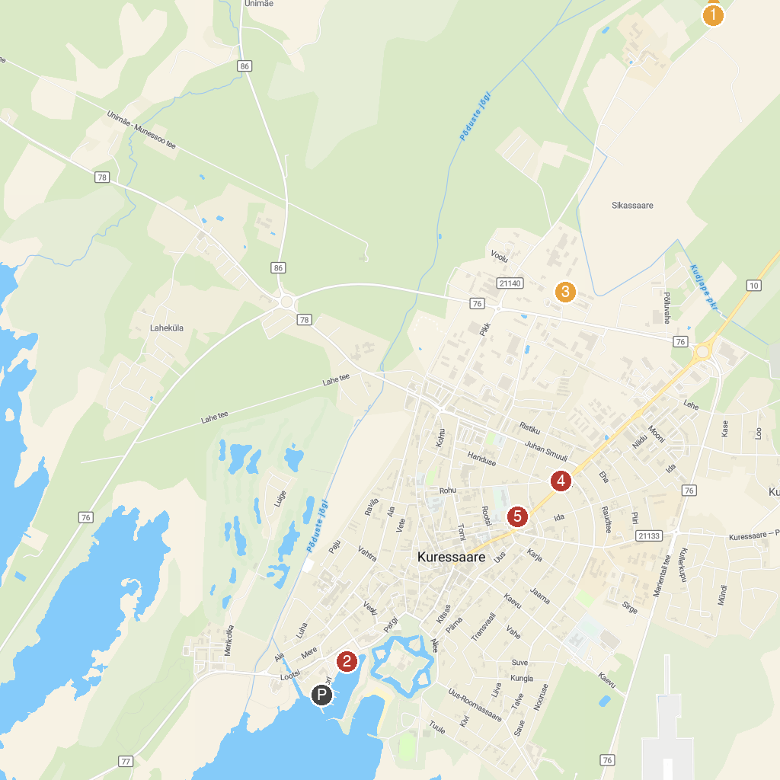
MAP KEY
1. Kaarma maalinn | 4. Kuressaare Siioni kirik
2. Suur Tõll ja Piret | 5. Keskaja Elamuskeskus/ Medieval Activity Centre/ Archebald
3. Reta Wood Ltd.
P. Cruise port / terminal
Map © MapTiler © OpenStreetMap contributors · cruiseports.org

