Safaga, Red Sea, Egypt
Safaga is a working Red Sea port that punches far above its size — it's the closest seaport to the wonders of Luxor, and it sits atop some of Egypt's finest coral reefs. The real Egypt starts the moment you step off the ship.
⚓ Pier (docked) · 🕒 Typical call: 8–12 hrs · 💵 Egyptian Pound (USD/EUR widely accepted) · 🗣️ Arabic (English at tourist sites)
✍️ MY DAY IN PORT (FILL IN)
Ship / Date
In port | arrive ______ · all aboard ______
Booked excursion
Notes / meeting point
GETTING ASHORE
- Docking: Pier — ships dock directly; new AD Ports terminal opened 2025
- Walk to Center: Port area is industrial; taxis needed for town or excursions
- Best For: Luxor day trips, snorkeling/diving, desert safari
- Don't Miss: Valley of the Kings & Karnak Temple (full-day excursion)
GETTING AROUND
- 🚕 Taxi: $3–$5 — Local taxis can take you from the port to Safaga town center, roughly 2–3 km away. Taxis may be scarce directly at the p
TOP THINGS TO DO
- Luxor Full-Day: Valley of the Kings & Karnak Temple — Egypt's crown jewel is 215 km west across the desert — a 3-hour drive each way.
- Snorkeling & Diving — Hurghada Reefs — Hurghada (63 km north) is the Red Sea's dive capital.
- Soma Bay Beach Day — Soma Bay is a luxury resort peninsula 25 km north of Safaga.
- Desert Safari & Bedouin Village — Head into the Eastern Desert for a quad-bike or jeep safari over sand dunes, a camel ride, and tea with Bedouin hosts in a desert…
- Luxor by Air — Fly & See — Some operators offer charter flights from Hurghada Airport to Luxor for a faster Nile Valley day.
BEST WALKS
- Safaga Corniche Stroll: ~1 km • Easy • 15–20 min — A short walk along the seafront past local tea shops and the fish market.
WEATHER · DAYLIGHT · MONEY
Month | High °F | Low °F | Rainy days
May | 93 | 78 | 0
Jul | 99 | 85 | 0
Sep | 97 | 82 | 0
Daylight: May 5:57AM–7:24PM · Jul 6:00AM–7:39PM · Sep 6:30AM–6:48PM
cruiseports.org/safaga · Confirm terminal & all-aboard time with your ship

Safaga, Red Sea, Egypt — Port Map
Red = walkable sights · Amber = excursions farther out · P = cruise terminal
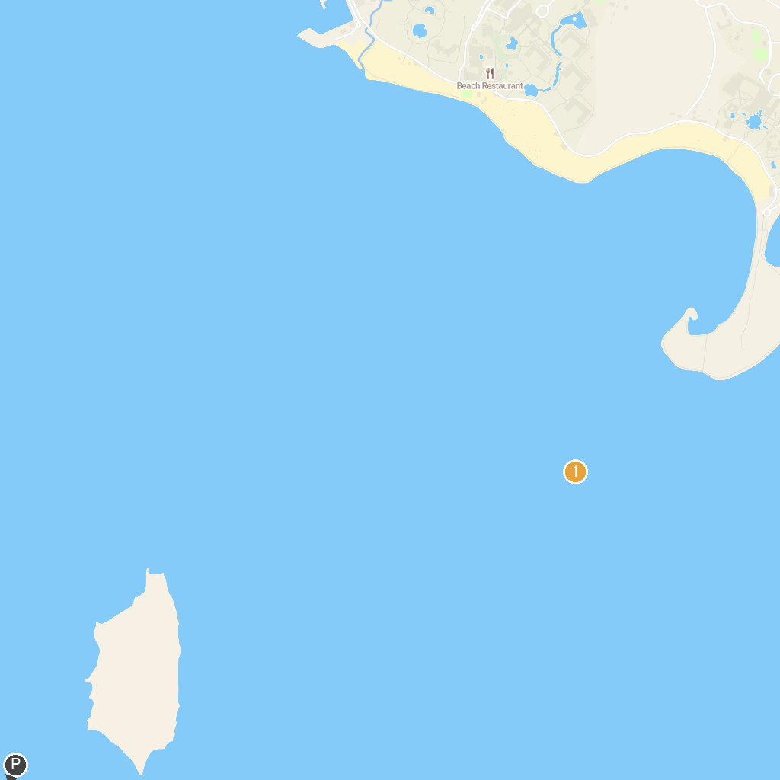
MAP KEY
1. Tobia Arbaa | 2. The Jetty
P. Cruise port / terminal
Map © MapTiler © OpenStreetMap contributors · cruiseports.org

