Safi, Marrakesh-Safi, Morocco
Morocco's pottery capital sits on the rugged Atlantic coast — a gritty, authentic port city famous for hand-thrown ceramics, fresh sardines, and centuries of Portuguese and Moroccan history packed into a compact medina.
⚓ Pier (commercial port — shuttle to gate) · 🕒 Typical call: 8–10 hrs · 💵 Moroccan Dirham (MAD) · 🗣️ Arabic & French · 🏺 Pottery capital of Morocco
✍️ MY DAY IN PORT (FILL IN)
Ship / Date
In port | arrive ______ · all aboard ______
Booked excursion
Notes / meeting point
GETTING ASHORE
- Docking: Pier at Port of Safi (Marsa Safi) — shuttle bus to port gate required; pedestrians not permitted through working port
- Walk to center: 5–10 min walk from port gate to Medina; Potters' Hill 15–20 min or short taxi
- Best For: Ceramics shopping, Portuguese fortress history, Atlantic seafood, authentic Moroccan medina
- Don't Miss: Colline des Potiers (Potters' Hill) — watch artisans throw, paint, and fire traditional Safi pottery
GETTING AROUND
- 🚕 Taxi: 20–30 MAD (~$2–3.50) — Small blue petit taxis wait at the port entrance. Agree on the fare before departing — no meters used for short city run
TOP THINGS TO DO
- Potters' Hill & Ceramics Quarter — Colline des Potiers is Safi's most famous attraction — dozens of working pottery studios line the lanes where artisans shape clay…
- Kechla Fortress & National Ceramics Museum — The massive 16th-century Portuguese citadel looms over the medina.
- Château de la Mer (Dar el-Bahar) — A compact 16th-century Portuguese fortress perched right on the Atlantic waterfront, five minutes from the port gate.
- Safi Medina Walk — Safi's compact walled medina blends Portuguese, Moroccan, French, and Jewish heritage into a labyrinth of lanes.
- Lalla Fatna Beach & Cliff Coast — About 15 km north of Safi, this stunning Atlantic beach is sheltered by dramatic clay cliffs and is a legendary surf break.
BEST WALKS
- Port Gate to Medina & Château de la Mer: Easy · ~1 km · 20–30 min — From the port exit, walk north along the waterfront to reach the Château de la Mer (Dar el-Bahar).
- Medina to Kechla Fortress & Potters' Hill: Easy · ~1.5 km · 30–40 min — From the medina center, head uphill toward the towering Kechla (Portuguese Citadel) and its…
WEATHER · DAYLIGHT · MONEY
Month | High °F | Low °F | Rainy days
May | 74 | 61 | 3
Jul | 79 | 67 | 0
Sep | 78 | 66 | 1
Daylight: May 6:39AM–8:27PM · Jul 6:41AM–8:44PM · Sep 7:21AM–7:42PM
cruiseports.org/safi · Confirm terminal & all-aboard time with your ship

Safi, Marrakesh-Safi, Morocco — Port Map
Red = walkable sights · Amber = excursions farther out · P = cruise terminal
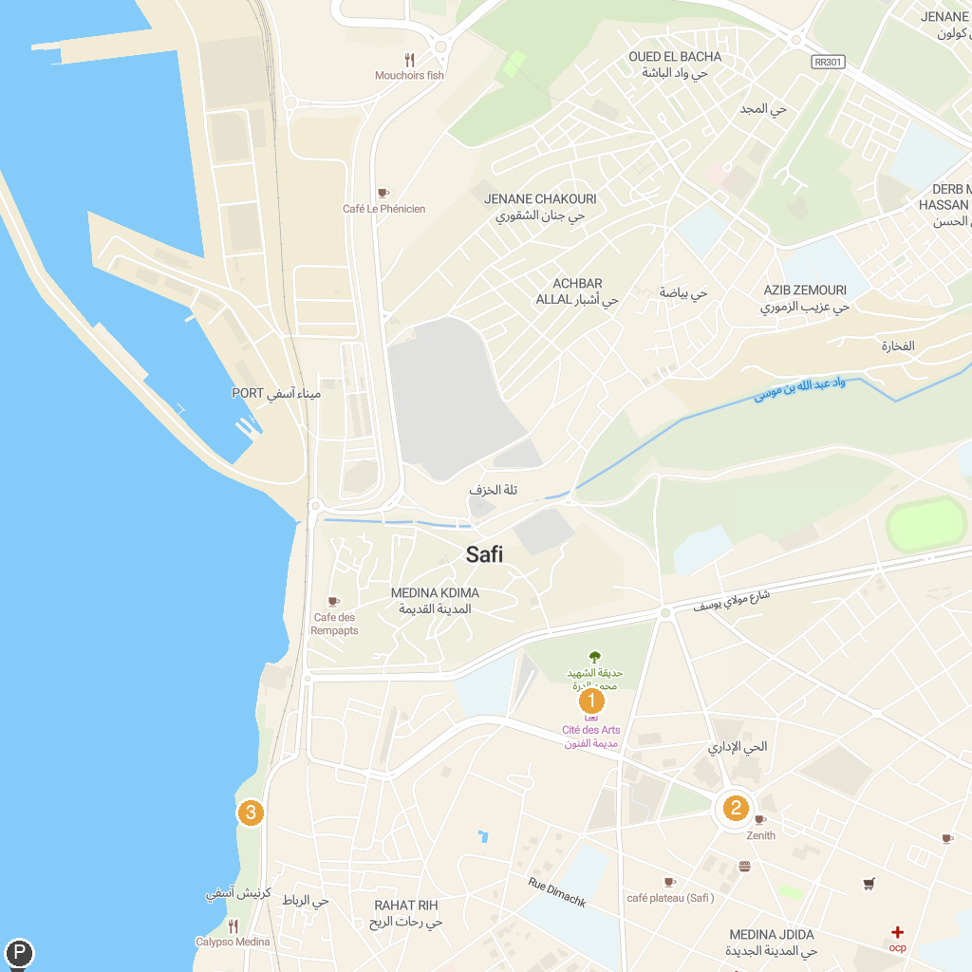
MAP KEY
1. National Museum of Ceramics | 3. Safi Corniche
2. Tajine
P. Cruise port / terminal
Map © MapTiler © OpenStreetMap contributors · cruiseports.org

