Saguenay, Quebec, Canada
Ships dock deep inside a breathtaking fjord carved by glaciers, welcomed by costumed locals offering maple taffy — and sent off by hundreds waving flags at the pier.
⚓ Pier (Quai Marcel-Dionne, La Baie) · 🕒 Typical call: 8-10 hrs · 💵 Canadian Dollar (CAD) · 🗣️ French (English widely spoken in tourism) · 🍁 Canada & New England itineraries
✍️ MY DAY IN PORT (FILL IN)
Ship / Date
In port | arrive ______ · all aboard ______
Booked excursion
Notes / meeting point
GETTING ASHORE
- Docking: Pier at Bagotville Wharf, La Baie (tender if 2+ ships)
- Walk to center: 10–15 min flat walk to La Baie town center
- Best For: Fjord scenery, fall foliage, French-Canadian food & culture
- Don't Miss: The sail-away farewell — locals gather to wave flags and sing
GETTING AROUND
- 🚕 Taxi: CAD $30–55 one-way — Taxis queue at the terminal on arrival. Fare to Chicoutimi is roughly CAD $30–55 for the 20 km ride; Taxi Sourire offers
- 📱 Rideshare: ✅ Uber, Lyft
- 🚌 Hop-on hop-off: ✅
TOP THINGS TO DO
- Saguenay Fjord Cruise — Board a local vessel and glide past 1,000-ft cliffs to Cap Trinité and the Notre-Dame-du-Saguenay statue.
- Parc National du Fjord-du-Saguenay Hike — Drive ~45 min to the national park for trails like Point de Vue du Soupir with stunning fjord overlooks.
- La Fabuleuse Histoire d'un Royaume — A legendary theatrical show performed by 150 local volunteers telling the region's history with live animals, fire, water…
- La Pulperie de Chicoutimi — A historic pulp mill turned regional museum in Chicoutimi, 20 min by shuttle.
- Local Food & Artisan Tour — Sample squeaky cheese curds at Fromagerie Boivin, wild blueberry treats, craft beer at Hopera, and regional tourtière.
BEST WALKS
- Pier to Ha! Ha! Pyramid & Musée du Fjord: 1.5 km / ~25 min one-way | Flat, paved | Free — Walk the waterfront path through Parc Mars from the cruise terminal toward La Baie.
- La Baie Town Center Stroll: 1 km / ~15 min one-way | Flat | Free — Follow Rue de la Fabrique from the pier end into La Baie's compact downtown for local shops, the…
cruiseports.org/saguenay · Confirm terminal & all-aboard time with your ship

Saguenay, Quebec, Canada — Port Map
Red = walkable sights · Amber = excursions farther out · P = cruise terminal
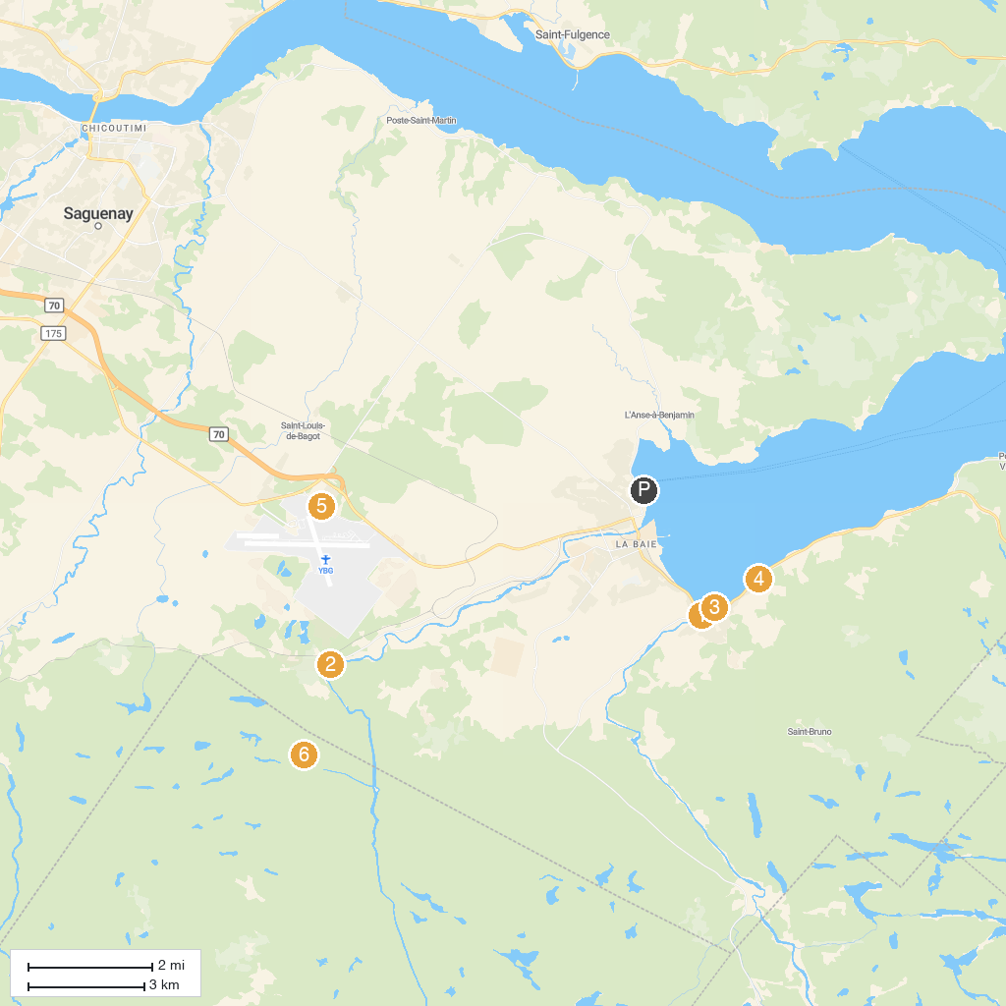
MAP KEY
1. Pyramide des Ha! Ha! | 5. Air Defence Museum
2. Okwari - Contact Nature | 6. Alaskan du Nord
3. Musée du Fjord (Fjord Museum) | 7. Parc de la Rivière-du-Moulin
4. Centre de ski Mont-Bélu
P. Cruise port / terminal
Map © MapTiler © OpenStreetMap contributors · cruiseports.org

