Saint-Denis, Réunion, France
France's volcanic island in the Indian Ocean — an active lava-spewing caldera, three UNESCO-listed cirques carved into jungle mountains, and a Creole capital that smells of vanilla and rhum agricole.
⚓ Docked (Le Port / Port Réunion) · 🕒 Typical call: 8–10 hrs · 💶 Euro (EUR) · 🗣️ French / Réunionnais Creole
✍️ MY DAY IN PORT (FILL IN)
Ship / Date
In port | arrive ______ · all aboard ______
Booked excursion
Notes / meeting point
GETTING ASHORE
- Docking: Le Port (Port Réunion), NW coast
- Walk to Saint-Denis: ~20 min by taxi/shuttle
- Best For: Volcano · Cirques · Creole culture
- Don't Miss: Piton de la Fournaise (active volcano)
GETTING AROUND
- 🚕 Taxi: ~€45 one-way — Taxis are available at Pointe des Galets cruise terminal for the ~24 km ride to Saint-Denis city center. Confirm fare be
- 📱 Rideshare: ✅ Uber
TOP THINGS TO DO
- Piton de la Fournaise — Active Volcano — One of the world's most active volcanoes, with hikes across hardened lava fields to the crater rim.
- Cirque de Cilaos — The most accessible of Réunion's three UNESCO calderas — a mountain bowl of soaring peaks, terraced fields, lentils, and thermal…
- Cirque de Salazie & Hell-Bourg — The lushest cirque, dripping with waterfalls including the spectacular Cascade du Voile de la Mariée.
- Saint-Denis: Rue de Paris & Le Barachois — Réunion's capital has elegant Creole colonial architecture along the Rue de Paris, the seafront promenade of Le Barachois, the…
- Saint-Paul Market & Rum Distillery — The open-air Saturday market in Saint-Paul (south of Le Port) is one of the best in the Indian Ocean — spices, vanilla, Creole…
BEST WALKS
- Saint-Denis Creole Quarter & Seafront: ~3 km · 1.5–2 hrs · easy — Walk the elegant Rue de Paris lined with colonial Creole mansions, through the Jardin de l'État…
- Saint-Paul Seafront: ~1.5 km · 45 min · easy (best on Saturday for the market) — The seafront promenade in Saint-Paul is just a few minutes south of Le Port — a pleasant stroll…
WEATHER · DAYLIGHT · MONEY
Month | High °F | Low °F | Rainy days
May | 79 | 72 | 12
Jul | 75 | 67 | 7
Sep | 77 | 68 | 9
Daylight: May 6:40AM–5:47PM · Jul 6:55AM–5:53PM · Sep 6:14AM–6:12PM
cruiseports.org/saint-denis · Confirm terminal & all-aboard time with your ship

Saint-Denis, Réunion, France — Port Map
Red = walkable sights · Amber = excursions farther out · P = cruise terminal
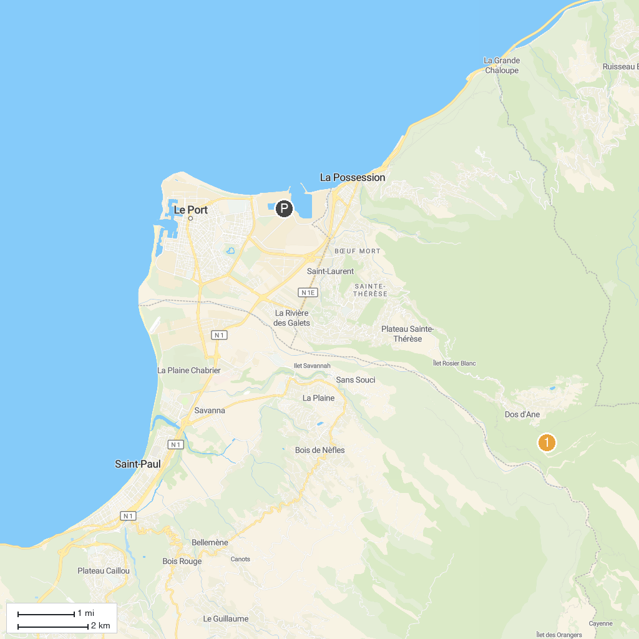
MAP KEY
1. Château Morange | 5. Happy Valley
2. Cap Noir | 6. The vanilla plantation, Domaine du Grand Hazier
3. Muséum d'Histoire naturelle | 7. Musée Léon-Dierx
4. Cathedral Of Saint Denis Reunion
P. Cruise port / terminal
Map © MapTiler © OpenStreetMap contributors · cruiseports.org

