Saint-Florent, Corsica, France
A sun-drenched marina town where mega-yachts and fishing trawlers share the same quay — and the most spectacular wild beaches in the Mediterranean are just a short boat ride away.
⚓ Tender port · 🕒 Typical call: 6–8 hrs · 💶 Currency: Euro (€) · 🗣️ French / Corsican
✍️ MY DAY IN PORT (FILL IN)
Ship / Date
In port | arrive ______ · all aboard ______
Booked excursion
Notes / meeting point
GETTING ASHORE
- Docking: Tender — ships anchor in the gulf; tenders land at Quai d'Honneur in the marina
- Walk to center: 0 min — you step off the tender into the heart of the village
- Best For: Wild beaches (Loto, Saleccia), Corsican food & wine, Patrimonio wine tasting
- Don't Miss: Boat shuttle to Loto Beach and a cold Pietra beer at Place Doria
GETTING AROUND
- 🚕 Taxi: €7–€20 — Local taxis are available in the village. Short rides within Saint-Florent are inexpensive; longer trips to Bastia run €
- 📱 Rideshare: ✅ Uber
TOP THINGS TO DO
- Boat Shuttle to Loto Beach — Hop the 20-minute taxi boat to Plage de Loto in the Désert des Agriates — turquoise water, fine white sand, wild cows, and one…
- Saleccia Beach by Boat + Hike — Take the shuttle to Loto, then hike 45 minutes along the coastal trail to Saleccia — Corsica's most famous beach, ringed by pines…
- Genoese Citadel & Old Town Walk — Climb the 15th-century Genoese citadel for panoramic views over the gulf and mountains, wander cobbled alleys to Place Doria, and…
- Patrimonio Wine Tasting — A 10-minute taxi ride brings you to Corsica's premier AOC wine village of Patrimonio.
- Désert des Agriates 4x4 Safari — Explore the vast uninhabited Agriates wilderness — 16,000 hectares of maquis scrubland, hidden coves, and flamingo lagoons — by…
BEST WALKS
- Marina to Citadel & Old Town: 1.2 km loop · 30–40 min · Easy with one short uphill — From the tender pier, walk along Quai d'Honneur past marina cafés, then head uphill through the…
- Marina to Nebbio Cathedral & La Roya Beach: 3 km one way · 45–50 min · Flat & easy — Head south-east from the marina along the waterfront path to the 12th-century Santa Maria Assunta…
WEATHER · DAYLIGHT · MONEY
Month | High °F | Low °F | Rainy days
May | 72 | 58 | 9
Jul | 88 | 72 | 3
Sep | 80 | 66 | 7
Daylight: May 6:00AM–8:38PM · Jul 5:58AM–8:58PM · Sep 7:02AM–7:32PM
cruiseports.org/saint-florent · Confirm terminal & all-aboard time with your ship

Saint-Florent, Corsica, France — Port Map
Red = walkable sights · Amber = excursions farther out · P = cruise terminal
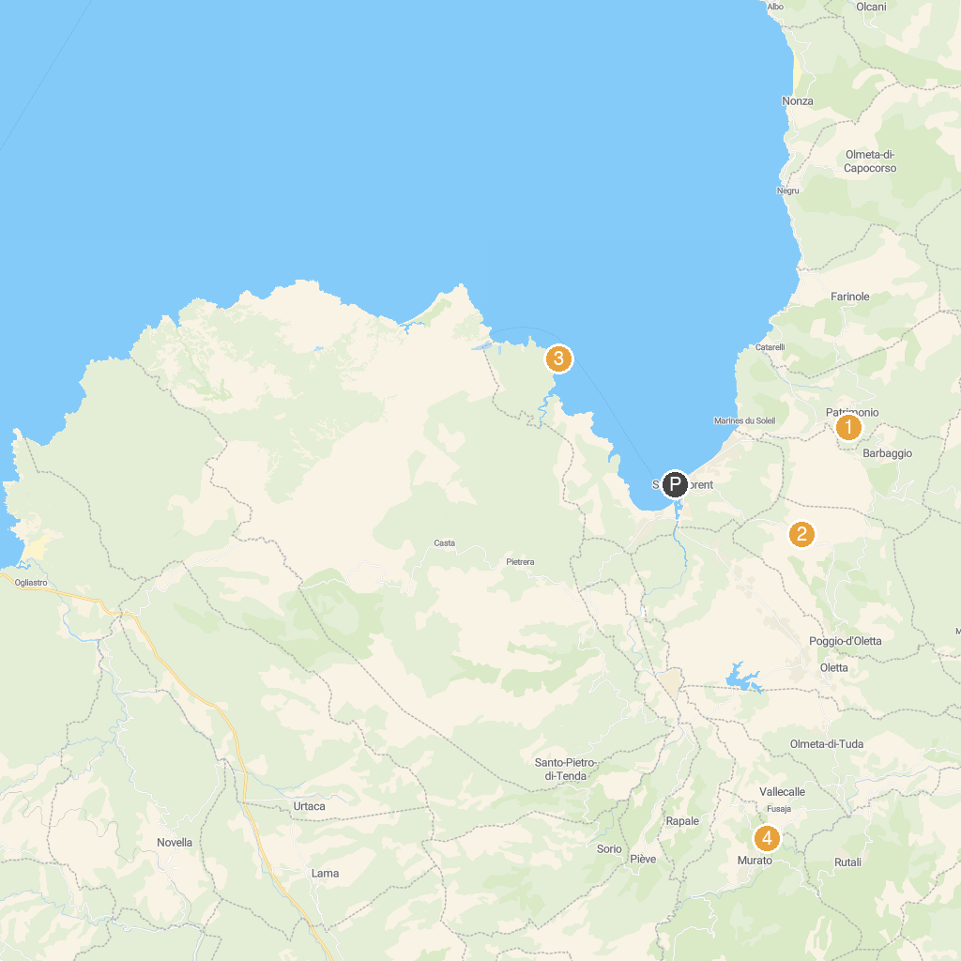
MAP KEY
1. Clos de Bernardi | 5. Ghjesgia San Michele
2. VIGNOBLE YVES LECCIA | 6. Place Saint Nicolas
3. Tour Genoise de la Mortella - Torra Ghjenuvese di A Mortella | 7. Église Saint Jean-Baptiste
4. Palais des Gouverneurs
P. Cruise port / terminal
Map © MapTiler © OpenStreetMap contributors · cruiseports.org

