Saint John, New Brunswick, Canada
Canada's oldest incorporated city sits where the Saint John River meets the Bay of Fundy — twice a day the river literally reverses course, and cruise ships dock minutes from a walkable uptown full of Victorian brick and a market that's been running since 1876.
⚓ Docked (pier) · 🕒 Typical call: 7-9 hrs · 💵 Canadian Dollar (CAD) · 🗣️ English
✍️ MY DAY IN PORT (FILL IN)
Ship / Date
In port | arrive ______ · all aboard ______
Booked excursion
Notes / meeting point
GETTING ASHORE
- Docking: Marco Polo or Diamond Jubilee terminal; 5-min walk to uptown
- Walk to centre: 5 minutes flat from all three berths
- Best For: Reversing Falls, Bay of Fundy whale watching, historic uptown
- Don't Miss: Saint John City Market — oldest farmers' market in Canada (est. 1876)
GETTING AROUND
- 🚕 Taxi: CAD $10–20 — Taxis use a zone-based fare system (not meters) — confirm the fare before riding. Short hops around downtown are afforda
- 📱 Rideshare: ✅ Uride
- 🚌 Hop-on hop-off: ✅ Big Pink Hop-On Hop-Off Bus
TOP THINGS TO DO
- Reversing Falls Rapids — The Bay of Fundy's massive tides push the Saint John River backwards twice a day — whirlpools, standing waves, and a complete…
- Bay of Fundy Whale Watching — Humpback, finback, and minke whales feed in the nutrient-rich Bay of Fundy waters.
- Uptown Historic Walking Tour — Trinity Royal Preservation Area protects blocks of Victorian brick and sandstone rebuilt after the Great Fire of 1877.
- Saint John City Market — Canada's oldest continuously operating farmers' market (1876) fills a stunning barrel-vaulted iron building.
- St. Martins Sea Caves & Covered Bridges — Drive 45 minutes to the fishing village of St.
BEST WALKS
- Uptown Core Loop: 1.5 km · 30-40 min · Easy, flat — From the cruise terminal, walk up to King's Square, cut through to the Saint John City Market on…
- Harbour Passage Waterfront Trail: 4 km return · 1-1.5 hrs · Easy, paved — Harbour Passage is a paved multi-use 'red brick road' trail that follows the inner harbour west…
WEATHER · DAYLIGHT · MONEY
Month | High °F | Low °F | Rainy days
May | 57 | 42 | 12
Jul | 70 | 59 | 12
Sep | 66 | 54 | 9
Daylight: May 5:54AM–8:47PM · Jul 5:51AM–9:08PM · Sep 7:03AM–7:34PM
Representative sunrise/sunset — 2025, 15th of each month; local civil time including DST (America/Moncton). Source: Astral; not a forecast or climate average.
cruiseports.org/saint-john-nb · Confirm terminal & all-aboard time with your ship

Saint John, New Brunswick, Canada — Port Map
Red = walkable sights · Amber = excursions farther out · P = cruise terminal
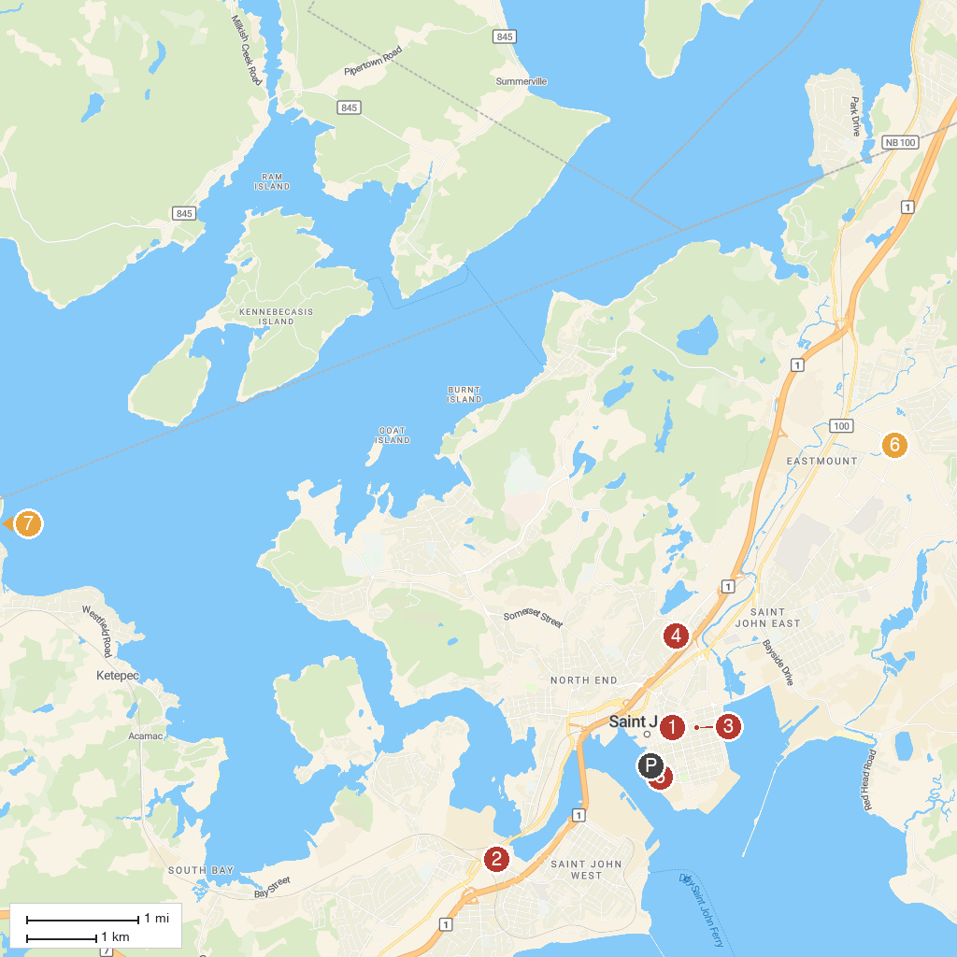
MAP KEY
1. King’s Square | 5. Three Sisters Lamp
2. Wolastoq Park | 6. Breakout Saint John
3. Saint John Jewish Historical Museum | 7. Blueberry Hill Nature Preserve
4. Saint John Public Gardens | 8. Rothesay Common
P. Cruise port / terminal
Map © MapTiler © OpenStreetMap contributors · cruiseports.org

