Saint-Malo, Brittany, France
A granite corsair city encircled by medieval ramparts, Saint-Malo juts into the English Channel with some of Europe's most dramatic tides — and a walled old town that's entirely walkable from the tender dock.
⚓ Pier (small ships) / Tender (large ships) · 🕒 Typical call: 8-10 hrs · 💶 Currency: Euro (€) · 🗣️ Language: French (English widely spoken)
✍️ MY DAY IN PORT (FILL IN)
Ship / Date
In port | arrive ______ · all aboard ______
Booked excursion
Notes / meeting point
GETTING ASHORE
- Docking: Small ships (<150m) dock at inner harbour berths; larger ships anchor offshore and tender (~10 min ride)
- Walk to centre: Tender drop-off: 5-min walk to Porte Saint-Vincent. Ferry terminal (Gare Maritime du Naye): 15-20 min walk
- Best For: History, coastal walks, Breton food, day trips to Mont Saint-Michel
- Don't Miss: Walking the full 2km rampart loop and trying a galette with salted caramel crêpe
GETTING AROUND
- 🚕 Taxi: €7–€12 — Taxis charge approximately €7–9 during daytime and €10–12.50 on evenings, Sundays, and public holidays for the ride to I
- 📱 Rideshare: ✅ Uber, Bolt
TOP THINGS TO DO
- Mont Saint-Michel Day Trip — The iconic island abbey is 45–50 minutes by road.
- Ramparts & Corsair City Walk — Walk the full 2km circuit along Saint-Malo's medieval ramparts for sweeping Channel views, then explore cobblestone streets, the…
- Tidal Islands: Grand Bé & Fort National — At low tide, stone paths emerge to offshore islands.
- Dinan Medieval Town — 30 minutes south along the Rance River, Dinan is one of Brittany's best-preserved medieval towns — half-timbered houses, a…
- Breton Food & Market Tour — Brittany is France's buckwheat belt.
BEST WALKS
- Rampart Circuit: 2km loop · ~1 hr · flat (steps at gates) — Climb the ramparts at Porte Saint-Vincent and walk the full perimeter of Intra-Muros.
- Intra-Muros Old Town Stroll: 1.5km · ~45 min · cobblestones — From Porte Saint-Vincent, wind through the old town via Place Chateaubriand to Saint-Vincent…
- Tidal Walk to Grand Bé (Low Tide Only): ~1km return · 30 min · tidal — check schedule! — At low tide a stone causeway appears from the ramparts near Porte des Champs-Vauverts leading to…
WEATHER · DAYLIGHT · MONEY
Month | High °F | Low °F | Rainy days
May | 62 | 51 | 12
Jul | 70 | 61 | 10
Sep | 68 | 59 | 10
Daylight: May 6:27AM–9:42PM · Jul 6:22AM–10:05PM · Sep 7:45AM–8:20PM
cruiseports.org/saint-malo · Confirm terminal & all-aboard time with your ship

Saint-Malo, Brittany, France — Port Map
Red = walkable sights · Amber = excursions farther out · P = cruise terminal
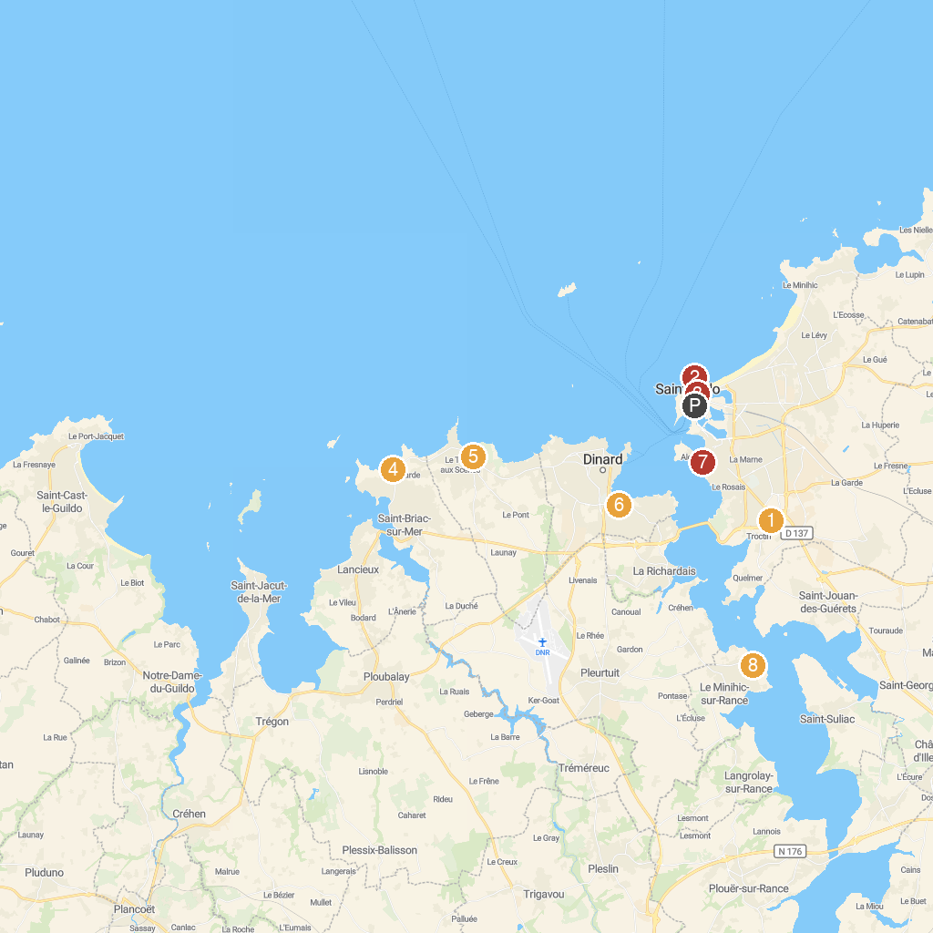
MAP KEY
1. Grand Aquarium Saint Malo | 5. Ploubalay
2. National Fort | 6. Parc du Port Breton
3. Petit Train De Saint-malo SAS | 7. Corbières Park
4. Dinard Golf | 8. Cale sèche de la Landriais
P. Cruise port / terminal
Map © MapTiler © OpenStreetMap contributors · cruiseports.org

