Kingstown, Saint Vincent, Caribbean
Saint Vincent is the Caribbean unfiltered — a volcanic island of rainforest peaks, black-sand coves, and a city where real life happens around you. No manicured cruise village here; just the genuine article.
⚓ Pier (Kingstown Cruise Terminal) · 🕒 Typical call: 7-9 hrs · 💵 USD & Eastern Caribbean Dollar (XCD) · 🗣️ English · 🌋 Active volcanic island
✍️ MY DAY IN PORT (FILL IN)
Ship / Date
In port | arrive ______ · all aboard ______
Booked excursion
Notes / meeting point
GETTING ASHORE
- Docking: Deep-water pier; 2 ships simultaneously. 3+ ships may require tendering.
- Walk to center: 5-10 min flat walk to downtown Kingstown
- Best For: History, nature, authentic local culture, Pirates of the Caribbean fans
- Don't Miss: Oldest botanical garden in the Western Hemisphere (est. 1765)
GETTING AROUND
- 🚕 Taxi: USD $8–$15 (city/port area) — Government-regulated fixed rates; taxis are not metered so confirm the fare before departure. Taxis identifiable by an "
- 📱 Rideshare: ❌ not available
TOP THINGS TO DO
- Fort Charlotte & Panoramic Views — This 1806 British fort perches 600 ft above Kingstown harbor with cannons famously facing inland (to defend against Carib raids…
- St. Vincent Botanical Gardens — Established in 1765, this is the oldest botanical garden in the Western Hemisphere.
- Pirates of the Caribbean Film Set — Wallilabou Bay — This bay on the leeward coast was the fictional 'Port Royal' in the original Pirates of the Caribbean film.
- Dark View Falls — Twin waterfalls cascade into natural swimming pools deep in the rainforest.
- Villa Beach & Indian Bay — The most convenient beaches from the port — a 15-20 minute taxi south.
BEST WALKS
- Kingstown City Stroll: 45 min | Flat | Free — A short walk from the terminal takes you past the Kingstown Market (fresh spices, fish…
WEATHER · DAYLIGHT · MONEY
Month | High °F | Low °F | Rainy days
May | 85 | 78 | 14
Jul | 84 | 78 | 22
Sep | 85 | 79 | 20
Daylight: May 5:39AM–6:23PM · Jul 5:46AM–6:35PM · Sep 5:54AM–6:05PM
cruiseports.org/saint-vincent-island · Confirm terminal & all-aboard time with your ship

Kingstown, Saint Vincent, Caribbean — Port Map
Red = walkable sights · Amber = excursions farther out · P = cruise terminal
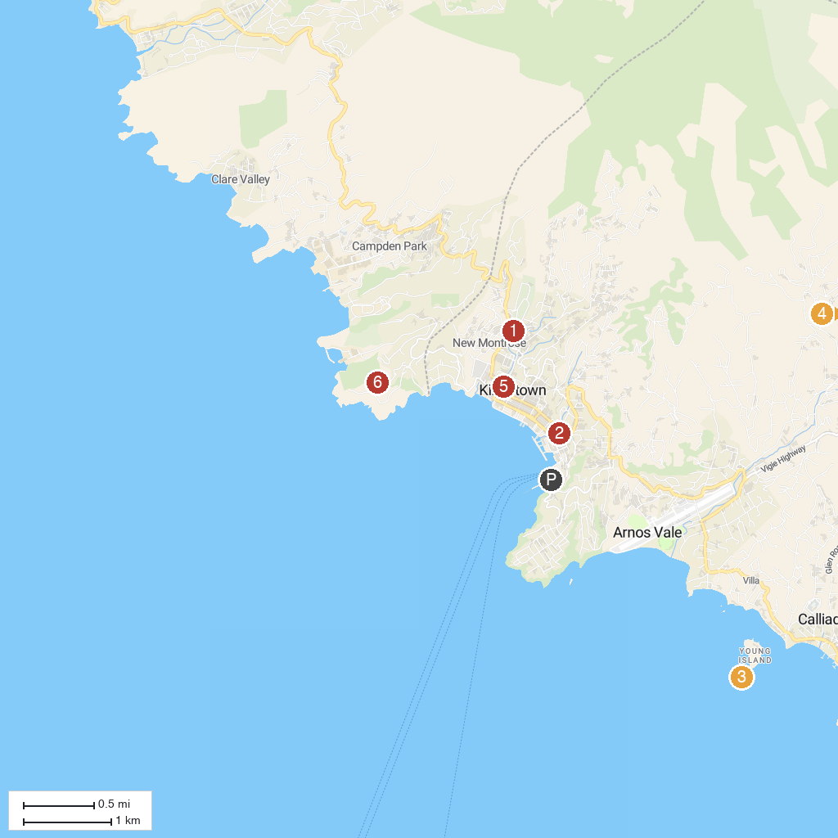
MAP KEY
1. Botanical Gardens | 4. Belmont Lookout
2. National Trust | 5. St. Mary's Cathedral
3. Fort Duvernette | 6. Fort Charlotte
P. Cruise port / terminal
Map © MapTiler © OpenStreetMap contributors · cruiseports.org

