Sal Island, Cape Verde
A flat, sun-baked Atlantic island where Saharan sand meets vivid blue water — and you can float in a volcanic salt crater or wade with juvenile sharks.
⚓ Docked at Palmeira pier · 🕒 Typical call: 8-10 hrs · 💵 Euro or Cape Verdean Escudo (CVE) · 🗣️ Portuguese / Cape Verdean Creole · ☀️ Windy, arid, year-round sun
✍️ MY DAY IN PORT (FILL IN)
Ship / Date
In port | arrive ______ · all aboard ______
Booked excursion
Notes / meeting point
GETTING ASHORE
- Docking: Pier at Port of Palmeira (west coast); larger ships may tender
- Walk to center: ~20 km to Santa Maria — taxi or shuttle required
- Best For: Beaches, kitesurfing, salt crater float, shark snorkel, 4x4 tours
- Don't Miss: Pedra de Lume Salt Crater and Buracona Blue Eye
GETTING AROUND
- 🚕 Taxi: €30 for 1–3 passengers — Private taxis wait at Porto de Palmeira and charge roughly €30 for 1–3 people to Santa Maria (about 15 km). Agree on the
- 📱 Rideshare: ❌ not available
TOP THINGS TO DO
- Pedra de Lume Salt Crater Float — Wade into a hypersaline lake inside an extinct volcanic crater and float effortlessly, Dead Sea-style.
- Buracona — The Blue Eye — A natural tidal pool and sea cave on the northwest coast where sunlight hits an underwater arch around midday, projecting an…
- Shark Bay Wading Experience — Wade knee-deep into the crystal-clear shallows of Shark Bay (Baía de Tubãrao), on the island's east side near Pedra de Lume…
- 4x4 Island Safari — Dust-fueled loop of the island taking in sand dunes, the salt crater, Buracona, Terra Boa desert mirage, and traditional fishing…
- Kitesurfing & Wind Sports at Kite Beach — Ponta Sino (Kite Beach) is world-class for kitesurfing and windsurfing from October–April.
BEST WALKS
- Santa Maria Waterfront Stroll: 1.5 km · 20 min · Easy — Wander from the historic Pontão fishing pier through the town market and along the beachfront…
- Palmeira Fishing Village: 0.5 km · 10 min · Easy — Stroll Palmeira's colorful lanes from the cruise port into the compact fishing village for a…
WEATHER · DAYLIGHT · MONEY
Month | High °F | Low °F | Rainy days
May | 77 | 70 | 0
Jul | 80 | 73 | 1
Sep | 84 | 78 | 7
Daylight: May 6:01AM–6:55PM · Jul 6:07AM–7:08PM · Sep 6:20AM–6:33PM
cruiseports.org/sal-island · Confirm terminal & all-aboard time with your ship

Sal Island, Cape Verde — Port Map
Red = walkable sights · Amber = excursions farther out · P = cruise terminal
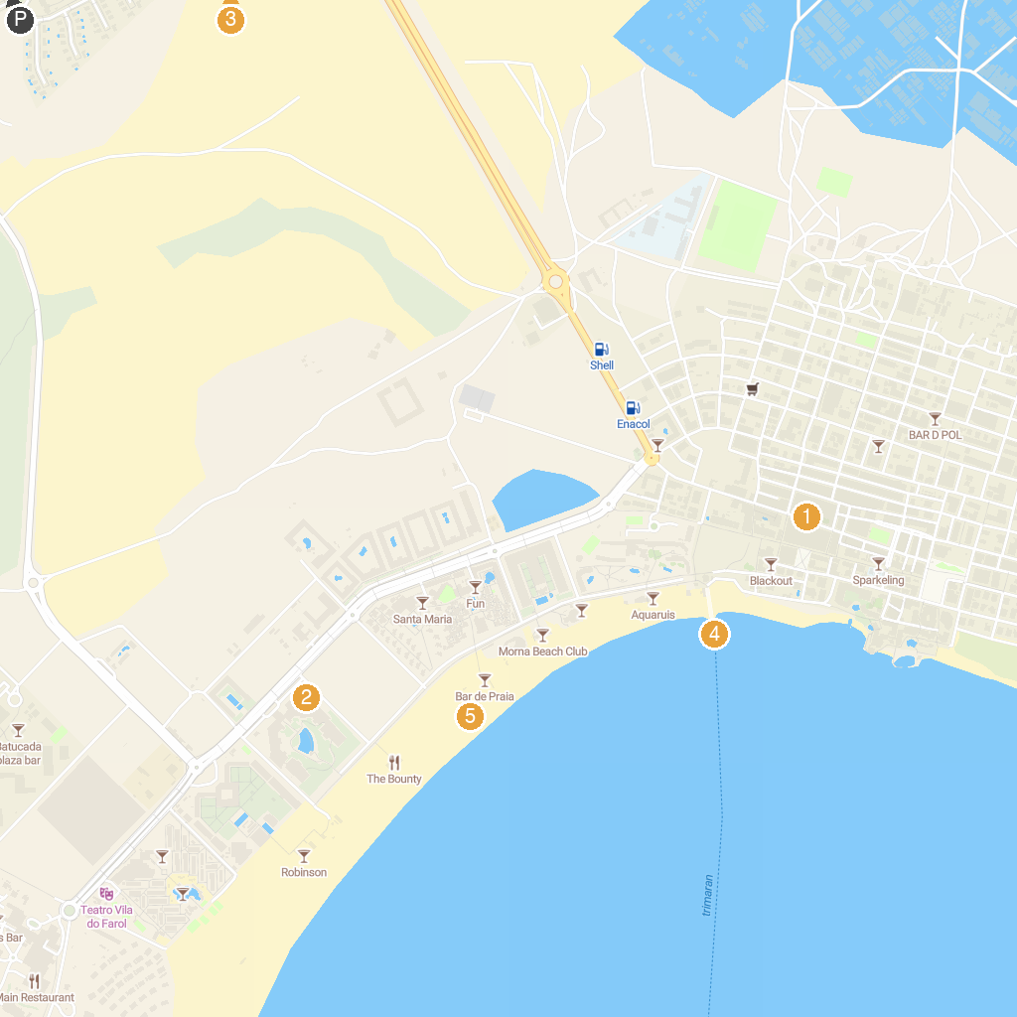
MAP KEY
1. Church of the Nazarene | 4. The Pier of Santa Maria
2. Casino Royal | 5. Santa Maria Beach
3. Pachamama Eco Park - Botanical Garden
P. Cruise port / terminal
Map © MapTiler © OpenStreetMap contributors · cruiseports.org

