Salerno, Campania, Italy
Southern Italy's most underrated cruise stop — the Amalfi Coast without the chaos. Salerno pairs a medieval old town with ferry access to Positano and Amalfi, fast trains to Pompeii, and a futuristic terminal designed by Zaha Hadid.
⚓ Docked (pier) · 🕒 Typical call: 8–10 hrs · 💶 Currency: Euro · 🗣️ Italian (some English in tourist areas)
✍️ MY DAY IN PORT (FILL IN)
Ship / Date
In port | arrive ______ · all aboard ______
Booked excursion
Notes / meeting point
GETTING ASHORE
- Docking: Pier — Molo Manfredi, Zaha Hadid Stazione Marittima
- Walk to center: 10–15 min to historic center; 5 min to seafront promenade
- Best For: Amalfi Coast day trips, Pompeii, Greek temples at Paestum
- Don't Miss: Cathedral crypt of St Matthew & ferry to Amalfi — skip the bus
GETTING AROUND
- 🚕 Taxi: €8–€10 — Taxis are available at the port exit and take about 9–10 minutes to reach the city center. Metered fares are regulated.
TOP THINGS TO DO
- Amalfi Coast by Ferry — Walk to the ferry dock and hop a Travelmar hydrofoil to Amalfi (35 min) and optionally continue to Positano (70 min).
- Pompeii by Train — Board a direct train from Salerno Centrale (35–40 min) to the Pompeii Scavi station.
- Paestum Greek Temples — Three of the world's best-preserved ancient Greek temples sit 30 minutes south of Salerno by train — far less crowded than…
- Salerno Historic Center Walk — Explore the medieval Duomo di Salerno (crypt of St Matthew, remarkable Baroque frescoes), wander Via dei Mercanti, and climb to…
- Vietri sul Mare & Ceramics — A 10-minute taxi or train ride west brings you to Vietri sul Mare, the gateway town of the Amalfi Coast famous for its vivid…
BEST WALKS
- Lungomare to Duomo & Old Town: 3.5 km round trip · Flat · 90 min — From the Stazione Marittima, walk the Lungomare Trieste seafront promenade past Villa Comunale…
- Giardino della Minerva & Castle View: 1.5 km one-way · Moderate uphill · 1 hr — From the Duomo, climb through medieval alleyways to the Giardino della Minerva (~€3), Europe's…
WEATHER · DAYLIGHT · MONEY
Month | High °F | Low °F | Rainy days
May | 70 | 57 | 12
Jul | 85 | 71 | 5
Sep | 79 | 65 | 8
Daylight: May 5:44AM–8:10PM · Jul 5:42AM–8:30PM · Sep 6:41AM–7:09PM
cruiseports.org/salerno · Confirm terminal & all-aboard time with your ship

Salerno, Campania, Italy — Port Map
Red = walkable sights · Amber = excursions farther out · P = cruise terminal
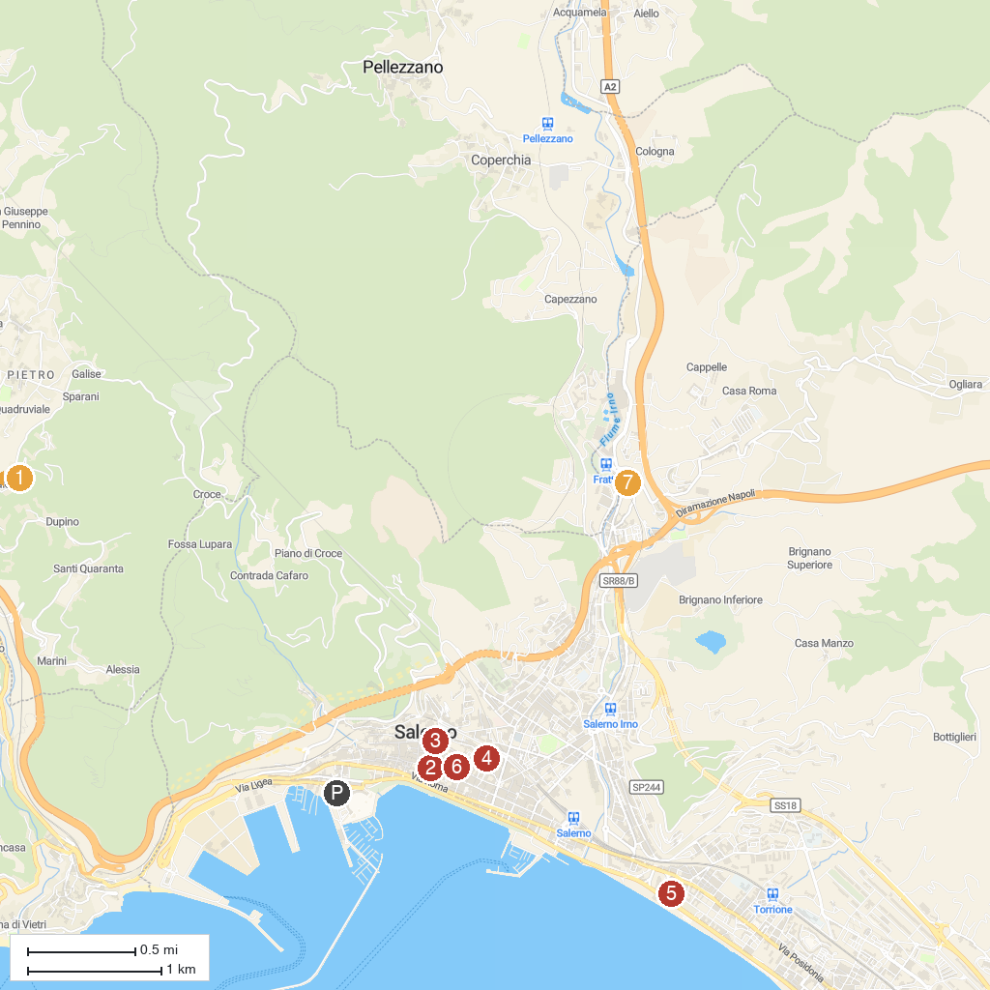
MAP KEY
1. Art of the Nativity | 5. Chiesa di Santa Maria ad Martyres
2. Provincial Art Gallery of Salerno | 6. Provincial Archaeological Museum of Salerno
3. Diocesan Museum of San Matteo | 7. Area Archeologica Etrusco-Sannitica di Fratte
4. Medieval Aqueduct
P. Cruise port / terminal
Map © MapTiler © OpenStreetMap contributors · cruiseports.org

