Salzburg, Austria
Mozart's birthplace, a clifftop fortress, and Baroque streetscapes that inspired The Sound of Music — Salzburg rewards every minute of a day ashore.
🚌 Shore excursion from Linz or Passau · 🕒 Typical call: full day (8-10 hrs) · 💶 Currency: Euro (EUR) · 🗣️ Language: German (English widely spoken)
✍️ MY DAY IN PORT (FILL IN)
Ship / Date
In port | arrive ______ · all aboard ______
Booked excursion
Notes / meeting point
GETTING ASHORE
- Access: Bus or train from Linz (~75 min) or Passau (~2 hrs)
- Old Town walk: Compact — Mirabell to Cathedral is ~15 min on foot
- Best For: History, music, architecture, food
- Don't Miss: Hohensalzburg Fortress and the original Mozartkugel at Café Fürst
GETTING AROUND
- 🚕 Taxi: €10–€15 — Short taxi rides within Salzburg city center are typically €10–€15. Taxis are readily available near the main train stat
- 📱 Rideshare: ✅ Uber, Bolt
- 🚌 Hop-on hop-off: ✅
TOP THINGS TO DO
- Hohensalzburg Fortress — One of Europe's largest preserved medieval castles perches dramatically on a clifftop above the city.
- Mozart's Birthplace — At No.
- Old Town Altstadt Walking Tour — Stroll Getreidegasse's famous wrought-iron guild signs, visit the Baroque Salzburg Cathedral where Mozart was baptized, and…
- Sound of Music Highlights — Visit Mirabell Gardens where Maria and the children sang 'Do-Re-Mi,' see Nonnberg Abbey (the real Maria's convent), and…
- Salzburg Café & Food Culture — Coffee at Café Tomaselli (Austria's oldest café, est.
BEST WALKS
- Mirabell to the Fortress: 2.5 km · 30 min walk · easy terrain — Cross the Staatsbrücke bridge from Mirabell Gardens into the Old Town, stroll Getreidegasse, visit…
- Old Town to St. Peter's Cemetery: 0.5 km · 10 min · flat — From the Cathedral, walk through the DomQuartier courtyard to St.
WEATHER · DAYLIGHT · MONEY
Month | High °F | Low °F | Rainy days
May | 64 | 47 | 20
Jul | 76 | 58 | 17
Sep | 68 | 51 | 14
Daylight: May 5:29AM–8:39PM · Jul 5:25AM–9:01PM · Sep 6:45AM–7:19PM
cruiseports.org/salzburg · Confirm terminal & all-aboard time with your ship

Salzburg, Austria — Port Map
Red = walkable sights · Amber = excursions farther out · P = cruise terminal
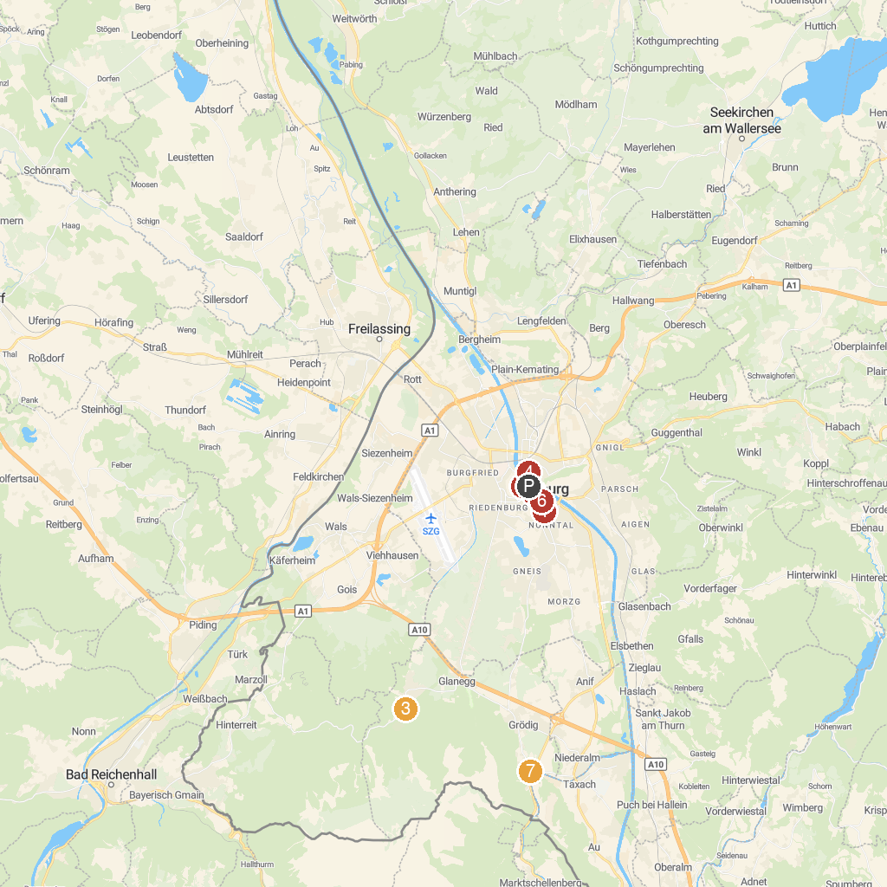
MAP KEY
1. Burgruine Thürndl | 5. Mirabell Palace
2. Fortress Hohensalzburg | 6. Mozart's Birthplace
3. Haus der Natur | 7. Salzburg Cathedral
4. Untersbergmuseum Grödig-Fürstenbrunn | 8. Untersbergbahn GmbH
P. Cruise port / terminal
Map © MapTiler © OpenStreetMap contributors · cruiseports.org

