Samaná, Samaná Province, Dominican Republic
A lush, coconut-draped peninsula where humpback whales winter in the bay and waterfalls plunge through rainforest. Samaná rewards cruisers who go beyond the pier.
⚓ Tender (anchors in bay) · 🕒 Typical call: 7-9 hrs · 💵 USD widely accepted / Dominican Peso · 🗣️ Spanish (basic English at tourist spots) · 🐋 Whale watching: Jan–Mar
✍️ MY DAY IN PORT (FILL IN)
Ship / Date
In port | arrive ______ · all aboard ______
Booked excursion
Notes / meeting point
GETTING ASHORE
- Docking: Tender — ships anchor in Samaná Bay; 15-min tender to public pier
- Walk to center: Step off tender onto the Malecón — town is immediate
- Best For: Humpback whale watching, Cayo Levantado beach, El Limón waterfall, Los Haitises caves
- Don't Miss: Cayo Levantado (Bacardi Island) by water taxi; 15-min ride from pier
GETTING AROUND
- 🚕 Taxi: $3–5 USD — Official taxis wait just outside the port and charge roughly $3–5 USD to the town center (5–10 min). Always agree on the
TOP THINGS TO DO
- Humpback Whale Watching — From mid-January through late March, thousands of North Atlantic humpback whales gather in Samaná Bay to mate and calve.
- Cayo Levantado (Bacardi Island) — A postcard-perfect island in the middle of the bay with powdery white sand and turquoise water.
- El Limón Waterfall — A 130-foot cascade hidden in dense tropical rainforest.
- Los Haitises National Park — Accessible only by boat, this protected park features dramatic limestone karst formations rising from the water, dense mangrove…
- Playa Rincón — Consistently ranked among the world's top beaches — a vast, wild crescent of white sand backed by coconut palms, with a…
BEST WALKS
- Malecón to the Bridge to Nowhere: 2 km round-trip · Flat · 30-40 min — Head along the waterfront Malecón from the tender pier past Pueblo Príncipe shopping and La Churcha…
- Town Center & Market Stroll: 1 km · Flat · 20 min — From the pier, walk the Malecón past waterfront restaurants and vendors.
WEATHER · DAYLIGHT · MONEY
Month | High °F | Low °F | Rainy days
May | 84 | 75 | 20
Jul | 86 | 77 | 21
Sep | 86 | 77 | 22
Daylight: May 6:02AM–7:05PM · Jul 6:08AM–7:18PM · Sep 6:25AM–6:39PM
cruiseports.org/samana · Confirm terminal & all-aboard time with your ship

Samaná, Samaná Province, Dominican Republic — Port Map
Red = walkable sights · Amber = excursions farther out · P = cruise terminal
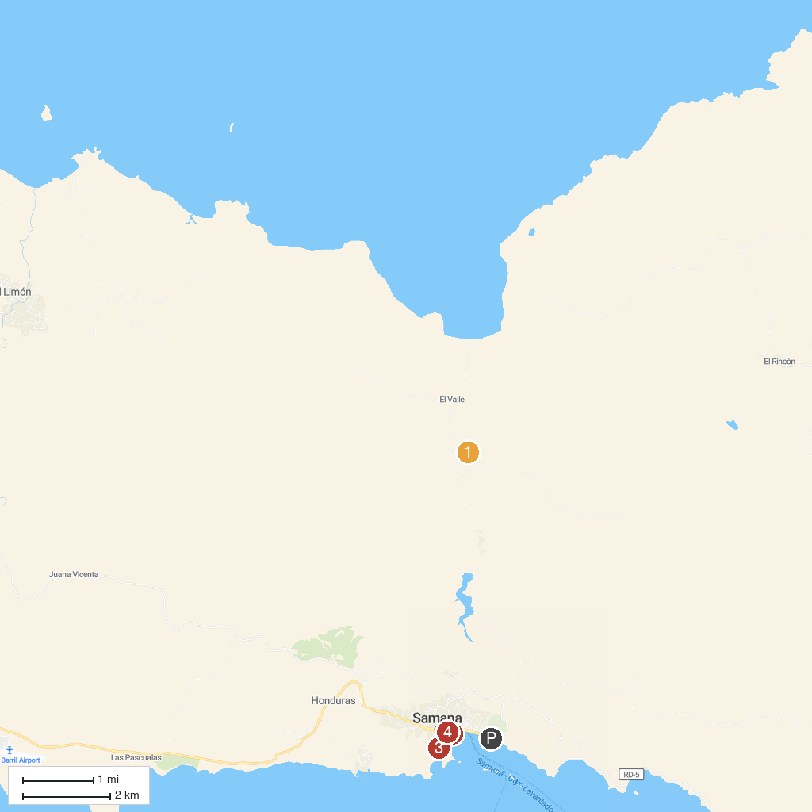
MAP KEY
1. Cascada Lulu - Waterfall | 3. Whale Museum of Samana / Nature Center
2. Samaná Boardwalk | 4. Las Casitas de Colores
P. Cruise port / terminal
Map © MapTiler © OpenStreetMap contributors · cruiseports.org

