Samos Island, Eastern Aegean, Greece
Birthplace of Pythagoras, home to a UNESCO aqueduct tunnel, and draped in Muscat vines — Samos rewards curious cruisers with history, beaches, and honest Greek cooking.
⚓ Pier (Vathy) / Tender (Pythagorion) · 🕒 Typical call: 7-9 hrs · 💶 Currency: Euro (€) · 🗣️ Language: Greek (English widely spoken)
✍️ MY DAY IN PORT (FILL IN)
Ship / Date
In port | arrive ______ · all aboard ______
Booked excursion
Notes / meeting point
GETTING ASHORE
- Docking: Vathy: pier for ships up to 150 m; Pythagorion: anchor + tender
- Walk to center: Vathy old port: immediate; Malagari pier: ~15 min walk. Pythagorion: immediate from tender dock
- Best For: Ancient history, beaches, wine tasting, scenic hill villages
- Don't Miss: Tunnel of Eupalinos (Pythagorion) or Kouros statue at Vathy's Archaeological Museum
GETTING AROUND
- 🚕 Taxi: €5–€15 — Regulated metered taxis with a base fare of ~€2.90 plus ~€1.80/km. Short rides within Vathy are cheap; longer trips to b
- 📱 Rideshare: ❌ not available
TOP THINGS TO DO
- Tunnel of Eupalinos — A 1,036-meter aqueduct carved through a mountain in the 6th century BC — dug simultaneously from both ends and meeting with…
- Heraion & Archaeological Museum — Visit the Temple of Hera — once one of the largest Greek temples ever built — then head to Vathy's Archaeological Museum to see…
- Beach Day — Psili Ammos or Potokaki — Psili Ammos offers shallow, fine-sand water with Turkey's coast visible across the strait.
- Samos Muscat Wine Tasting — The island's sweet White Muscat — Samos Nectar and Samos Vin Doux — has been prized since antiquity.
- Ano Vathy Village Walk — A steep 15-minute climb above Vathy port leads to the old town, a preserved maze of narrow lanes, 19th-century stone houses with…
BEST WALKS
- Pythagorion Harbor & Pythagoras Statue: 1.5 km · 30-45 min · Flat · Easy — From the tender dock, stroll the pedestrianized promenade west past waterfront tavernas, continue…
- Vathy Waterfront to Ano Vathy: 2 km loop · 1 hr · Hilly finish · Moderate — Start at Pythagoras Square on the Vathy waterfront, walk the harbor promenade, then head uphill…
WEATHER · DAYLIGHT · MONEY
Month | High °F | Low °F | Rainy days
May | 75 | 63 | 5
Jul | 90 | 75 | 0
Sep | 83 | 71 | 2
Daylight: May 6:02AM–8:14PM · Jul 6:02AM–8:33PM · Sep 6:54AM–7:19PM
cruiseports.org/samos-island · Confirm terminal & all-aboard time with your ship

Samos Island, Eastern Aegean, Greece — Port Map
Red = walkable sights · Amber = excursions farther out · P = cruise terminal
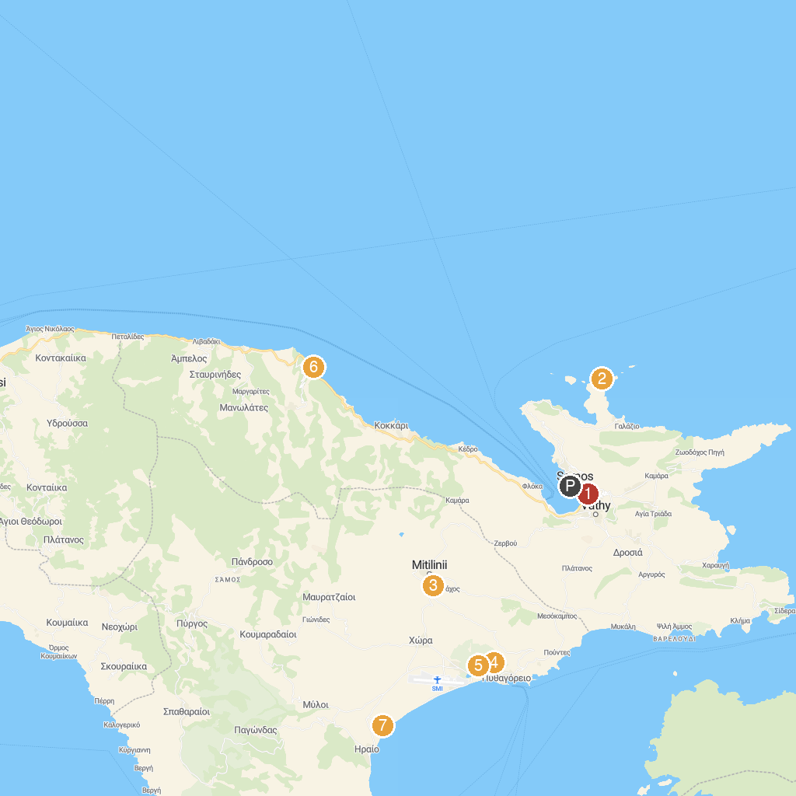
MAP KEY
1. Archaeological Museum of Vathi, Samos | 5. Eupalinus Aqueduct
2. Livadaki Beach bar Samos | 6. Avlakia Beach
3. Μουσείο Φυσικής Ιστορίας Αιγαίου | 7. Archaeological Site of Heraion of Samos
4. Panagia Spiliani Holy Monastery | 8. Ιερά Μονή Μεγάλης Παναγιάς Σάμου
P. Cruise port / terminal
Map © MapTiler © OpenStreetMap contributors · cruiseports.org

