San Antonio, Valparaíso Region, Chile
Once overshadowed by Valparaíso, San Antonio has become Chile's go-to cruise turnaround hub — a springboard to Santiago's skyline, hillside street art, Nobel-winning poetry, and world-class Casablanca wines.
⚓ Pier (docked) · 🕒 Typical call: 8–10 hrs (often turnaround port) · 💵 Chilean Peso (CLP) · 🗣️ Spanish
✍️ MY DAY IN PORT (FILL IN)
Ship / Date
In port | arrive ______ · all aboard ______
Booked excursion
Notes / meeting point
GETTING ASHORE
- Docking: Pier — DP World Puerto Central terminal, free shuttle to passenger terminal
- Walk to Center: 5 min from terminal to Paseo Bellamar waterfront
- Best For: Santiago day trip, wine tasting, Pablo Neruda's Isla Negra house
- Don't Miss: Wild sea lions at the Puertecito fish market — free and unforgettable
GETTING AROUND
- 🚕 Taxi: $5–$10 USD — Short taxi rides within San Antonio are inexpensive. The local bus terminal is also reachable on foot or by a brief taxi
- 📱 Rideshare: ✅ Uber, DiDi
TOP THINGS TO DO
- Isla Negra — Pablo Neruda's Clifftop House — Chile's most visited literary site sits 30 minutes north on a windswept cliff.
- Valparaíso & Viña del Mar — UNESCO-listed Valparaíso is Chile's most photogenic city — steep hills, historic funicular elevators (ascensores), and murals…
- Casablanca Valley Wine Tasting — One of the world's premier cool-climate wine regions lies 45 minutes northeast.
- Santiago City Tour — Chile's capital is 90–120 minutes east.
- Humedal Río Maipo Birdwatching — The wetlands at the mouth of the Maipo River, just south of the port, shelter thousands of migratory birds including black-necked…
BEST WALKS
- Paseo Bellamar & the Sea Lions: 1.5 km · Flat · 30–45 min — From the passenger terminal, head north along the Paseo Bellamar boardwalk past craft stalls and…
- Mirador 21 de Mayo Viewpoint: 2 km round-trip · Uphill · 45 min — From the terminal, walk uphill through the town center to this hilltop viewpoint.
WEATHER · DAYLIGHT · MONEY
Month | High °F | Low °F | Rainy days
May | 86 | 68 | 15
Jul | 96 | 76 | 6
Sep | 90 | 73 | 10
Daylight: May 6:41AM–8:19PM · Jul 6:44AM–8:34PM · Sep 7:19AM–7:38PM
cruiseports.org/san-antonio · Confirm terminal & all-aboard time with your ship

San Antonio, Valparaíso Region, Chile — Port Map
Red = walkable sights · Amber = excursions farther out · P = cruise terminal
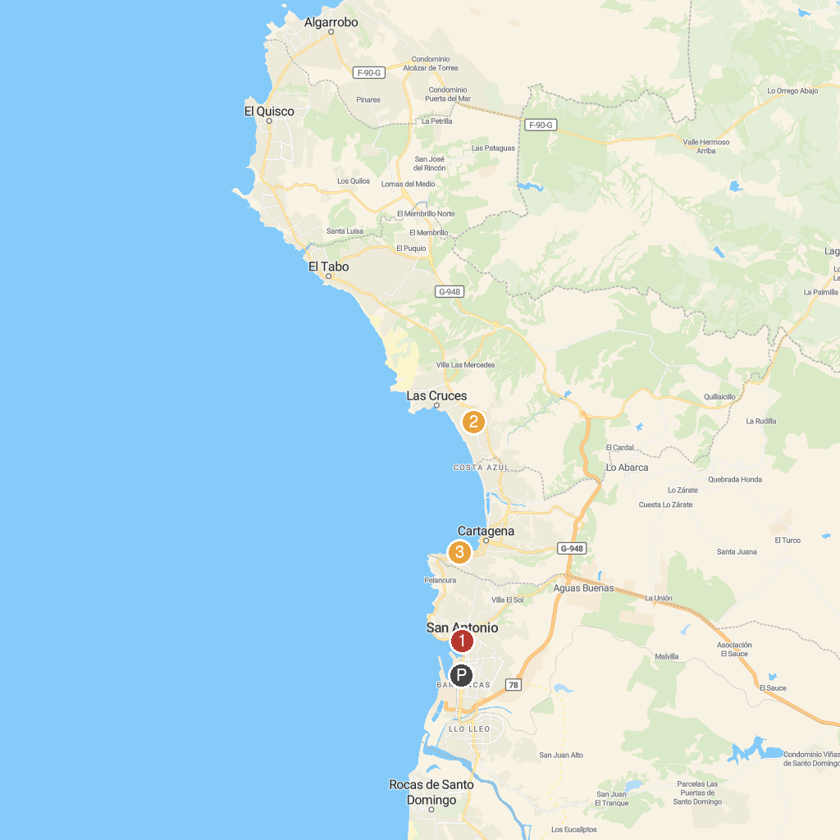
MAP KEY
1. Paseo Bellamar | 3. Caleta San Pedro
2. Sanctuary Laguna el Peral
P. Cruise port / terminal
Map © MapTiler © OpenStreetMap contributors · cruiseports.org

