San Blas Islands, Guna Yala, Panama
Some 365 islands strung along Panama's Caribbean coast, governed entirely by the indigenous Guna people — no cruise piers, no chain hotels, no ATMs, just postcard-perfect white sand and turquoise water the way the Caribbean used to look.
⚓ Tender only (no pier) · 🕒 Typical call: 6–8 hrs · 💵 USD cash only · 🗣️ Guna / Spanish
✍️ MY DAY IN PORT (FILL IN)
Ship / Date
In port | arrive ______ · all aboard ______
Booked excursion
Notes / meeting point
GETTING ASHORE
- Docking: Tender only — ships anchor offshore; 15–30 min ride to landing island
- Walk to Center: 5–15 min across any given island (they're tiny)
- Best For: Snorkeling, beach days, Guna culture, mola shopping
- Don't Miss: Isla Perro shipwreck snorkel and a fresh lobster lunch on the beach
GETTING AROUND
- 📱 Rideshare: ❌ not available
TOP THINGS TO DO
- Isla Perro Shipwreck Snorkel — A 1940s cargo ship rests in the shallows off Isla Perro, now encrusted with coral and swarming with tropical fish.
- Natural Pools (Piscina Natural) — Shallow sandbars rise from open water creating waist-deep turquoise pools — you boat out and step into the middle of the sea.
- Guna Village Walk & Mola Shopping — Walk through a traditional Guna village — bamboo chozas, hammocks, dugout canoes — and buy molas directly from the women who sew…
- Island-Hopping Lancha Charter — Hire a Guna motorized canoe to visit three or four islands in a day — Isla Pelícano, Isla Diablo, Chichime — each with its own…
- Coral Reef Snorkel at Chichime — The reef around Chichime cay is one of Guna Yala's healthiest, with visibility often exceeding 25 metres.
BEST WALKS
- El Porvenir Village Stroll: ~15 min • Flat sand • Cultural — Walk the full perimeter of Isla El Porvenir, Panama's Guna Yala administrative capital.
- Nalunega Beach Walk: ~10 min • White sand • Easy — Stroll the beach fringe of Isla Nalunega, one of the most visited Guna communities.
WEATHER · DAYLIGHT · MONEY
Month | High °F | Low °F | Rainy days
May | 84 | 76 | 30
Jul | 84 | 76 | 30
Sep | 85 | 76 | 29
Daylight: May 5:55AM–6:28PM · Jul 6:03AM–6:40PM · Sep 6:05AM–6:15PM
cruiseports.org/san-blas-islands-panama · Confirm terminal & all-aboard time with your ship

San Blas Islands, Guna Yala, Panama — Port Map
Red = walkable sights · Amber = excursions farther out · P = cruise terminal
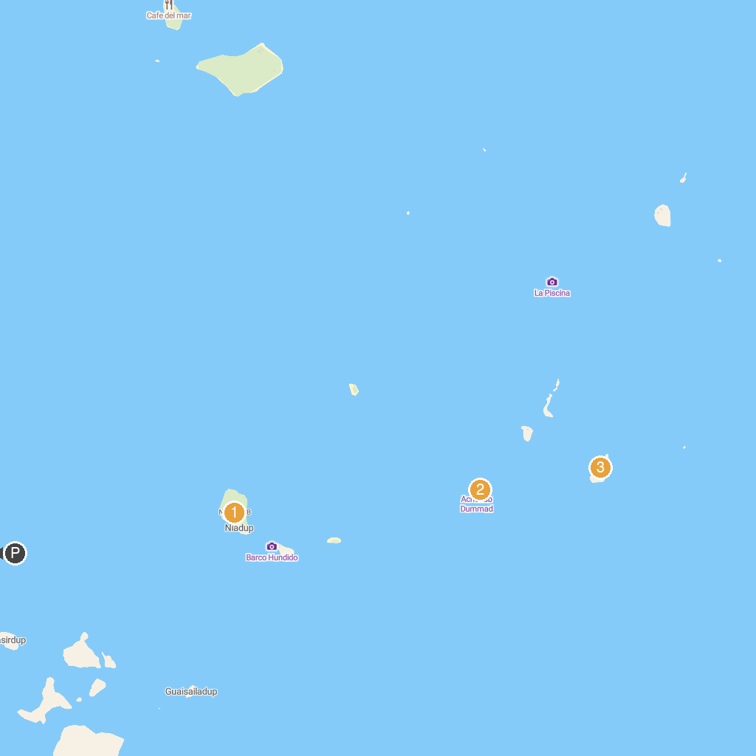
MAP KEY
1. Isla Diablo (Cabañas Niadub) | 3. Nugnudub
2. Achudub Dummad ,Perro Grande
P. Cruise port / terminal
Map © MapTiler © OpenStreetMap contributors · cruiseports.org

