San Cristobal Island, Galapagos, Ecuador
Where Charles Darwin first set foot in the Galapagos, sea lions sleep on park benches and marine iguanas sun themselves on the pier — wildlife doesn't just live here, it owns the place.
⚓ Tender port · 🕒 Typical call: 6–9 hrs · 💵 US Dollar (USD) · 🗣️ Spanish (English widely spoken) · 🦭 Wildlife-rich
✍️ MY DAY IN PORT (FILL IN)
Ship / Date
In port | arrive ______ · all aboard ______
Booked excursion
Notes / meeting point
GETTING ASHORE
- Docking: Tender — ships anchor in Shipwreck Bay (Bahía Naufragio)
- Walk to center: 2 min from tender pier to waterfront; town fully walkable
- Best For: Wildlife encounters, snorkeling, Darwin history, tortoise viewing
- Don't Miss: Kicker Rock (Leόn Dormido) snorkel tour and Cerro Tijeretas frigatebird hill
GETTING AROUND
- 🚕 Taxi: $2–$4 per ride — White pickup trucks serve as taxis around town and to nearby sites. Fares are low and mostly standardized; always confir
TOP THINGS TO DO
- Kicker Rock (León Dormido) Snorkel Tour — The island's signature excursion.
- Cerro Tijeretas (Frigatebird Hill) Walk — A paved trail from the Interpretation Center climbs to a hilltop where both Magnificent and Great Frigatebirds nest side by side.
- La Galapaguera de Cerro Colorado — Giant Tortoise Reserve — A semi-natural breeding center in the highlands, about 35 minutes by taxi, where you can see the endangered San Cristobal Giant…
- El Junco Lagoon & Highlands Tour — The only permanent freshwater lake in the Galapagos sits in a volcanic caldera in the highlands.
- Isla Lobos Sea Lion & Booby Snorkel — A short boat hop to a small islet where Blue-footed Boobies nest close to the trail and a large sea lion colony invites…
BEST WALKS
- Malecón to Playa Mann: 1.2 km · 15 min · Easy — Walk the waterfront Malecón (Avenida Charles Darwin) north from the pier, past sea-lion-occupied…
- Town to Cerro Tijeretas via Interpretation Center: 2.5 km · 40 min · Easy–Moderate — Head north along the waterfront, past the Interpretation Center (free, worth a stop), and continue…
WEATHER · DAYLIGHT · MONEY
Month | High °F | Low °F | Rainy days
May | 79 | 74 | 8
Jul | 75 | 71 | 4
Sep | 73 | 68 | 4
Daylight: May 5:52AM–5:56PM · Jul 6:02AM–6:06PM · Sep 5:50AM–5:56PM
cruiseports.org/san-cristobal-island · Confirm terminal & all-aboard time with your ship

San Cristobal Island, Galapagos, Ecuador — Port Map
Red = walkable sights · Amber = excursions farther out · P = cruise terminal
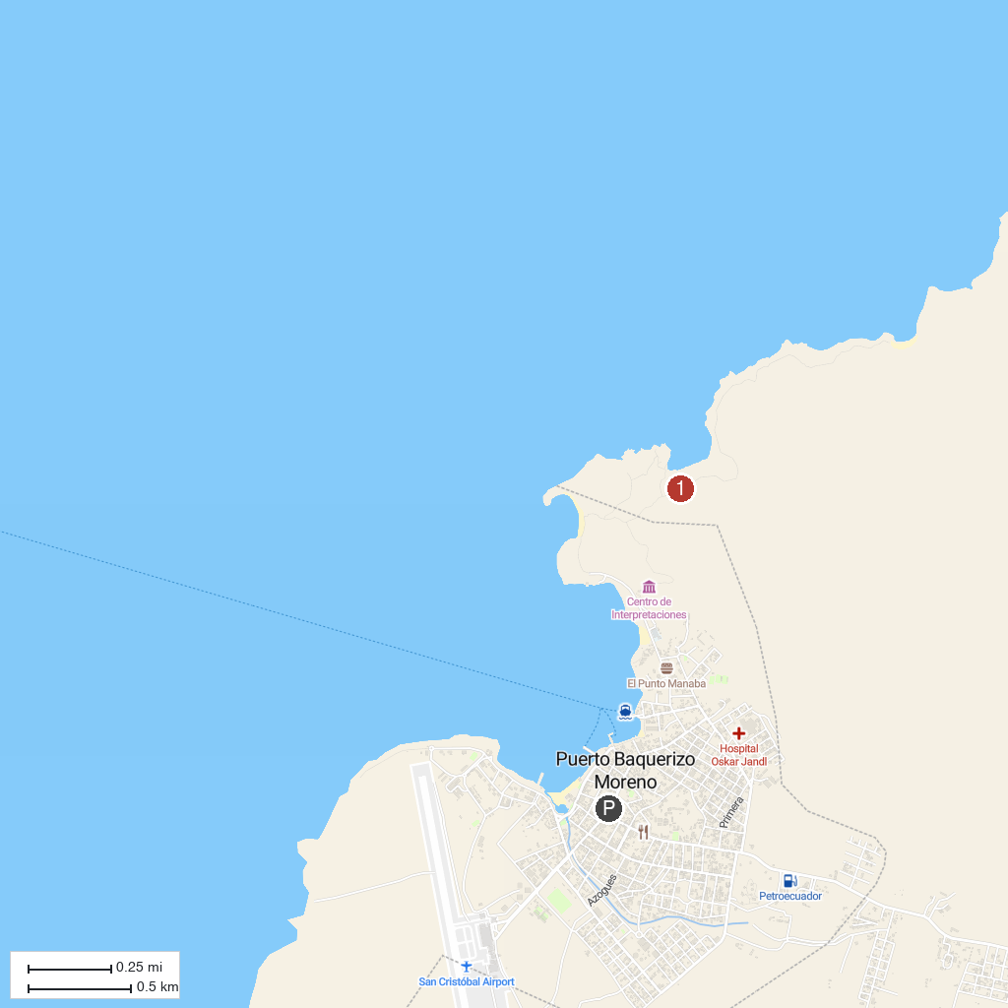
MAP KEY
1. Galapaguera de Cerro Colorado | 2. Mirador Cerro Tijeretas
P. Cruise port / terminal
Map © MapTiler © OpenStreetMap contributors · cruiseports.org

