San Diego, California, USA
Southern California's crown jewel docks cruise ships steps from the Gaslamp Quarter, a decommissioned aircraft carrier turned museum, and one of the world's great zoos — all under near-permanent sunshine.
⚓ Docked (pier) · 🕒 Typical call: 8-10 hrs (homeport or turnaround) · 💵 USD · 🗣️ English · ☀️ 266 sunny days per year
✍️ MY DAY IN PORT (FILL IN)
Ship / Date
In port | arrive ______ · all aboard ______
Booked excursion
Notes / meeting point
GETTING ASHORE
- Docking: B Street Pier (2 berths) or Broadway Pier — both on the downtown Embarcadero
- Walk to center: Gaslamp Quarter ~10 min; Little Italy ~15 min; USS Midway 5 min
- Best For: Families, history buffs, foodies, and beach lovers
- Don't Miss: USS Midway Museum, San Diego Zoo, and the Coronado ferry
GETTING AROUND
- 🚕 Taxi: $8–20 — Taxis queue at the terminal and can reach most downtown destinations in under 10 minutes. Metered fares start around $2.
- 📱 Rideshare: ✅ Uber, Lyft
- 🚌 Hop-on hop-off: ✅ Old Town Trolley Tours
TOP THINGS TO DO
- USS Midway Museum — The world's longest-serving 20th-century naval aircraft carrier is moored steps from the pier.
- San Diego Zoo & Balboa Park — Widely considered one of the world's best zoos, with 4,000+ animals in open-air habitats across 800 species.
- Coronado Island & Hotel del Coronado — Take the 15-minute ferry from Broadway Pier to Coronado.
- Gaslamp Quarter & Downtown Walk — San Diego's historic 16-block Victorian district buzzes with restaurants, galleries, and rooftop bars.
- Maritime Museum of San Diego — A fleet of historic vessels moored on the Embarcadero, including the Star of India (1863), the world's oldest active sailing ship.
BEST WALKS
- Embarcadero Waterfront Walk: 3 miles round-trip · Flat · 60-90 min — The classic San Diego cruise walk: head south from the pier past the USS Midway, Seaport Village…
- Gaslamp Quarter History Stroll: 1.5 miles · Flat · 45-60 min — Walk southeast from the pier into the Gaslamp Quarter's 16-block Victorian Historic District.
WEATHER · DAYLIGHT · MONEY
Month | High °F | Low °F | Rainy days
May | 68 | 58 | 3
Jul | 76 | 65 | 0
Sep | 78 | 65 | 1
Daylight: May 5:49AM–7:40PM · Jul 5:52AM–7:57PM · Sep 6:32AM–6:54PM
ESSENTIAL TRAVEL QUALIFICATIONS
MTS bus: $3.00 standard adult one-way (checked 3 Oct 2026).
cruiseports.org/san-diego · Confirm terminal & all-aboard time with your ship

San Diego, California, USA — Port Map
Red = walkable sights · Amber = excursions farther out · P = cruise terminal
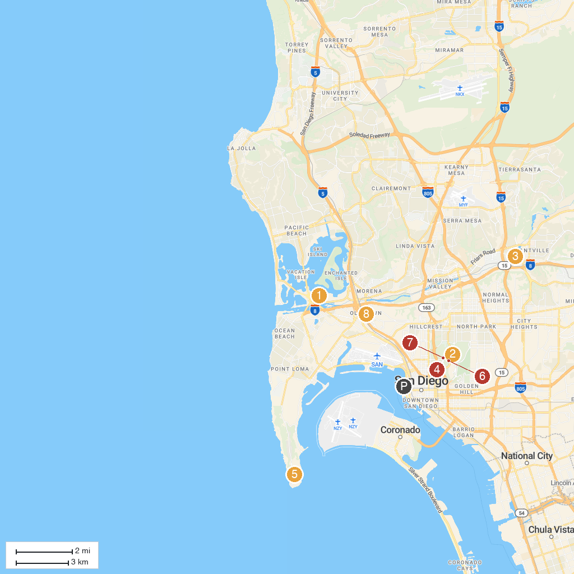
MAP KEY
1. SeaWorld San Diego | 5. Cabrillo National Monument
2. Balboa Park | 6. Fleet Science Center
3. Mission Basilica San Diego de Alcalá | 7. The San Diego Museum of Art
4. San Diego Air & Space Museum | 8. Old Town San Diego State Historic Park
P. Cruise port / terminal
Map © MapTiler © OpenStreetMap contributors · cruiseports.org

