San Juan del Sur, Rivas, Nicaragua
A crescent bay framed by jungle hills, a giant Christ statue gazing over the Pacific, and surf beaches just a short ride away — San Juan del Sur delivers an easygoing Nicaragua in a single shore day.
⚓ Tender port · 🕒 Typical call: 7-9 hrs · 💵 USD & Nicaraguan Córdoba · 🗣️ Spanish · 🏄 Surf & beach town
✍️ MY DAY IN PORT (FILL IN)
Ship / Date
In port | arrive ______ · all aboard ______
Booked excursion
Notes / meeting point
GETTING ASHORE
- Docking: Tender — ships anchor in the bay; tenders land at the municipal pier
- Walk to centre: 2-3 min from the tender pier to the main beach and market
- Best For: Beach relaxation, surfing, hiking to the Cristo statue, zip-lining
- Don't Miss: Cristo de la Misericordia viewpoint — giant hilltop Christ statue (~110 m above the bay) with panoramic views
GETTING AROUND
- 🚕 Taxi: $2-5 USD — Taxis wait at the tender dock and are readily available throughout town. Always negotiate and agree on a fare before get
TOP THINGS TO DO
- Cristo de la Misericordia Hike & Views — Hike or take a short taxi up to the base of the giant Cristo statue on the hilltop overlooking the bay, roughly 110 m above the…
- Surf Lesson at Playa Maderas — Playa Maderas, about 10 km north of town, is one of Nicaragua's top surf beaches.
- Olive Ridley Turtle Tour (Seasonal) — Between July and January, Olive Ridley sea turtles nest on nearby beaches.
- Zip-Line Canopy Tour — Several operators run zip-line tours through the jungle hills surrounding the bay, with platforms offering aerial views of the…
- Beach Day at Playa Hermosa — Playa Hermosa, a few kilometres south, is a quieter alternative to the town beach — good swimming and far fewer vendors.
BEST WALKS
- Bay Promenade & Town Wander: 1.5 km · 30 min · Easy · Flat — Walk south from the tender pier along the beach road, past restaurants and souvenir stalls, to the…
- Cristo de la Misericordia Hilltop: 2 km round-trip · 45-60 min · Moderate · Steep — From the south end of town, follow the signed path uphill to the base of the giant Cristo statue.
WEATHER · DAYLIGHT · MONEY
Month | High °F | Low °F | Rainy days
May | 88 | 77 | 18
Jul | 84 | 76 | 25
Sep | 84 | 76 | 27
Daylight: May 5:20AM–5:59PM · Jul 5:28AM–6:10PM · Sep 5:33AM–5:43PM
cruiseports.org/san-juan-del-sur · Confirm terminal & all-aboard time with your ship

San Juan del Sur, Rivas, Nicaragua — Port Map
Red = walkable sights · Amber = excursions farther out · P = cruise terminal
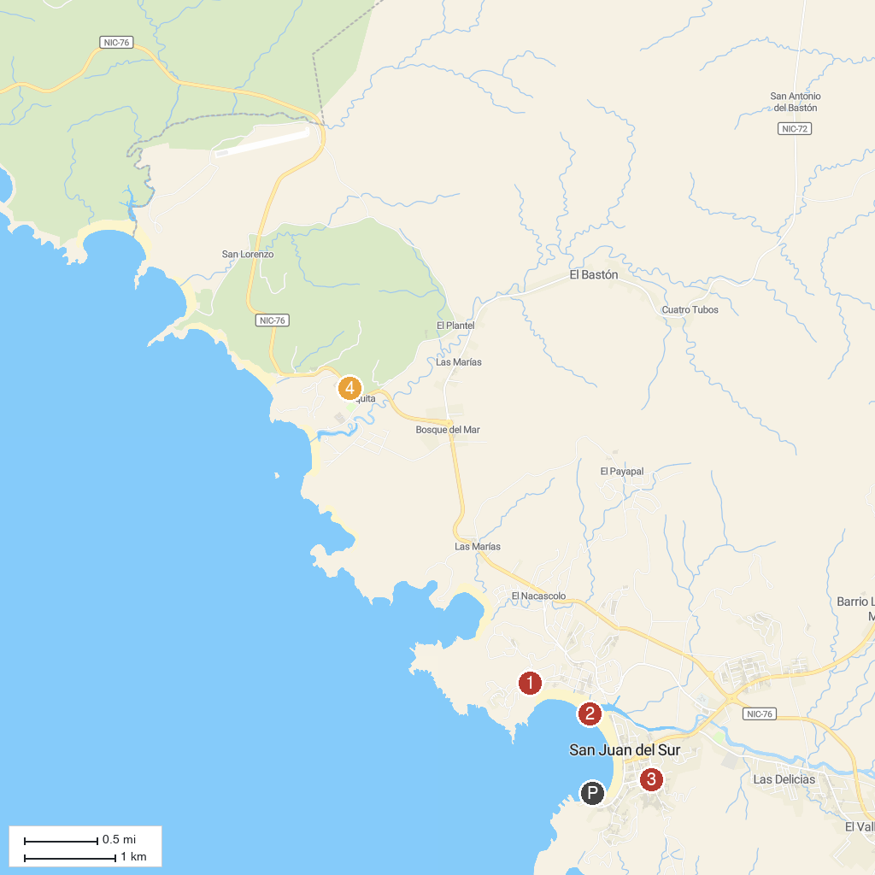
MAP KEY
1. Cristo de la Misericordia | 3. Iglesia San Juan Bautista
2. Playa San Juan del Sur | 4. Playa Maderas
P. Cruise port / terminal
Map © MapTiler © OpenStreetMap contributors · cruiseports.org

