San Juan, Puerto Rico, USA
Puerto Rico's capital delivers one of the Caribbean's most rewarding cruise days — a UNESCO-listed walled city, two massive Spanish forts, and some of the best rum and food in the region, all starting steps from the pier.
⚓ Docked (pier) · 🕒 Typical call: 8–12 hrs · 💵 USD · 🗣️ Spanish / English · 🌴 Caribbean
✍️ MY DAY IN PORT (FILL IN)
Ship / Date
In port | arrive ______ · all aboard ______
Booked excursion
Notes / meeting point
GETTING ASHORE
- Docking: Old San Juan Piers 1, 3, 4 & 6 (walkable to historic district); larger and homeport ships use Pan American Pier on Isla Grande (short taxi). $425M port modernization underway through 2026–27.
- Walk to center: Pier 1/3/4/6: 2–5 min walk to Paseo de la Princesa and the walled city. Pan American Pier: 10–15 min taxi.
- Best For: History, walking, rum, beaches, rainforest day trips
- Don't Miss: El Morro at opening time, a piña colada at Barrachina (the birthplace), and the Bacardí ferry
GETTING AROUND
- 🚕 Taxi: $8-20 USD — Fixed-rate taxis from the cruise piers run ~$15-20 to Condado from Old San Juan piers and ~$8-12 to Old San Juan from th
- 📱 Rideshare: ✅ Uber, Lyft
- 🚌 Hop-on hop-off: ✅ City Sightseeing San Juan
TOP THINGS TO DO
- Castillo San Felipe del Morro — The 16th-century Atlantic-facing citadel at the tip of the peninsula is one of the most photographed fortresses in the Americas.
- Castillo San Cristóbal — The largest Spanish fort built in the New World, designed to defend against land attacks.
- Old San Juan Walking Tour — Blue cobblestone alleys, La Fortaleza (oldest executive mansion in the Americas), the Cathedral of San Juan Bautista…
- El Yunque Rainforest — The only tropical rainforest in the US National Forest System, about 45 minutes east.
- Casa Bacardí Rum Distillery — Puerto Rico is rum country and Bacardí started here.
BEST WALKS
- The Fort Walk: 3 km · 2–2.5 hrs · Moderate — From the pier, follow Paseo de la Princesa past the Raíces Fountain, through the San Juan Gate…
- Old San Juan Culture Loop: 1.5 km · 1 hr · Easy — A tight loop through the heart of the walled city: Calle Fortaleza (restaurants, shops, umbrella…
WEATHER · DAYLIGHT · MONEY
Month | High °F | Low °F | Rainy days
May | 88 | 74 | 16
Jul | 89 | 77 | 18
Sep | 88 | 77 | 22
Daylight: May 5:50AM–6:50PM · Jul 5:56AM–7:04PM · Sep 6:12AM–6:26PM
ESSENTIAL TRAVEL QUALIFICATIONS
Current old free municipal trolley operation unconfirmed; do not rely on a scheduled fort loop. Advertised shore-excursion trolley is a separate service.
cruiseports.org/san-juan · Confirm terminal & all-aboard time with your ship

San Juan, Puerto Rico, USA — Port Map
Red = walkable sights · Amber = excursions farther out · P = cruise terminal
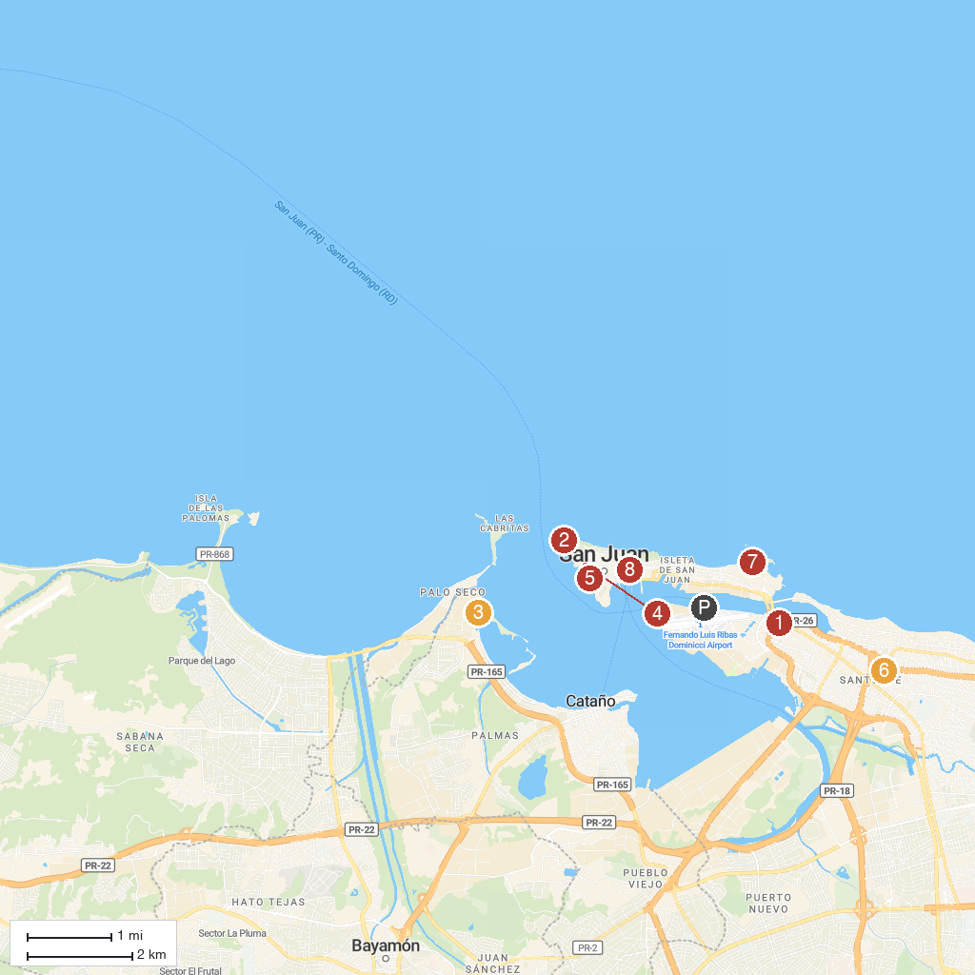
MAP KEY
1. Capilla Nuestra Señora de Lourdes | 5. La Fortaleza
2. Castillo San Felipe del Morro | 6. Museo de Arte de Puerto Rico
3. Casa BACARDÍ | 7. Balneario El Escambrón
4. Casa Blanca | 8. Teatro Alejandro Tapia y Rivera
P. Cruise port / terminal
Map © MapTiler © OpenStreetMap contributors · cruiseports.org

