San Sebastian de la Gomera, La Gomera, Spain
The last port Columbus touched before America — a sleepy volcanic island capital where laurel forests drip in mist, locals whistle across ravines, and the pier drops you five minutes from 500-year-old history.
⚓ Docked (pier) · 🕒 Typical call: 6–8 hrs · 💶 Currency: Euro (€) · 🗣️ Language: Spanish
✍️ MY DAY IN PORT (FILL IN)
Ship / Date
In port | arrive ______ · all aboard ______
Booked excursion
Notes / meeting point
GETTING ASHORE
- Docking: Docked at Dique de San Sebastián — no tender
- Walk to center: 5–10 min flat walk to Plaza de las Américas
- Best For: Columbus history, UNESCO rainforest, volcanic scenery
- Don't Miss: Torre del Conde, Garajonay National Park, Silbo demo
GETTING AROUND
- 🚕 Taxi: ~€3–4 — Taxis are available at the port. The ride to town is very short; meter starts at €3.50 plus €1.10/km. Agree on fare in a
- 📱 Rideshare: ❌ not available
TOP THINGS TO DO
- Columbus Trail: Torre del Conde & Casa de Colón — The 15th-century Torre del Conde is the oldest military building in the Canary Islands.
- Garajonay National Park — A UNESCO World Heritage laurisilva forest — prehistoric laurel trees draped in mist at the island's volcanic heart.
- Silbo Gomero — The Whistled Language — La Gomera is the only place on Earth where an entire population communicates by whistling.
- Black Sand Beaches — Playa de San Sebastián sits a 5-minute walk left of the pier — calm, protected harbour swimming with showers.
- Mirador de Abrante Glass Skywalk — A glass-bottomed viewing platform hanging 400 metres above the cliffs near Agulo, with sweeping views over the village and across…
BEST WALKS
- Columbus Quarter Loop: 45 min · Easy · Flat — Hit all the historic landmarks in one easy loop from the pier: Torre del Conde park → Iglesia de la…
- Waterfront to Playa de la Cueva: 20 min · Easy · Paved — Follow the promenade right from the port past the ferry terminal, through a short pedestrian tunnel…
WEATHER · DAYLIGHT · MONEY
Month | High °F | Low °F | Rainy days
May | 75 | 65 | 1
Jul | 81 | 70 | 0
Sep | 82 | 72 | 2
Daylight: May 7:18AM–8:51PM · Jul 7:22AM–9:06PM · Sep 7:53AM–8:12PM
cruiseports.org/san-sebastian-de-la-gomera · Confirm terminal & all-aboard time with your ship

San Sebastian de la Gomera, La Gomera, Spain — Port Map
Red = walkable sights · Amber = excursions farther out · P = cruise terminal
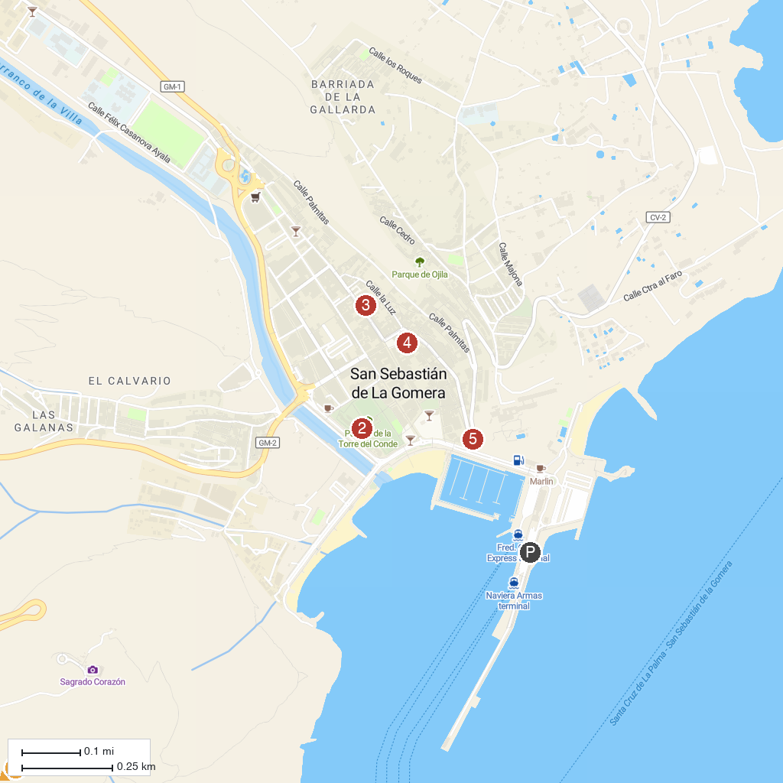
MAP KEY
1. Parque Nacional de Garajonay | 4. Casa de Colón
2. Gomera Walking | 5. Archaeological Museum of La Gomera
3. Torre del Conde Park | 6. Mirador de la Hila
P. Cruise port / terminal
Map © MapTiler © OpenStreetMap contributors · cruiseports.org

