Sankt Goarshausen, Rhineland-Palatinate, Germany
A storybook Rhine village beneath the legendary Loreley cliff, where river cruisers tie up steps from castles, vineyards, and one of Europe's most dramatic gorges.
⚓ Docked (KD pier) · 🕒 Typical call: 5–8 hrs · 💶 Euro (€) · 🗣️ German
✍️ MY DAY IN PORT (FILL IN)
Ship / Date
In port | arrive ______ · all aboard ______
Booked excursion
Notes / meeting point
GETTING ASHORE
- Docking: KD landing stage, central waterfront — step off into town
- Walk to centre: 2 min to old town; Loreley plateau 30–40 min on foot or 7 min by taxi
- Best For: Loreley Rock views, Rhine castle-spotting, riverside walks
- Don't Miss: Loreley plateau panorama and the ferry crossing to Rheinfels Castle
GETTING AROUND
- 🚕 Taxi: ~€10–20 within region — Local taxis (e.g., Simone Taxi Fluck) serve the area. Useful for reaching towns not on bus routes. Arrange at the pier o
- 📱 Rideshare: ✅ Uber
TOP THINGS TO DO
- Loreley Plateau & Visitor Centre — Climb or taxi to the 132 m slate clifftop for sweeping Rhine Gorge panoramas.
- Rheinfels Castle (St. Goar) — Take the ~10-min Rhine ferry across to St.
- Loreley-Bob Alpine Coaster — A 700 m summer toboggan run on the Loreley plateau, reaching speeds up to 40 km/h — good fun after the viewpoint visit.
- Rheinsteig Trail Walk — Pick up the Rheinsteig long-distance path above town for ridge-top views over the gorge, vineyards, and Burg Katz looming overhead.
- Rhine in Flames (Rhein in Flammen) — If your call falls on the third Saturday of September, fireworks are launched from Burg Katz and Rheinfels Castle over the river…
BEST WALKS
- Rhine Promenade & Old Town Stroll: 1.5 km · Flat · 25 min — From the KD pier walk north along the waterfront past half-timbered houses to the old town centre…
- Staircase Path to Loreley Rock: 3 km · Moderate climb · 35–40 min — A signposted staircase and footpath ascends from the Rhine jetty to the Loreley plateau.
WEATHER · DAYLIGHT · MONEY
Month | High °F | Low °F | Rainy days
May | 65 | 48 | 13
Jul | 76 | 59 | 11
Sep | 68 | 53 | 9
Daylight: May 5:42AM–9:09PM · Jul 5:36AM–9:33PM · Sep 7:05AM–7:42PM
cruiseports.org/sankt-goarshausen · Confirm terminal & all-aboard time with your ship

Sankt Goarshausen, Rhineland-Palatinate, Germany — Port Map
Red = walkable sights · Amber = excursions farther out · P = cruise terminal
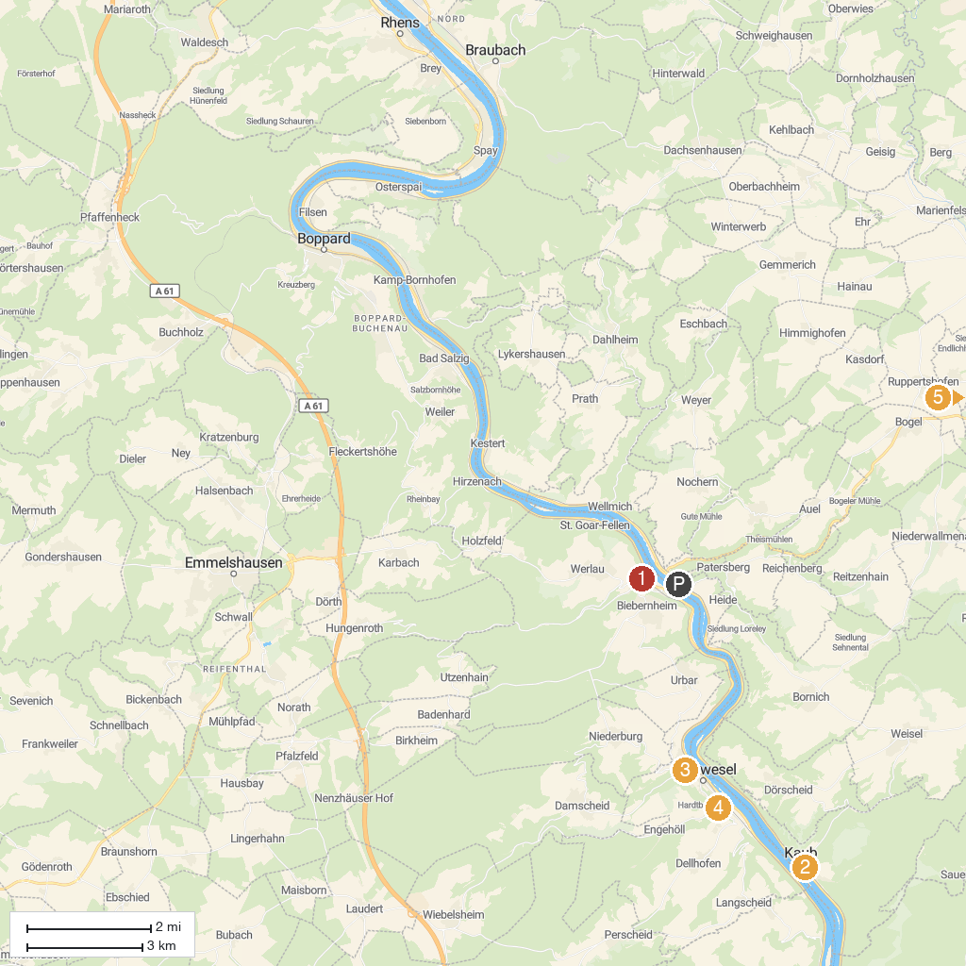
MAP KEY
1. Rheinfels Castle | 5. Turmmuseum auf Schönburg (Tower Museum)
2. Marksburg | 6. Regionalmuseum "Leben und Arbeiten"
3. Blüchermuseum Kaub | 7. Loreley-linie port
4. St. Martinskirche | 8. Karmeliterkirche
P. Cruise port / terminal
Map © MapTiler © OpenStreetMap contributors · cruiseports.org

