Santa Catalina Island, California, USA
Twenty-two miles from the Los Angeles coast, Avalon is California's quirky island getaway — golf carts, wild bison, Art Deco splendor, and sea-clear water that turns neon orange with Garibaldi fish.
⚓ Tender port · 🕒 Typical call: 7-9 hrs · 💵 USD · 🗣️ English · 🚗 No rental cars — golf carts rule
✍️ MY DAY IN PORT (FILL IN)
Ship / Date
In port | arrive ______ · all aboard ______
Booked excursion
Notes / meeting point
GETTING ASHORE
- Docking: Tender to Cabrillo Mole pier, Avalon Harbor
- Walk to center: 0.3 mi / 5-10 min along flat waterfront
- Best For: Beach clubs, golf-cart exploring, Old Hollywood history
- Don't Miss: Catalina Casino tour & Buffalo Milk cocktail
GETTING AROUND
- 🚕 Taxi: $6–$15 — White 7-passenger vans meet arriving tenders at the pier. Fares start at $5.95 with a $3 road fee; call 310-510-0025 or
- 📱 Rideshare: ❌ not available
TOP THINGS TO DO
- Catalina Casino Historic Tour — The 1929 Art Deco Casino (a gathering place, not a gambling hall) houses the world's largest circular ballroom and a 1,184-seat…
- Golf Cart Island Exploration — Rent a golf cart and follow the provided map up to Buena Vista Scenic Overlook for postcard views of your ship.
- Bison Inland Expedition — A herd of ~150 American bison roams Catalina's rugged interior — stranded since 1924 when a Hollywood film crew left them behind.
- Glass-Bottom Boat / Semi-Sub Tour — Explore the Lovers Cove Marine Preserve without getting wet.
- Descanso Beach Club — The island's premier beach club just beyond the Casino.
BEST WALKS
- Harbor Waterfront Stroll: 1 mile each way · Flat · 20-25 min one way — Walk the full arc of Avalon Bay from the Cabrillo Mole tender pier to the Catalina Casino.
- Avalon Canyon & Wrigley Botanic Garden: 1.5 miles uphill · Moderate · 30 min walk or take Garibaldi Bus — Follow Avalon Canyon Road uphill to the Wrigley Memorial — built from island stone and hand-painted…
WEATHER · DAYLIGHT · MONEY
Month | High °F | Low °F | Rainy days
May | 64 | 58 | 2
Jul | 71 | 65 | 0
Sep | 73 | 66 | 1
Daylight: May 5:53AM–7:46PM · Jul 5:55AM–8:03PM · Sep 6:37AM–6:58PM
cruiseports.org/santa-catalina-island-ca · Confirm terminal & all-aboard time with your ship

Santa Catalina Island, California, USA — Port Map
Red = walkable sights · Amber = excursions farther out · P = cruise terminal
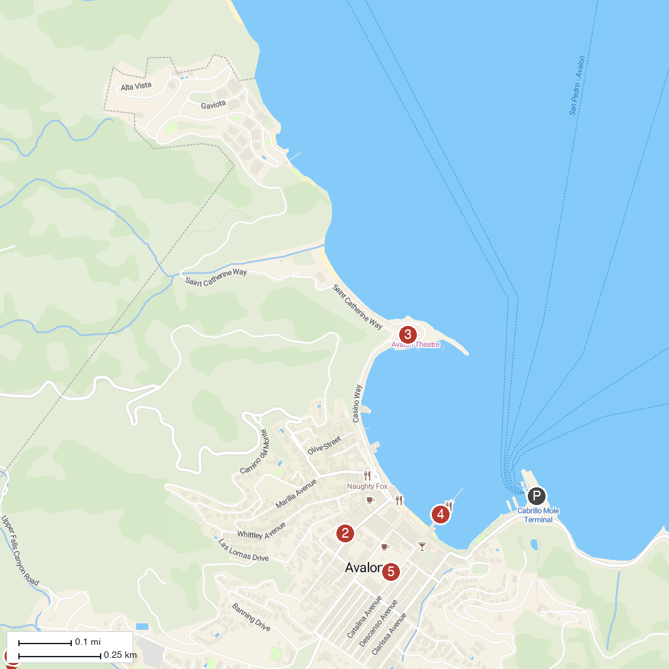
MAP KEY
1. Wrigley Memorial | 4. Catalina Island Company Ticket Booth
2. Catalina Museum For Art & History | 5. IMMERSED
3. Casino Ballroom
P. Cruise port / terminal
Map © MapTiler © OpenStreetMap contributors · cruiseports.org

