Santa Cruz de Tenerife, Tenerife, Spain
Tenerife's capital puts the world's third-largest volcano within reach of a cruise day. Ships dock steps from a walkable city center, making it one of the Atlantic's most versatile port calls.
⚓ Docked (cruise terminal) · 🕒 Typical call: 8-10 hrs · 💶 Currency: Euro (€) · 🗣️ Language: Spanish · 🌋 Volcano country
✍️ MY DAY IN PORT (FILL IN)
Ship / Date
In port | arrive ______ · all aboard ______
Booked excursion
Notes / meeting point
GETTING ASHORE
- Docking: Muelle de Santa Cruz — ships dock portside, 5-min walk to city center
- Walk to center: 5 min to Plaza de España; 10 min to Mercado de Nuestra Señora de África
- Best For: Volcano day-trips, wildlife parks, city strolls, Canarian food
- Don't Miss: Mount Teide by cable car — book ahead; views across three islands on clear days
GETTING AROUND
- 🚕 Taxi: €20–€30 — Taxis are available at the cruise terminal rank. Fare to city center is roughly €20–€30 depending on traffic; metered ri
- 📱 Rideshare: ✅ Uber, Bolt
- 🚌 Hop-on hop-off: ✅ City Sightseeing Santa Cruz de Tenerife
TOP THINGS TO DO
- Mount Teide Cable Car — Ride the cable car to La Rambleta at 3,555 m on Spain's highest peak (Teide summits at 3,718 m) for panoramic views over the…
- Loro Parque — World-renowned wildlife park in Puerto de la Cruz with orca, dolphin, sea lion, and penguin shows alongside one of the world's…
- Anaga Rural Park — Ancient laurisilva (laurel forest) draped over rugged peaks in the northeast corner of Tenerife.
- Playa de las Teresitas — Tenerife's most famous city beach — golden Saharan sand imported to a sheltered bay just 10 km from the port.
- Santa Cruz City Walk & Mercado Africano — Wander from Plaza de España past the Iglesia de la Concepción, through the Rambla de Santa Cruz, and into the vibrant Mercado de…
BEST WALKS
- Harbor to Plaza de España Loop: 1.5 km · 20 min · Flat · No map needed — Leave the port gate, turn right along Avenida de Anaga, and arrive at the grand Plaza de España…
- Rambla & Market Walk: 2.5 km · 35 min · Flat · Self-guided — From Plaza de España, follow Calle del Castillo (main shopping street) north to the Rambla de Santa…
- Waterfront to Old Town Loop: 3 km · ~1.5 hrs · Easy — A flat, shaded walk through the heart of Santa Cruz taking in the seafront promenade, the main…
WEATHER · DAYLIGHT · MONEY
Month | High °F | Low °F | Rainy days
May | 72 | 63 | 4
Jul | 77 | 68 | 2
Sep | 79 | 70 | 5
Daylight: May 7:14AM–8:48PM · Jul 7:17AM–9:04PM · Sep 7:50AM–8:09PM
cruiseports.org/santa-cruz-de-tenerife · Confirm terminal & all-aboard time with your ship

Santa Cruz de Tenerife, Tenerife, Spain — Port Map
Red = walkable sights · Amber = excursions farther out · P = cruise terminal
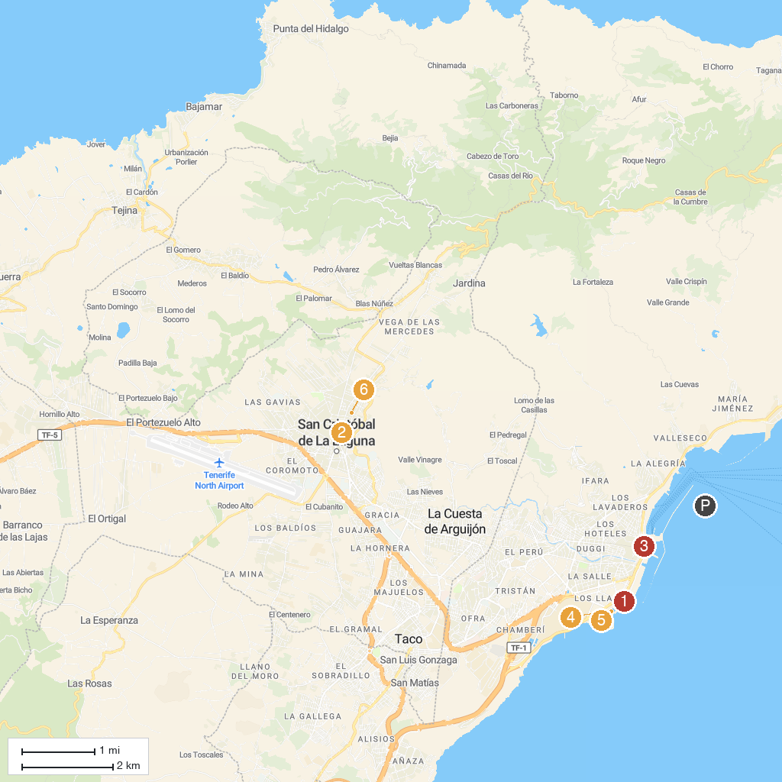
MAP KEY
1. Auditorio de Tenerife Adán Martín | 5. Parque Marítimo César Manrique
2. Real Club de Golf de Tenerife | 6. Palmetum
3. Fundación Cristino de Vera-Espacio Cultural CajaCanarias | 7. Real Santuario del Cristo de La Laguna
4. Castillo de San Cristobal
P. Cruise port / terminal
Map © MapTiler © OpenStreetMap contributors · cruiseports.org

