Santiago de Cuba, Oriente, Cuba
Havana's passionate rival, Santiago de Cuba pulses with revolutionary spirit, Afro-Caribbean music, and centuries of colonial history spilling onto its hilly streets.
⚓ Docked — city-center pier · 🕒 Typical call: 8–10 hrs · 💵 Cuban Peso (CUP); USD sometimes accepted · 🗣️ Spanish
✍️ MY DAY IN PORT (FILL IN)
Ship / Date
In port | arrive ______ · all aboard ______
Booked excursion
Notes / meeting point
GETTING ASHORE
- Docking: Ships berth at the Sierra Maestra Terminal, a 10–15 min walk from Parque Céspedes
- Walk to center: 15 min on foot; city center hills are steep in some districts
- Best For: History, Cuban music, rum, revolutionary sites
- Don't Miss: Castillo de San Pedro de la Roca (El Morro) — UNESCO World Heritage fortress
GETTING AROUND
- 🚕 Taxi: $3–$5 USD — Official taxis wait at the pier and charge fixed rates to the city center. Fares are short as the port sits at the base
- 📱 Rideshare: ❌ not available
TOP THINGS TO DO
- Castillo de San Pedro de la Roca (El Morro) — This 17th-century UNESCO fortress guards the mouth of Santiago Bay from a dramatic clifftop.
- Colonial Old Town & Parque Céspedes — Stroll the cobblestoned heart of the city: the Casa de Diego Velázquez (Cuba's oldest surviving house, 1522), the neoclassical…
- Cuartel Moncada & Revolution Museum — Stand at the site of Fidel Castro's audacious 1953 attack that sparked the Cuban Revolution.
- El Cobre Basilica & Sierra Maestra Foothills — Drive 20 km into the Sierra Maestra mountains to Cuba's most venerated shrine — the Basílica de Nuestra Señora del Cobre, home of…
- La Gran Piedra & Baconao Biosphere — Hike to a massive volcanic boulder perched about 1,225 m above sea level in the UNESCO-listed Baconao biosphere reserve — on…
BEST WALKS
- Waterfront to Parque Céspedes Loop: 2–3 hrs | 3 km | Easy–Moderate (hilly in Tivoli) — From the pier, follow Avenida Jesús Menéndez along the bay, passing cigar shops and the Rum Museum.
- Tivoli Quarter & Santa Ifigenia Cemetery: 2 hrs | 2.5 km | Moderate (steep slopes) — Climb into the Tivoli neighborhood — once a French-Haitian enclave — for ironwork balconies and…
WEATHER · DAYLIGHT · MONEY
Month | High °F | Low °F | Rainy days
May | 85 | 73 | 21
Jul | 89 | 76 | 16
Sep | 88 | 75 | 21
Daylight: May 6:27AM–7:32PM · Jul 6:32AM–7:45PM · Sep 6:50AM–7:05PM
cruiseports.org/santiago-de-cuba · Confirm terminal & all-aboard time with your ship

Santiago de Cuba, Oriente, Cuba — Port Map
Red = walkable sights · Amber = excursions farther out · P = cruise terminal
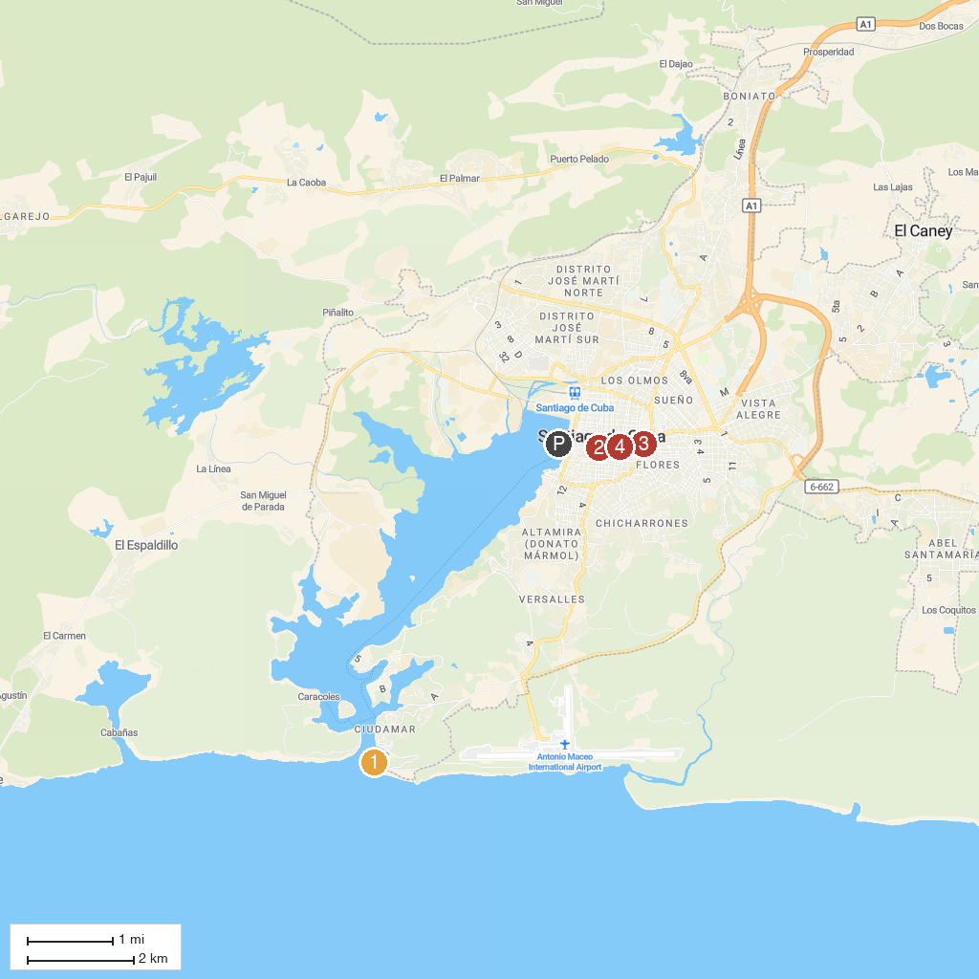
MAP KEY
1. Castillo del Morro | 4. Plaza de Marte
2. Casa de Diego Velazquez | 5. Plaza de Dolores
3. Basílica del Cobre
P. Cruise port / terminal
Map © MapTiler © OpenStreetMap contributors · cruiseports.org

