Santo Antão Island, Cape Verde
Cape Verde's wildest island swaps beach-resort clichés for towering volcanic ridges, misty crater farms, and valleys so green they seem transplanted from the tropics. Step off in arid Porto Novo — within 30 minutes you're inside a different world.
⚓ Docked (Porto Novo pier) · 🕒 Typical call: 6-9 hrs · 💶 Cape Verdean Escudo / Euros accepted · 🗣️ Portuguese / Cape Verdean Creole · 🥾 Hiking paradise
✍️ MY DAY IN PORT (FILL IN)
Ship / Date
In port | arrive ______ · all aboard ______
Booked excursion
Notes / meeting point
GETTING ASHORE
- Docking: Pier at Porto Novo (most ships dock directly; very large ships may tender or arrive via Mindelo ferry)
- Walk to center: ~5-10 min flat walk from pier to Porto Novo town
- Best For: Hiking, scenic mountain drives, grogue distilleries, off-the-beaten-path culture
- Don't Miss: The Corda Road over the ridge to Cova de Paul crater and Paul Valley
GETTING AROUND
- 🚕 Taxi: $65–$85 USD Porto Novo to Ponta do Sol; full-day 8,000–12,000 CVE (~$80–120 USD) — Taxis wait at Porto Novo terminal and offer flexible point-to-point or full-day hire. Negotiate price before departure;
- 📱 Rideshare: ❌ not available
TOP THINGS TO DO
- Corda Road, Cova de Paul & Paul Valley — The classic Santo Antão grand tour.
- Cova Crater Rim to Paul Valley Hike — Hike down from the Cova de Paul crater into Ribeira do Paul — one of Cape Verde's most celebrated trails.
- Grogue Distillery & Cachupa Lunch — Visit a traditional alambique (distillery) in Paul Valley where oxen still turn the sugarcane press to produce grogue, Cape…
- Fontainhas Cliffside Village — Fontainhas is a color-splashed village perched on the edge of a sheer cliff — cited by National Geographic for its extraordinary…
- Ribeira Grande Colonial Town — The northern capital of Santo Antão retains a well-preserved Portuguese colonial center with traditional stone houses, street…
BEST WALKS
- Porto Novo Town Stroll: 1-2 km · 20-30 min · Easy · Flat — From the pier, walk into Porto Novo's modest town center.
- Praia de Curraletes: 3 km west · 5-min taxi · Easy · Black sand — A local black-sand and pebble beach about 3 km west of the port, popular with residents.
WEATHER · DAYLIGHT · MONEY
Month | High °F | Low °F | Rainy days
May | 80 | 70 | 0
Jul | 83 | 73 | 1
Sep | 84 | 76 | 7
Daylight: May 6:08AM–7:04PM · Jul 6:15AM–7:17PM · Sep 6:28AM–6:41PM
cruiseports.org/santo-antao-island · Confirm terminal & all-aboard time with your ship

Santo Antão Island, Cape Verde — Port Map
Red = walkable sights · Amber = excursions farther out · P = cruise terminal
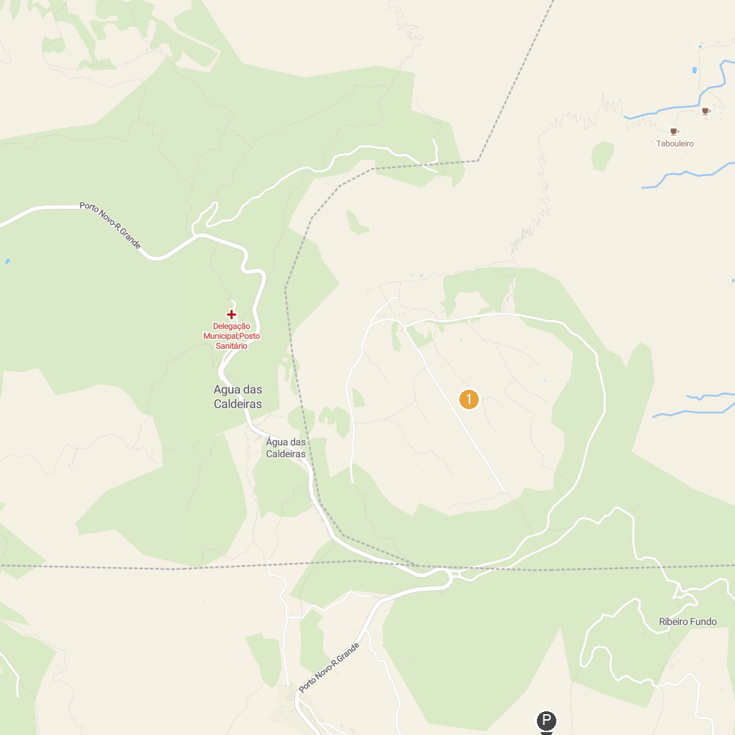
MAP KEY
1. Cova Crater | 2. Laginha Beach
P. Cruise port / terminal
Map © MapTiler © OpenStreetMap contributors · cruiseports.org

