Santos, São Paulo, Brazil
Latin America's largest seaport and gateway to São Paulo, Santos delivers its own rewards: a palatial Coffee Museum, the world's longest beachfront garden, and streets steeped in football legend.
⚓ Pier (Concais Terminal) · 🕒 Typical call: 8-10 hrs · 💵 Brazilian Real (BRL) · 🗣️ Portuguese · ☀️ Hot & humid year-round
✍️ MY DAY IN PORT (FILL IN)
Ship / Date
In port | arrive ______ · all aboard ______
Booked excursion
Notes / meeting point
GETTING ASHORE
- Docking: Pier — Concais Passenger Terminal; no tendering required
- Walk to center: Port is in an industrial zone — taxi or Uber required to exit
- Best For: Coffee history, football fans, beachfront gardens, São Paulo day-trippers
- Don't Miss: Museu do Café in the former Coffee Stock Exchange
GETTING AROUND
- 🚕 Taxi: R$15–25 (city center) — Metered taxis are plentiful at the port. The cruise terminal is roughly 3 km from downtown Santos — expect a short, inex
- 📱 Rideshare: ✅ Uber, 99 (DiDi)
TOP THINGS TO DO
- Museu do Café — Coffee Exchange Palace — The star of Santos.
- Monte Serrat Funicular & Viewpoint — A 1920s funicular climbs Monte Serrat to a hilltop chapel and casino ruins with sweeping 360° views over the port, estuaries, and…
- Museu Pelé — Football Royalty — A sleek modern museum in the Valongo district dedicated to Pelé, who spent most of his career at Santos FC.
- Beachfront Gardens & Gonzaga Beach — The Jardins da Orla stretches 7 km along Santos' beach — Guinness-certified as the world's longest beachfront garden.
- Guarujá Beach Day — Cross the channel by ferry to Guarujá for cleaner, more sheltered beaches like Praia das Pitangueiras and Praia da Enseada — a…
BEST WALKS
- Historic Centre Coffee Trail: 1.5 km · 30–45 min · Flat — Walk from the Coffee Museum through the Valongo neighbourhood past the Igreja do Valongo…
- Gonzaga Beach Promenade: 2 km · 30 min · Flat — Stroll the Jardins da Orla beachfront gardens between Canal 2 and Canal 4, then grab a pastel and…
WEATHER · DAYLIGHT · MONEY
Month | High °F | Low °F | Rainy days
May | 76 | 66 | 13
Jul | 74 | 62 | 8
Sep | 76 | 66 | 13
Daylight: May 6:33AM–5:30PM · Jul 6:47AM–5:35PM · Sep 6:02AM–5:59PM
cruiseports.org/santos · Confirm terminal & all-aboard time with your ship

Santos, São Paulo, Brazil — Port Map
Red = walkable sights · Amber = excursions farther out · P = cruise terminal
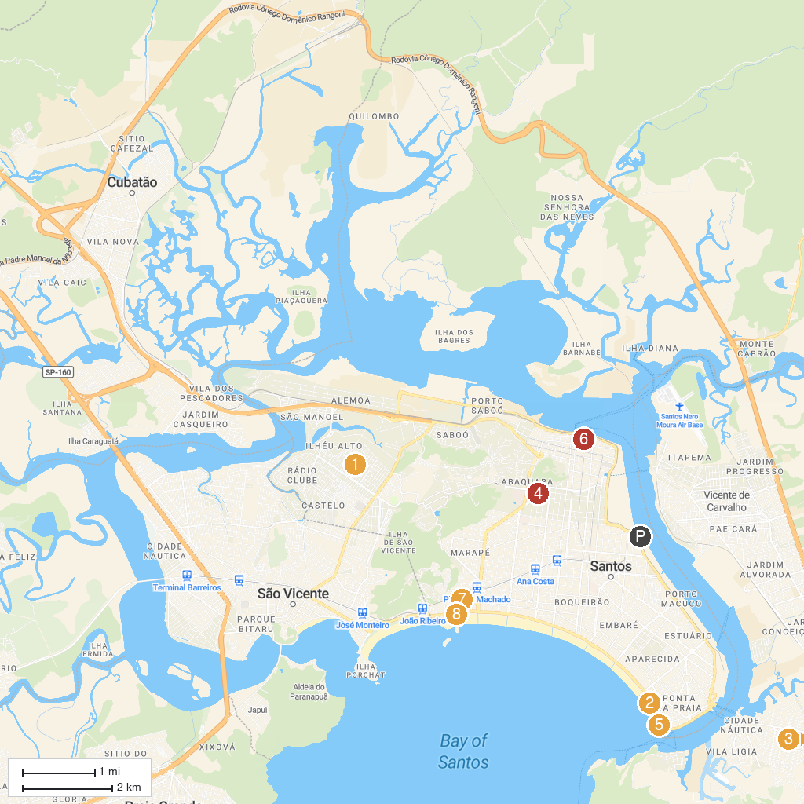
MAP KEY
1. Jardim Botânico de Santos "Chico Mendes" | 5. Museu de Pesca
2. Aquário Municipal de Santos | 6. Hill of Santa Catarina
3. Parish Our Lady Fatima and Santo Amaro | 7. Orquidário Municipal de Santos
4. MISS - Museum of Image and Sound Santos | 8. Municipal Park Roberto Mario Santini
P. Cruise port / terminal
Map © MapTiler © OpenStreetMap contributors · cruiseports.org

