Sasebo, Nagasaki Prefecture, Japan
Sasebo blends naval grit with Dutch kitsch and island scenery. Ships dock right in the city — and the famous made-to-order Sasebo Burger is a five-minute walk from the gangway.
⚓ Pier (docked) · 🕒 Typical call: 7-10 hrs · 💴 Japanese Yen (JPY) · 🗣️ Japanese / some English (US base nearby)
✍️ MY DAY IN PORT (FILL IN)
Ship / Date
In port | arrive ______ · all aboard ______
Booked excursion
Notes / meeting point
GETTING ASHORE
- Docking: Pier — Miura Berth (city center) or Uragashira Terminal (large ships, shuttle provided)
- Walk to center: 5 min from Miura; Uragashira requires shuttle (~30 min)
- Best For: 99 Islands cruise, Huis Ten Bosch theme park, Sasebo Burgers
- Don't Miss: Kujukushima Pearl Queen island cruise & Tenkaiho Observatory panorama
GETTING AROUND
- 🚕 Taxi: ¥510 start; ~¥5,000 from Uragashira — Metered taxis are available at both terminals. From Uragashira to Sasebo Station (city center) expect around ¥5,000 (~$3
- 📱 Rideshare: ✅ Uber
TOP THINGS TO DO
- Kujukushima 99 Islands Pearl Queen Cruise — Sail 50 minutes through 208 pine-covered islands in the East China Sea waters of Saikai National Park aboard the Pearl Queen ship.
- Huis Ten Bosch Dutch Theme Park — A meticulously recreated 17th-century Dutch town — canals, windmills, tulip gardens, museums, and evening light shows.
- Tenkaiho Observatory — The signature panoramic viewpoint over the Kujukushima archipelago.
- JMSDF Sasebo Museum (Sail Tower) — Seven floors tracing Japan's Maritime Self-Defense Force history, with a glass observatory at the top looking over the naval yards.
- Sasebo Burger Trail — Sasebo invented the Japanese gourmet burger in the 1950s — inspired by US Navy recipes — and perfected it over 70 years.
BEST WALKS
- City Center Loop — Pier to Arcade: 2.5 km · 30-40 min · flat — From Miura Berth, walk to Gobangai Mall for a Sasebo Burger, stroll through Yoncho-cho Arcade…
- JMSDF Museum & Naval Waterfront: 3 km round-trip · 45-60 min · easy — Head south along the waterfront from Sasebo Station past the naval yards to the Sail Tower museum.
WEATHER · DAYLIGHT · MONEY
Month | High °F | Low °F | Rainy days
May | 73 | 59 | 11
Jul | 84 | 74 | 18
Sep | 81 | 70 | 15
Daylight: May 5:21AM–7:13PM · Jul 5:23AM–7:30PM · Sep 6:04AM–6:27PM
cruiseports.org/sasebo · Confirm terminal & all-aboard time with your ship

Sasebo, Nagasaki Prefecture, Japan — Port Map
Red = walkable sights · Amber = excursions farther out · P = cruise terminal
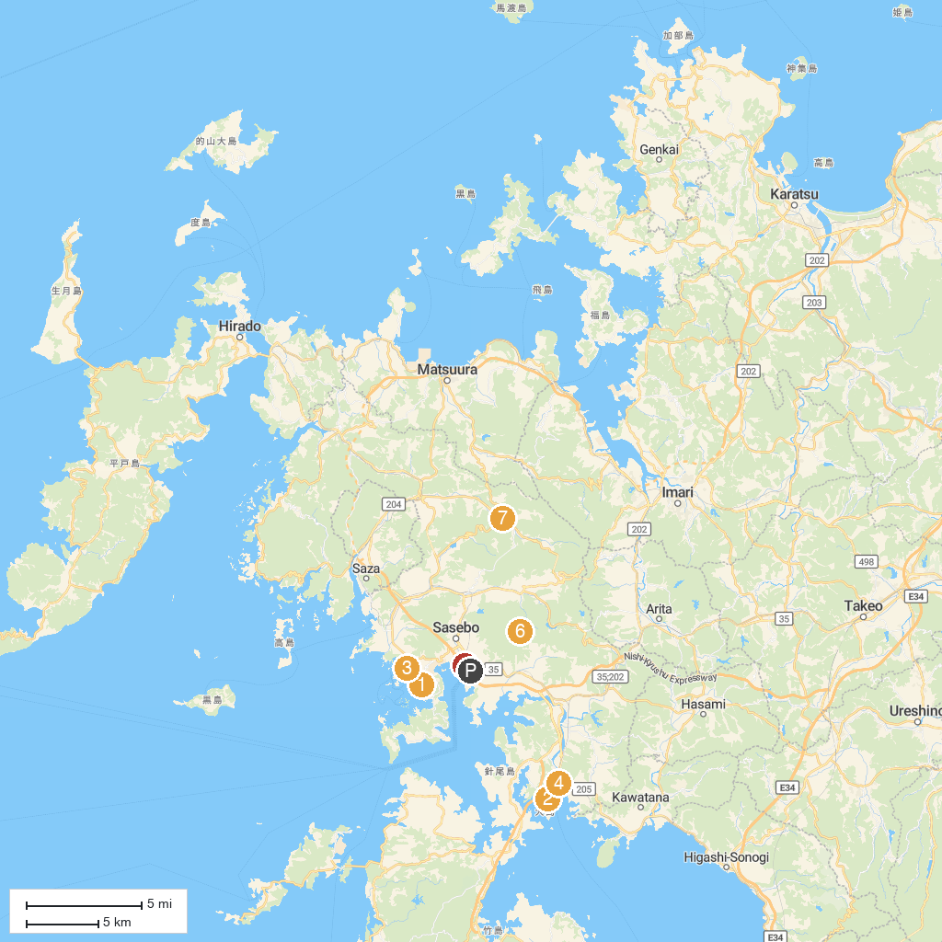
MAP KEY
1. Kujukushima Zoo & Botanical Gardens Mori Kirara | 5. Sasebo Seaside Park
2. Huis Ten Bosch Palace | 6. Eboshi Sports Village
3. UMIKIRARA | 7. Sechibaru Coal Mine Museum
4. Huis Ten Bosch
P. Cruise port / terminal
Map © MapTiler © OpenStreetMap contributors · cruiseports.org

