Scrabster, Caithness, Scotland
A rugged working harbour at the top of mainland Scotland, Scrabster opens the door to royal castles, windswept headlands, world-class surf, and some of the freshest seafood you'll ever taste.
⚓ Docked (pier) · 🕒 Typical call: 7-10 hrs · 💷 GBP (British pounds) · 🗣️ English
✍️ MY DAY IN PORT (FILL IN)
Ship / Date
In port | arrive ______ · all aboard ______
Booked excursion
Notes / meeting point
GETTING ASHORE
- Docking: Docked at St Ola Pier or Queen Elizabeth Pier; very large ships may tender
- Walk to centre: Thurso town is ~1.8 miles (3 km); free shuttle bus typically provided
- Best For: History lovers, whisky fans, scenery seekers, birdwatchers
- Don't Miss: Castle of Mey (Queen Mother's home) and Duncansby Head sea stacks
GETTING AROUND
- 🚕 Taxi: £7–£9 — Local taxis (Highland Cabs, Highland Taxis, Caithness Cabs) cover the 1.5-mile run to Thurso in 4–5 minutes. Taxis wait
TOP THINGS TO DO
- Castle of Mey & Royal Gardens — The Queen Mother's beloved 16th-century castle (now visited by King Charles III each year) sits 25 minutes east of Scrabster.
- Duncansby Head & Sea Stacks — Drive 40 minutes east to the northeastern tip of mainland Britain.
- Dunnet Head — Mainland Britain's True North — Dunnet Head (not John o' Groats) is the genuine northernmost point of mainland Britain.
- Wolfburn Distillery Tour — One of Scotland's most northerly mainland whisky distilleries sits just outside Thurso — a 5-minute taxi ride or 20-minute walk…
- John o' Groats & the North Coast 500 — The famous journey's-end hamlet 40 minutes east is more legend than landmark, but the harbour and cliff views are genuinely…
BEST WALKS
- Scrabster Pier to Holborn Head Lighthouse: 4 miles round-trip · Moderate · 1.5-2 hrs — Head west from the harbour along clifftop paths to Holborn Head, where sea stacks plunge into the…
- Thurso Esplanade & River Walk: 2 miles loop · Easy · 45 mins — From the shuttle bus drop-off at Sir John's Square, stroll down to the beach esplanade for views…
WEATHER · DAYLIGHT · MONEY
Month | High °F | Low °F | Rainy days
May | 53 | 44 | 17
Jul | 60 | 52 | 19
Sep | 58 | 51 | 17
Daylight: May 4:46AM–9:36PM · Jul 4:30AM–10:08PM · Sep 6:44AM–7:33PM
cruiseports.org/scrabster · Confirm terminal & all-aboard time with your ship

Scrabster, Caithness, Scotland — Port Map
Red = walkable sights · Amber = excursions farther out · P = cruise terminal
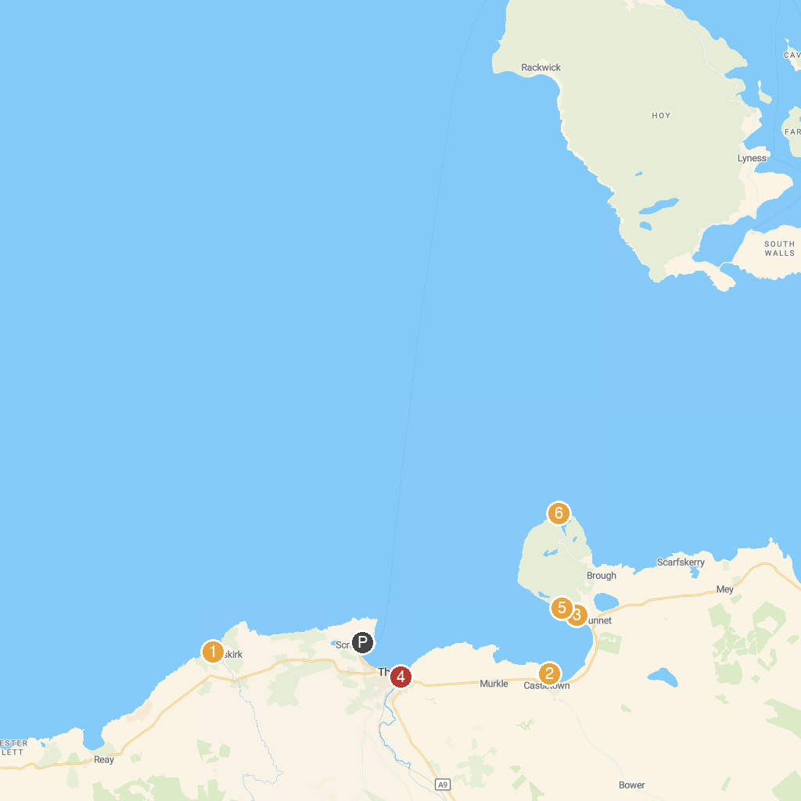
MAP KEY
1. St Mary’s Chapel | 4. Old St. Peter’s Church, Thurso
2. Castlehill Heritage Centre | 5. Peedie Sands
3. Mary Ann's Cottage | 6. RSPB Dunnet Head
P. Cruise port / terminal
Map © MapTiler © OpenStreetMap contributors · cruiseports.org

