Seattle, Washington, USA
Seattle is the undisputed gateway for Alaska cruises — a city where you can start the day with fresh Dungeness crab at a century-old market, gaze down at your ship from the Space Needle, and still make sailaway with time to spare.
⚓ Docked (Pier 91 or Pier 66) · 🕒 Homeport — embark/debark day · 💵 USD · 🗣️ English · 🌧️ Pack a compact rain layer
✍️ MY DAY IN PORT (FILL IN)
Ship / Date
In port | arrive ______ · all aboard ______
Booked excursion
Notes / meeting point
GETTING ASHORE
- Docking: Pier 91 (Smith Cove) for most ships; Pier 66 (Bell Street) for Norwegian, Oceania, and select others — both docked, no tendering
- Walk to center: Pier 66 is steps from downtown; from Pier 91 arrange a taxi/rideshare or confirm any cruise-line transfer — no universal free downtown shuttle is confirmed
- Best For: Pre/post-cruise city days, Pacific Northwest seafood, iconic landmarks, Alaska adventure planning
- Don't Miss: Pike Place Market before 10am — fish toss, flower stalls, and the original Starbucks without the line
GETTING AROUND
- 🚕 Taxi: $20–55 — Taxis available curbside at both Pier 66 (downtown waterfront) and Pier 91 (Interbay). Pier 66 fares to downtown run $20
- 📱 Rideshare: ✅ Uber, Lyft
- 🚌 Hop-on hop-off: ✅ City Sightseeing Seattle
TOP THINGS TO DO
- Space Needle & Seattle Center — Visit the 520-foot observation level and The Loupe revolving glass floor at 500 feet for panoramic views of Puget Sound, Mount…
- Pike Place Market Deep Dive — America's oldest continuously operating public market is a sensory feast — flying fish, fresh flower bouquets, artisan cheese…
- Underground Seattle Tour — Walk the buried city beneath Pioneer Square — original 1889 storefronts preserved one level below modern streets after the Great…
- Museum of Pop Culture (MoPOP) — Frank Gehry's wild titanium building houses hands-on exhibits on rock 'n' roll history, Nirvana, Jimi Hendrix, sci-fi film, and…
- Puget Sound Whale Watching — Orcas, minke whales, and harbor porpoise are regularly spotted in Puget Sound.
BEST WALKS
- Waterfront to Pike Place Loop: 1.5 miles · 45 min · Easy — Start at the Seattle Aquarium, walk north along Alaskan Way, climb the Pike Place Market hillclimb…
- Pioneer Square & Waterfall Garden: 1 mile · 30 min · Easy — Explore cobblestone Pioneer Square, duck into the hidden Waterfall Garden Park (built on the…
WEATHER · DAYLIGHT · MONEY
Month | High °F | Low °F | Rainy days
May | 64 | 49 | 10
Jul | 76 | 58 | 4
Sep | 69 | 55 | 11
Daylight: May 5:31AM–8:40PM · Jul 5:27AM–9:02PM · Sep 6:47AM–7:20PM
ESSENTIAL TRAVEL QUALIFICATIONS
Pier 91: no universal free downtown shuttle confirmed. Complimentary port shuttle is parking–terminal only; confirm any cruise-line transfer destination, availability and price. Use taxi/rideshare if needed.
cruiseports.org/seattle · Confirm terminal & all-aboard time with your ship

Seattle, Washington, USA — Port Map
Red = walkable sights · Amber = excursions farther out · P = cruise terminal
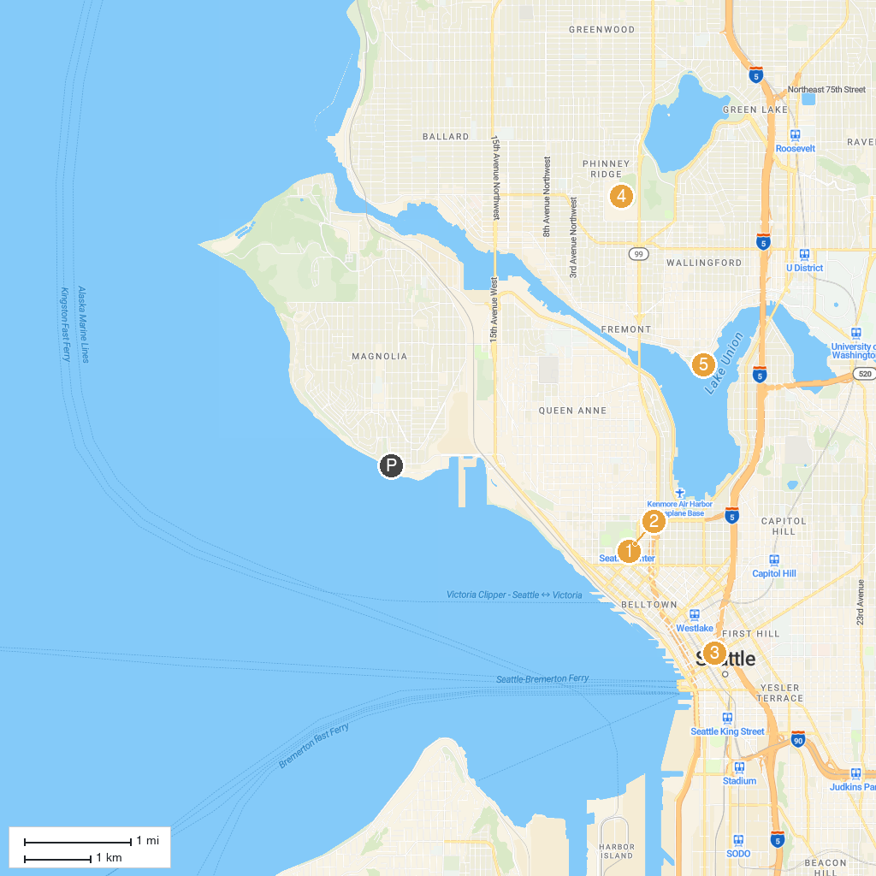
MAP KEY
1. Space Needle | 4. Seattle Public Library - Central Library
2. The Museum of Flight | 5. Woodland Park Zoo
3. Museum of Pop Culture | 6. Gas Works Park
P. Cruise port / terminal
Map © MapTiler © OpenStreetMap contributors · cruiseports.org

