Semarang, Java, Indonesia
The gateway to Central Java — ships dock at Tanjung Emas and the rewards are big: the world's largest Buddhist temple at Borobudur, soaring Hindu spires at Prambanan, and a colonial old town full of Dutch and Chinese heritage.
⚓ Docked (Tanjung Emas port) · 🕒 Typical call: 8–10 hrs · 💵 Indonesian Rupiah (IDR) · 🗣️ Indonesian / Javanese
✍️ MY DAY IN PORT (FILL IN)
Ship / Date
In port | arrive ______ · all aboard ______
Booked excursion
Notes / meeting point
GETTING ASHORE
- Docking: Tanjung Emas Port
- Walk to center: ~20 min by taxi/ojek
- Best For: Borobudur · Colonial Old Town
- Don't Miss: Borobudur at sunrise
GETTING AROUND
- 🚕 Taxi: $3–5 USD — Metered and fixed-rate taxis are available at the cruise terminal with a fare board inside. The city center and Old Town
- 📱 Rideshare: ✅ Grab
TOP THINGS TO DO
- Borobudur Temple — The world's largest Buddhist temple, a UNESCO World Heritage 9th-century stupa-pyramid rising from the Kedu Plain.
- Prambanan Hindu Temple Complex — A stunning UNESCO compound of towering 9th-century Hindu temples dedicated to the Trimurti — Brahma, Vishnu, and Shiva.
- Kota Lama (Old Town) & Lawang Sewu — Semarang's well-preserved Dutch colonial district — ornate facades, canal bridges, and the iconic Lawang Sewu ('Thousand Doors')…
- Sam Poo Kong Temple — A large and vivid Chinese-Javanese temple complex built to honor Admiral Zheng He, the Ming dynasty explorer who stopped here in…
- Gedong Songo Temples — Nine small Hindu temples scattered across the slopes of Mount Ungaran, surrounded by volcanic scenery and cool highland air.
BEST WALKS
- Kota Lama Colonial District Loop: ~2 km · 1–1.5 hrs · easy (flat) — A stroll through Semarang's Dutch colonial heart — past the Blenduk Church, colonial warehouses…
- Sam Poo Kong to Little Chinatown: ~1.5 km · 1 hr · easy — After visiting Sam Poo Kong temple, explore the surrounding Simongan neighborhood and nearby…
WEATHER · DAYLIGHT · MONEY
Month | High °F | Low °F | Rainy days
May | 88 | 76 | 15
Jul | 90 | 74 | 7
Sep | 92 | 75 | 8
Daylight: May 5:40AM–5:28PM · Jul 5:51AM–5:36PM · Sep 5:31AM–5:35PM
cruiseports.org/semarang · Confirm terminal & all-aboard time with your ship

Semarang, Java, Indonesia — Port Map
Red = walkable sights · Amber = excursions farther out · P = cruise terminal
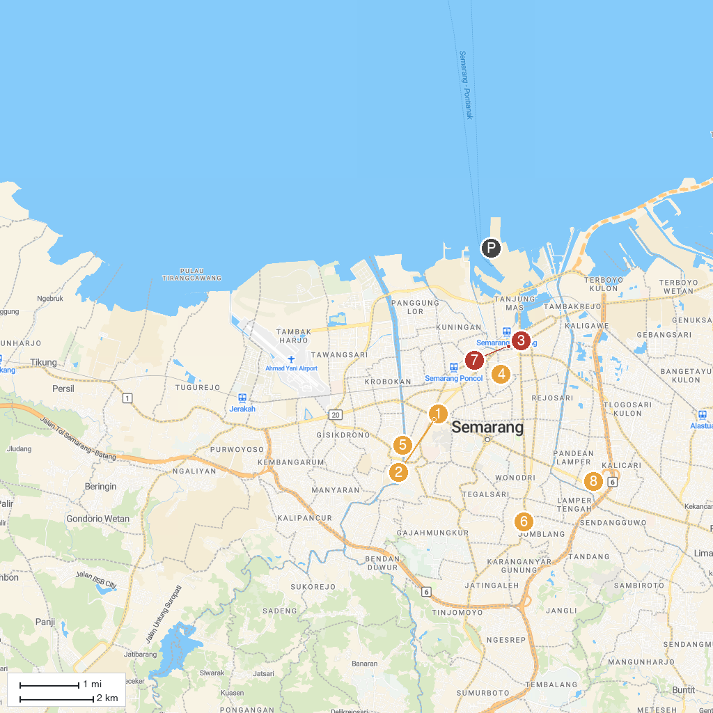
MAP KEY
1. Lawang Sewu | 5. Kanal Banjir Barat
2. Cathedral of the Virgin Mary, Queen of the Holy Rosary | 6. STI Vihara Tanah Putih
3. Saint Joseph Catholic Church, Gedangan | 7. Semarang Contemporary Art Gallery
4. Waroeng Semawis | 8. Taman Bermain Kel. Gayamsari
P. Cruise port / terminal
Map © MapTiler © OpenStreetMap contributors · cruiseports.org

