Shanghai, Shanghai, China
Where colonial grandeur faces a forest of supertall towers across the Huangpu River — Shanghai packs more contrast into a single skyline than almost any city on earth. One shore day barely scratches the surface.
⚓ Docked (pier) · 🕒 Typical call: 8-10 hrs · 💴 Chinese Yuan (CNY) · 🗣️ Mandarin Chinese
✍️ MY DAY IN PORT (FILL IN)
Ship / Date
In port | arrive ______ · all aboard ______
Booked excursion
Notes / meeting point
GETTING ASHORE
- Docking: Wusongkou International Cruise Terminal, Baoshan — 25–30 km from city center
- Walk to center: Not walkable; taxi or ship shuttle ~45–60 min to The Bund
- Best For: History, street food, contrasting architecture, day trips
- Don't Miss: The Bund waterfront promenade and Yu Garden bazaar
GETTING AROUND
- 🚕 Taxi: CNY 85–100 (~$12–16 USD) from Wusongkou; CNY 20–45 from North Bund terminal — Metered taxis are readily available at all terminals. Wusongkou (main port) is 25–30 km from downtown, a 45–60 min ride;
- 📱 Rideshare: ✅ DiDi
- 🚌 Hop-on hop-off: ✅
TOP THINGS TO DO
- The Bund & Pudong Skyline — Stroll the 1.5 km Bund promenade along the Huangpu River, soaking up the colonial-era banking facades opposite the sci-fi Pudong…
- Yu Garden & Old Town Bazaar — Yu Garden (Yuyuan) is a 16th-century Ming Dynasty classical garden of rockeries, pavilions, and koi ponds.
- French Concession & Tianzifang — The former French Concession retains tree-lined avenues, 1930s villas, and art galleries.
- Zhujiajiao Water Town Day Trip — About 50 km southwest of Shanghai, Zhujiajiao is an 1,700-year-old canal town with 36 stone bridges, riverside teahouses, and…
- Jade Buddha Temple — One of Shanghai's most celebrated Buddhist temples, housing two carved white jade Buddha statues brought from Myanmar in 1882.
BEST WALKS
- The Bund to Yu Garden: 3–4 km | 1.5–2 hrs | Easy flat terrain — Start at the northern end of the Bund near Waibaidu Bridge, walk the full promenade south past the…
- French Concession Stroll: 2–3 km | 1–1.5 hrs | Easy — Start at Fuxing Road Metro Station and wander west along Fuxing Middle Road past garden villas and…
WEATHER · DAYLIGHT · MONEY
Month | High °F | Low °F | Rainy days
May | 77 | 62 | 11
Jul | 88 | 77 | 19
Sep | 81 | 70 | 13
Daylight: May 4:58AM–6:42PM · Jul 5:00AM–6:59PM · Sep 5:38AM–5:59PM
cruiseports.org/shanghai · Confirm terminal & all-aboard time with your ship

Shanghai, Shanghai, China — Port Map
Red = walkable sights · Amber = excursions farther out · P = cruise terminal
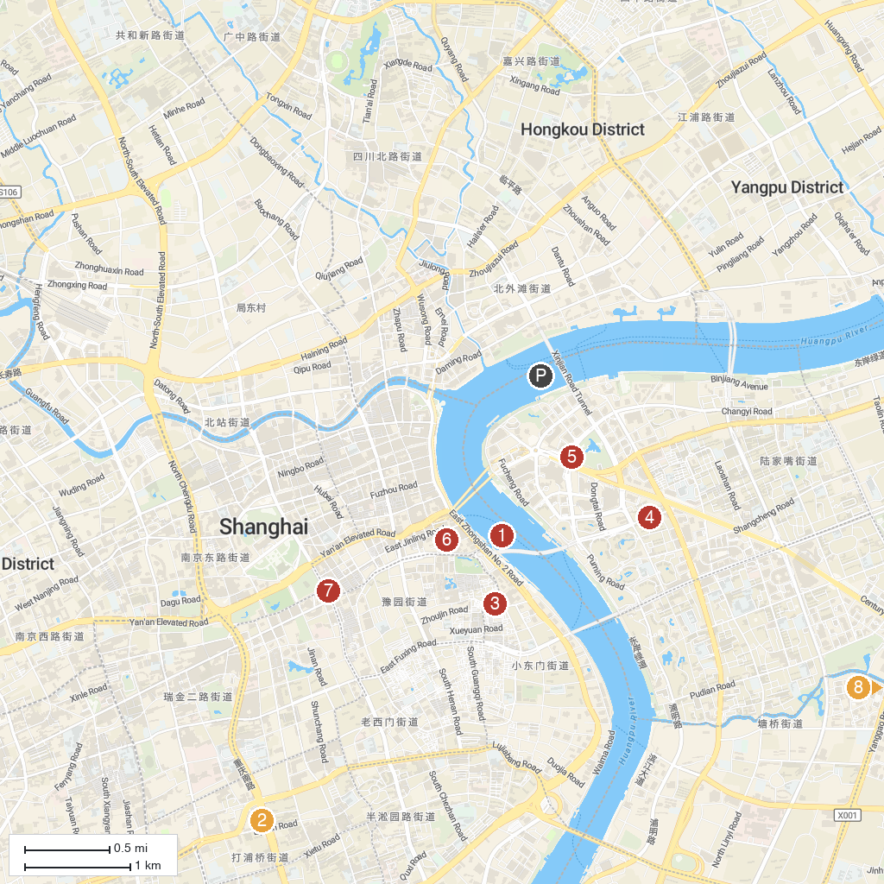
MAP KEY
1. Waitan | 5. Oriental Pearl TV Tower
2. Tianzifang | 6. 外滩中心
3. Yu Garden | 7. Shanghai Museum
4. Shanghai World Financial Center | 8. Century Square
P. Cruise port / terminal
Map © MapTiler © OpenStreetMap contributors · cruiseports.org

