Sharm El Sheikh, Sinai, Egypt
Where the Sinai desert meets the Red Sea — Sharm El Sheikh offers cruise passengers some of the world's best snorkeling at Ras Mohammed, a vibrant old-town souq, and quad-bike rides into the mountains all in one stop.
⚓ Docked (pier) · 🕒 Typical call: 8-10 hrs · 💵 USD widely accepted · 🗣️ Arabic (English common in tourist areas) · 🌡️ Hot desert climate year-round
✍️ MY DAY IN PORT (FILL IN)
Ship / Date
In port | arrive ______ · all aboard ______
Booked excursion
Notes / meeting point
GETTING ASHORE
- Docking: Cruise pier at Sharm Old Town (Sharm al-Maya) — ships dock directly
- Walk to center: Old Market ~5 min walk from pier gate; Naama Bay 6–8 km by taxi (~$10–15)
- Best For: Snorkeling, diving, desert adventures, Red Sea beaches
- Don't Miss: Ras Mohammed National Park — one of the world's top snorkeling sites
GETTING AROUND
- 🚕 Taxi: 100–200 EGP ($3–6 USD) — Taxis are the primary way to get from the cruise terminal to Naama Bay (~10 km). Meters are not used — always agree on t
- 📱 Rideshare: ✅ inDrive
TOP THINGS TO DO
- Ras Mohammed National Park Snorkeling — Egypt's premier marine reserve at the confluence of the Gulf of Suez and Gulf of Aqaba.
- Quad Biking & Camel Trek in the Sinai Desert — Ride ATVs through the ochre Sinai mountains, then switch to camel for a traditional Bedouin camp visit with tea and stargazing.
- Naama Bay Beach Day — The main resort strip 6 km from the port offers sandy beaches, clear snorkeling right off the shore, and a lively promenade of…
- St. Catherine's Monastery & Mount Sinai — One of the oldest Christian monasteries in the world, at the foot of the mountain where Moses received the Ten Commandments.
- Old Market Souq & Al Sahaba Mosque — Sharm's original village market is a short walk from the pier.
BEST WALKS
- Old Market & Al Sahaba Mosque Stroll: ~1 km | Easy | 30–60 min — Walk from the pier gate through the colourful Sharm al-Maya souq.
- Sharm al-Maya Bay Waterfront: ~1.5 km | Easy | 20–30 min — A gentle walk along the bay promenade from the port, passing fishing boats, local cafes, and a view…
WEATHER · DAYLIGHT · MONEY
Month | High °F | Low °F | Rainy days
May | 96 | 76 | 0
Jul | 103 | 83 | 0
Sep | 100 | 81 | 0
Daylight: May 5:53AM–7:25PM · Jul 5:56AM–7:40PM · Sep 6:28AM–6:47PM
cruiseports.org/sharm-el-sheikh · Confirm terminal & all-aboard time with your ship

Sharm El Sheikh, Sinai, Egypt — Port Map
Red = walkable sights · Amber = excursions farther out · P = cruise terminal
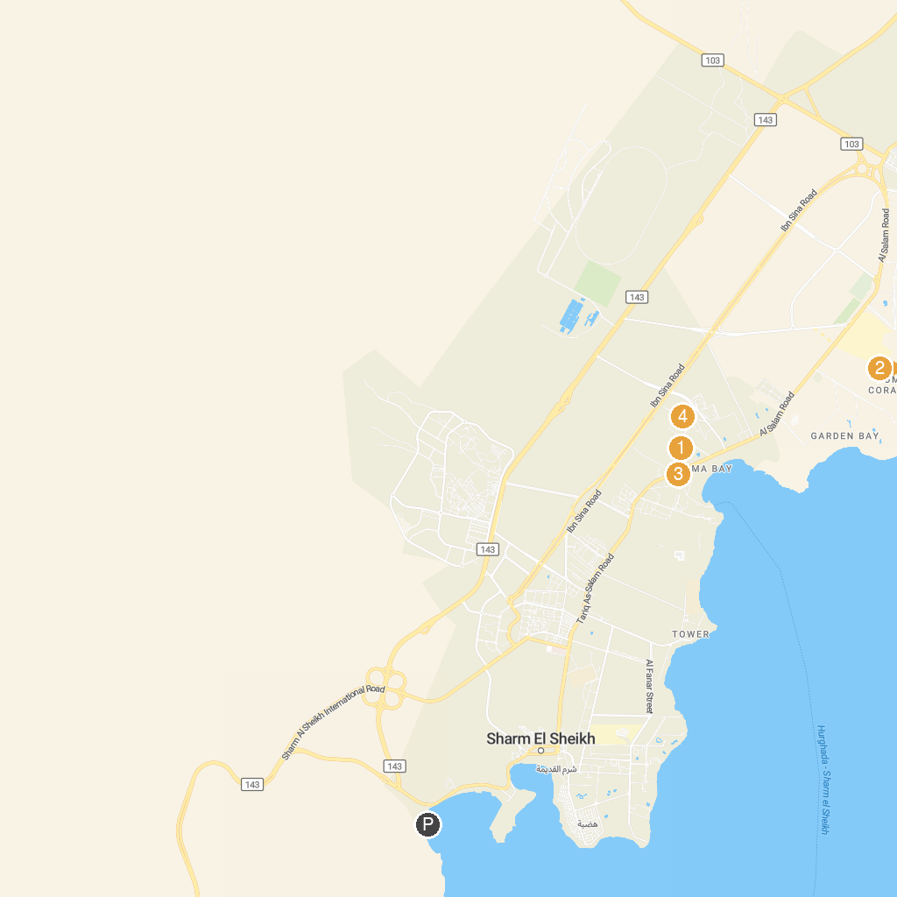
MAP KEY
1. Cleo Park | 3. Pedestrian Rd Neama Bay
2. Aladin Casino | 4. Safari Sharm El Sheikh
P. Cruise port / terminal
Map © MapTiler © OpenStreetMap contributors · cruiseports.org

